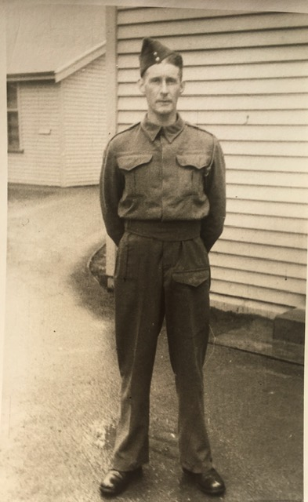
Robert Gordon Hutton - Anzac Biography- Part A

Private Robert Gordon Hutton, commonly known as Bob, was a great Anzac, he was brave, strong and resilient. He very rarely spoke about his time in the war as he really didn’t like the memories. He was a Christian man and really struggled with the idea of having to either take the life of a stranger or have his own life taken. He was an amazing husband, father and poppa. He looked after his little brother Eric while they were away together during World War II. Eric was injured the night after Bob during the same battle and they eventually came home to New Zealand but on different boats. Bob arrived in Dunedin on 6 February 1943. The journey took about 7 weeks.
Bob was born on March 16th 1915 to John and Margaret Hutton. Prior to war Bob was a farmer on his father's farm. He still lived at home on the farm in Livingstone, New Zealand. He was one of three

Official training camp photo of
Robert Gordon Hutton.

boys. Two went to war and one stayed home because he had flat feet. He attended a small school in Livingstone and he married Ina Wally Person. On 14 April 1941 they were married at Ina’s parents house in Kyburn before he went to war. The wedding was not a big event because at the time they were drafting single men and not married men so they were married sooner than initially planned, in hope that married men wouldn't be drafted. Only Bob and Ina’s immediate families attended the wedding. There was snow on the ground on this special day, which was very early, as it was still Autumn (Figure 1).

In New Zealand at the time, the men were 'drafted' to war. Single men first, followed by married men. To be 'drafted' or 'conscripted' was compulsory. If the men did not want to go to war, which most of them didn’t, they had no choice but to serve their country.
Bob was enlisted to Army Training Camp on 4th July 1941 aged 26 years. He joined the army in Oamaru in the South Island of New Zealand. He went to Training Camp at the Army Barracks outside of Christchurch 3 hours away from Oamaru.

It took several weeks to sail from New Zealand leaving on 13 September and arriving at Port Tewfik on 19 October 1941. He sailed from Wellington on the Aquitania which was the only major liner, and the largest commercial vessel, to serve in both World Wars. This luxurious and fast Cunard White Star liner served as a troopship throughout the Second World War. When they arrived, they slept the night on the jetty before arriving at their Camp the following day (Figure 2). Bob was based in Egypt, North Africa, specifically at Maadi Camp during the Campaign of El Alamein and he didn’t enjoy it one little bit. His Battalion was sent out on different campaigns, one being near Azaz and Aleppo in Syria.

Bob was in the Second New Zealand Expeditionary Force and in the 26 Infantry Battalion. The 26th Battalion was an infantry battalion of the New Zealand Military Forces, which served during the Second World War as part of the New Zealand 2nd Division.

Three major battles occurred around El Alamein between July and November 1942, and were the turning point of the war in North Africa. The Battle of El Alamein marked the culmination of the North African campaign between the forces of the British Empire and the German-Italian army. British-born but New Zealand-raised, Lieutenant-General Sir Bernard Freyberg was a charismatic and popular military leader (Figure 3). He was the commander in charge of the 2nd New Zealand Expeditionary Force, through campaigns in Greece and Crete, North Africa and Italy. On Thursday 9 April 1942, Bob refers to Sergeant General Freyberg in his personal diary when they “took salute” (Figure 4). He also mentions other duties in his diary such as guarding Prisoners of War (Figure 5) and going on Parades to practice drills. One drill he mentioned was on 9th February 1942 (Figure 5). On 3 April Bob wrote that it was Good Friday and they went for a routine march around Azaz. After that “we went along the road to pick out the best place to dig in defencelines” (Figure 6). On the 7 of April they were ordered to march as far as 12 miles and got bad blisters on their feet (figure 4). How far they marched depended a lot on which Sergeant was assigned to them. He went to Church on occasions, such as on the 8 February (Figure 5) and on Easter Sunday in Azaz (Figure 6). On the 12 of August he also makes note of his beloved wife Ina’s birthday and writes that he hopes that he is with her for her next birthday (Figure 7). On many occasions throughout Bob's journal, he talks about his wife and buys her many gifts that he sends home to her. For example on April 4th (Figure 6) he said that in Azaz he bought “slippers and hankies for honey” (Figure 14). He also sent home various purses and pouches for the wife he was very much in love with (Figure 15). He carried a lock of her hair wrapped in a tissue with him wherever he went, which is safely stored today with great grandchildren.

On the battlefield on the night of Friday 23 October, Bob states in his diary records that his own side accidently got the timings wrong and dropped a 25 pound bomb, which exploded near him. When it exploded his leg was lacerated by a big piece of shrapnel which was lodged deep within his thigh and he also got a fractured femur (Figure 8 and 13). The man who found him, Mr Barton, tied Bob’s own rifle to his leg as a splint to keep it straight and still. Bob lay there for 8 hours in the dark and in the mud amongst the chaos with the rifle strapped to his leg (Figure 9). The only problem was that the rifle was aiming upwards and he found out later that it was cocked and loaded the whole time!

His leg was so badly damaged that he had to wear a caliper for years to support it. He was never able to bend it again and walked with a walking stick for the rest of his life.
It took 7 years of operations to get the gangrene under control and for him to properly recover. He walked with a stiff leg for the rest of his life. For Army records Ina also wrote about her version of events from when Bob was injured the night and morning of 23 and 24 October 1942 (Figure 10).
Figure 13 is an extract of the exact battle of when Bob got injured by the bomb, taken from an article off of the Australian War Memorial Website.

Bob is worthy of the title, ‘Great Anzac’ due to his gallantry and bravery. He was awarded 3 medals 1939-1945 Star AWMM, Africa Star (8th Army clasp) AWMM, War Medal 1939-1945 and he also was awarded a New Zealand Long Service and Good Conduct medal (Figure 12).
The War Medal 1939-45 was awarded for 28 days full-time service in the Armed Forces between 3 September 1939 and 2 September 1945. A member qualifies for the award where service was brought to an end by death, wounds or other disabilities caused through service. The 1939 - 1945 Star is awarded for 180 days operational service. The African Star, 8th Army clasp for service in North Africa between 10 june 1940 and 12 May 1943. The New Zealand Army soldiers who completed their military service prior to 1 December 1977 required 18 years' service to be awarded the Long Service and Good Conduct Medal.

After returning from war, Ina and Bob won a farm called Rosedale through an Army Ballot for returned servicemen. Here they raised 4 daughters and they had 12 grandchildren. They lived a happy and content life on the farm undertaking many farming duties. They also bought a large section of land at the bottom of their hill and turned it into a thriving camping ground, called the Dansey Pass Holiday Park. This Park is no longer owned by the family but is still a thriving business.

Robert Gordon Hutton died of cancer at the age of 75 at his home in Oamaru and is buried at the Oamaru Cemetery, New Zealand. His children and grandchildren are extremely lucky to have many long lasting memories of him and his life and irreplaceable heirlooms that can be passed down and cherished throughout the generations to come.

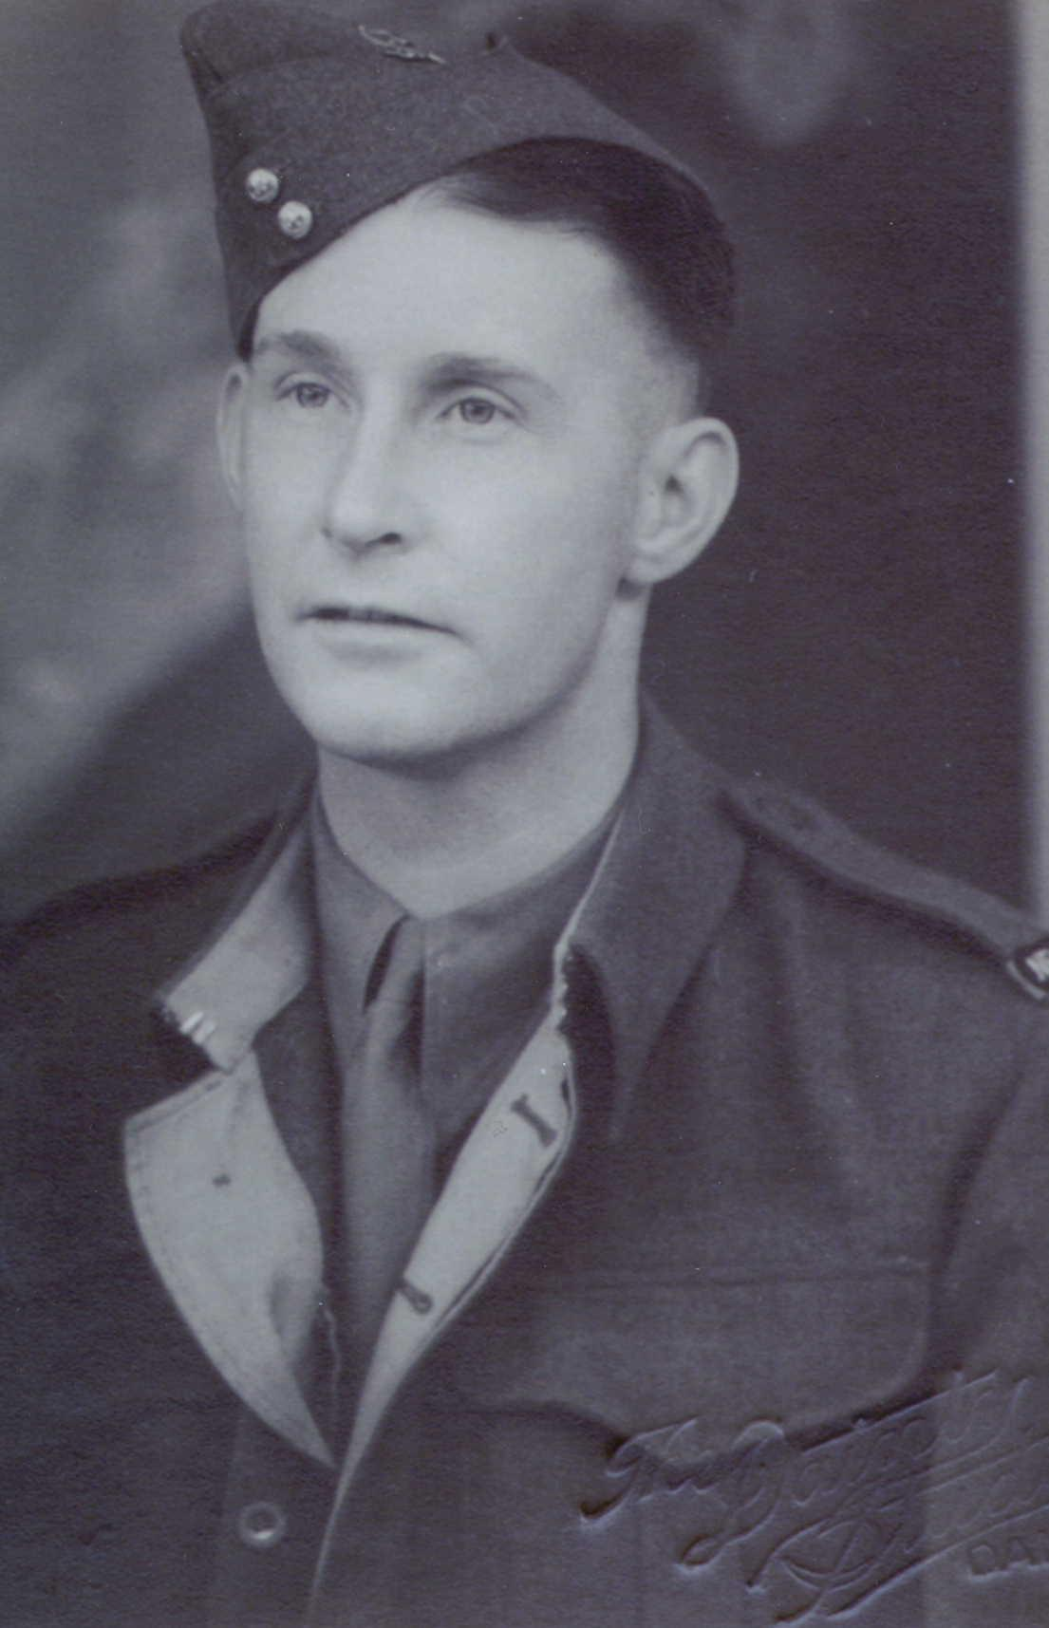

Figure 1

Bob’s Official training camp photo and enlistment picture (taken on his wedding day).

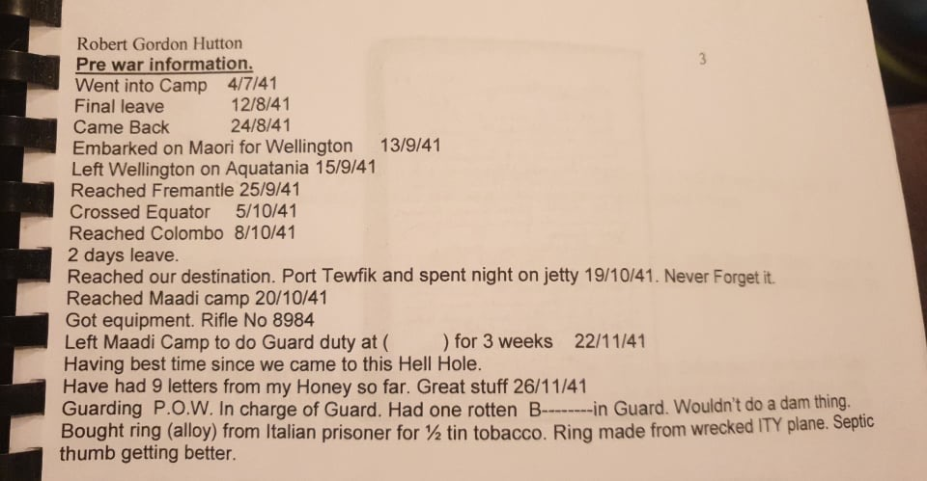

Pre War Information Figure 2

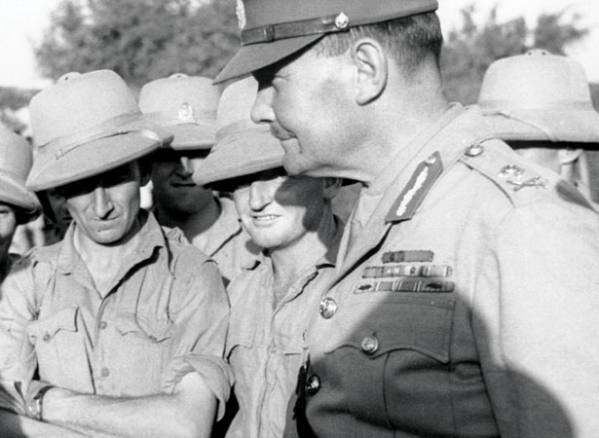
Lieutenant-General Sir Bernard Freyberg Figure 3

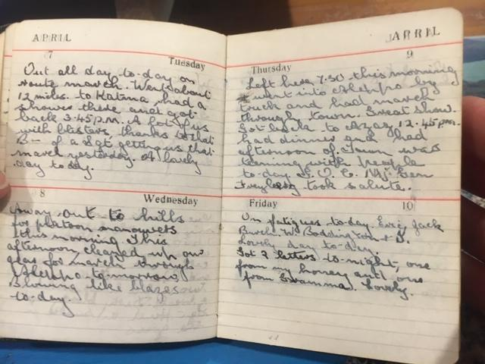
Soldiers “took salute” Figure 4
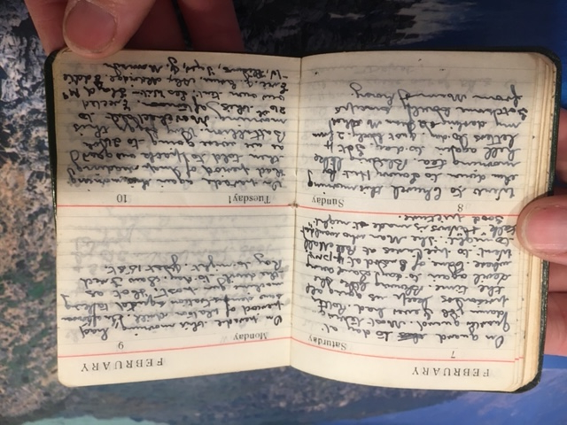
Guarding Prisoners of War, church and drills. Figure 5
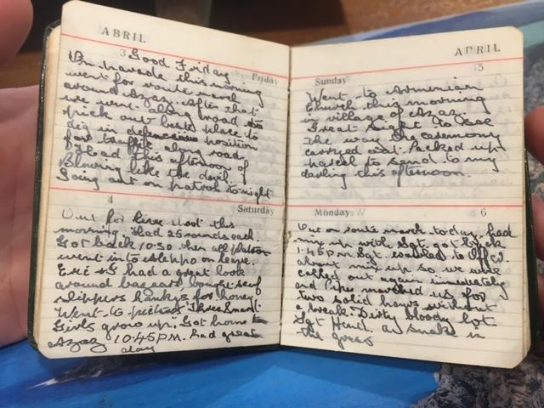

Good Friday and Church on Easter Sunday. Figure 6
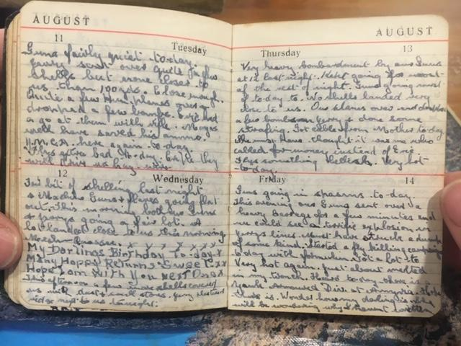

Ina’s Birthday Wishes. Figure 7

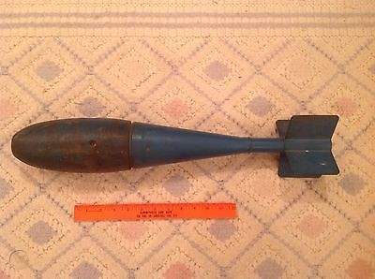

3” piece of shrapnel that got lodged in Bob’s thigh and an image of a 25 pound bomb that the shrapnel came from. Figure 8
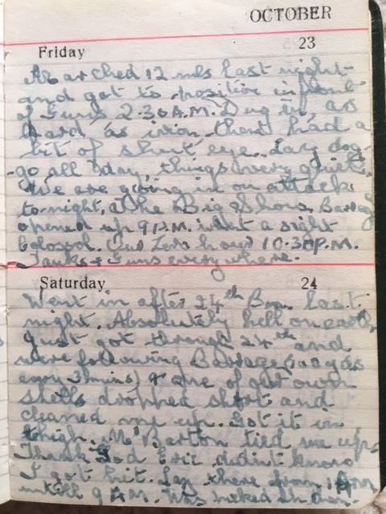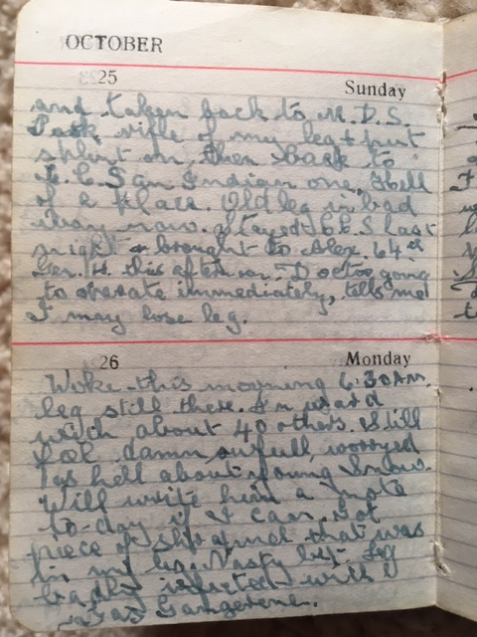
Diary entry of the night Bob was injured.
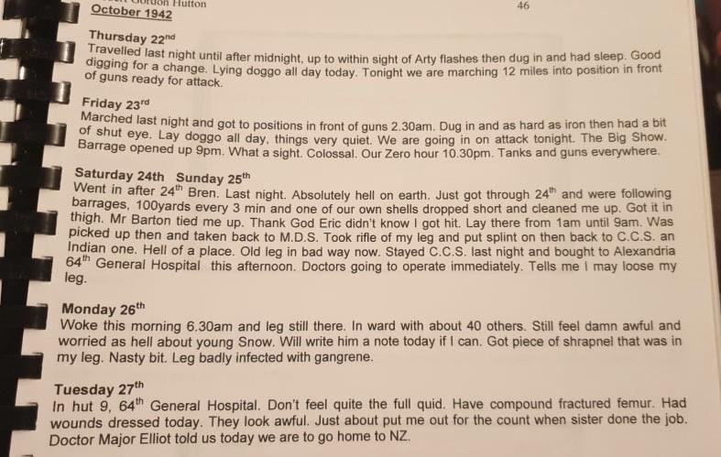
Transcript from diary entry above. Figure 9

Here is a piece that his wife, Ina wrote for Army records.

'On 23 October 1942, Bob was wounded at El Alamein when one of our own 25. pounders fell short and a piece of shrapnel hit him in the left thigh. Leg was almost cut off, as shrapnel lodged on inside of leg. The shrapnel was sent home with him. He arrived in Dunedin Hospital on 6 February 1943 , having come from Egypt on the hospital ship 'Oranje' which landed at Wellington. He then went straight to Dunedin Hospital, where he remained until July, having had two big operations while there. He went home for two days and then was admitted to Oamaru Hospital for twelve weeks. This went on for seven years before they got the leg cleared up. We bought a sheep farm and also built the Dansey Pass Holiday Camp after that. His leg was always stiff. I have kept his telegrams, diaries and other information.'

Figure 10

“On the night of 23 October 1942, a massive artillery barrage heralded the great Allied offensive. The infantry successfully captured most of their objectives; however, the tanks were unable to follow through and continue the thrust. With the Axis forces stubbornly holding their lines intact, Montgomery worried that his offensive was becoming bogged down. Changing tactics from the drive westwards, he ordered the Australians of 9th Division to switch their attack northward. What followed was a week of extremely fierce fighting, with the Australians grinding their way forward over well-defended enemy positions. As had happened in July, their gains so worried Rommel that he again diverted his strongest units to stop them. Places such as Thompson’s Post, the Fig Orchard, the Blockhouse and the Saucer became an inferno of fire and steel as the Australians weathered the storm of bombs, shells and bullets.”

Extract of the battle of when Bob got hit by the bomb. Figure 11

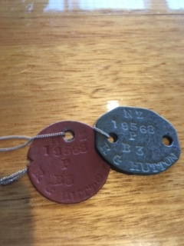
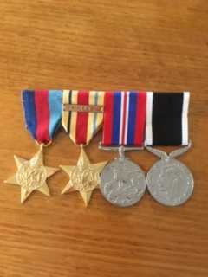

Bob’s Medals that he was awarded for his service, along with his Identity tags.
Figure 12

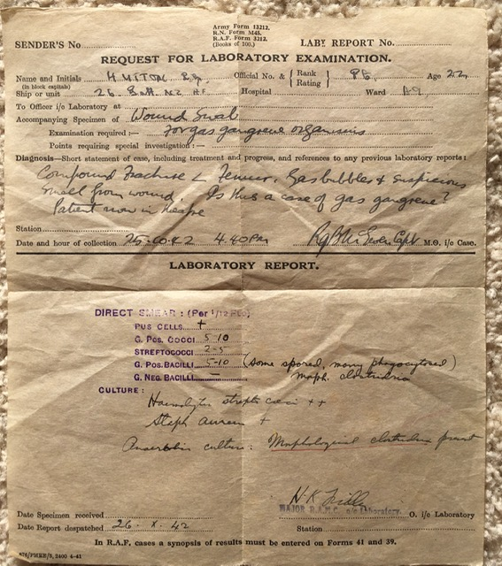
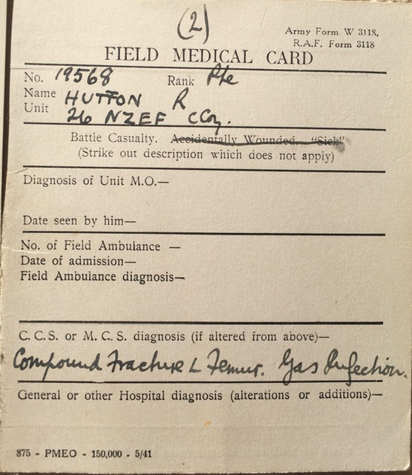

Medical Forms Figure 13
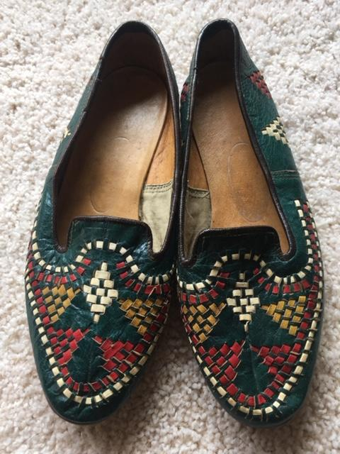

Slippers sent home, bought for Ina in Azaz. Figure 14

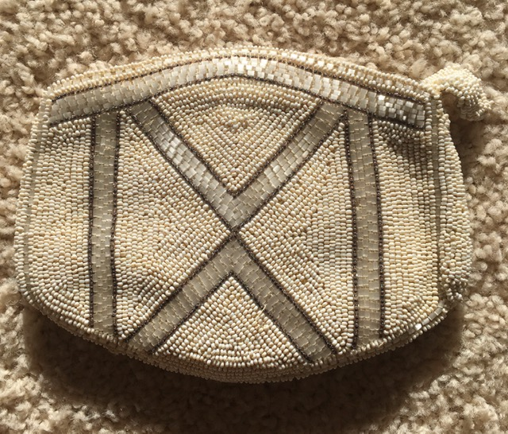
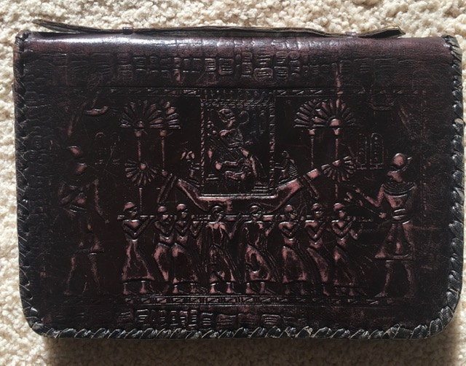
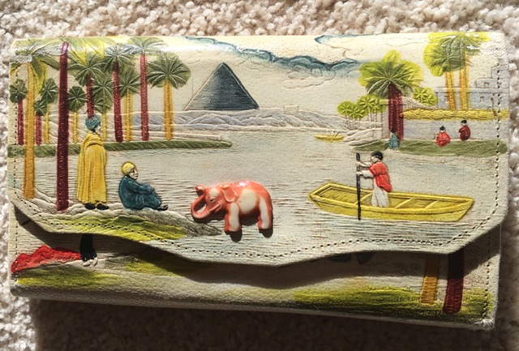

Purses sent home to Ina. Figure 15

Bibliography

http://www.danseyspass.com/-Home. 2020. Home. [ONLINE] Available at: http://www.danseyspass.com/. [Accessed 19 May 2020].

https://www.aucklandmuseum.com/-Auckland War Memorial Museum. 2020. Home - Auckland War Memorial Museum . [ONLINE] Available at: https://www.aucklandmuseum.com/. [Accessed 19 May 2020].

https://en.wikipedia.org/wiki/26th_Battalion_(New_Zealand)-Wikipedia. 2020. 26th Battalion (New Zealand) - Wikipedia. [ONLINE] Available at: https://en.wikipedia.org/wiki/26th_Battalion_(New_Zealand). [Accessed 19 May 2020].

Kohlhagen , Roberta, Email Communication, 30-4-20.

Kohlhagen , Roberta, Text Message Communication, 15-5-20.

Hutton , Gordon , Personal Diary written during WWII, 1942.

http://medals.nzdf.mil.nz/category/h/h9.html-NZDF Medals - The 1939 - 1945 Star. 2020. NZDF Medals - The 1939 - 1945 Star. [ONLINE] Available at: http://medals.nzdf.mil.nz/category/h/h9.html. [Accessed 19 May 2020].

https://www.defence.gov.au/medals/imperial/wwii/War-Medal.aspWar Medal 1939-1945 : World War Two : Department of Defence. 2020. War Medal 1939-1945 : World War Two : Department of Defence. [ONLINE] Available at: https://www.defence.gov.au/medals/imperial/wwii/War-Medal.asp. [Accessed 20 May 2020].
War Medal 1939-1945 : World War Two : Department of Defence. 2020. War Medal 1939-1945 : World War Two : Department of Defence. [ONLINE] Available at: https://www.defence.gov.au/medals/imperial/wwii/War-Medal.asp. [Accessed 19 May 2020].

https://www.nam.ac.uk/explore/battle-alamein-Second Battle of El Alamein | National Army Museum. 2020. Second Battle of El Alamein | National Army Museum. [ONLINE] Available at: https://www.nam.ac.uk/explore/battle-alamein. [Accessed 19 May 2020].

https://www.nam.ac.uk/explore/battle-alamein-Second Battle of El Alamein | National Army Museum. 2020. Second Battle of El Alamein | National Army Museum. [ONLINE] Available at: https://www.nam.ac.uk/explore/battle-alamein. [Accessed 19 May 2020].

https://nzhistory.govt.nz/bernard-freyberg-assumes-command-of-the-nz-expeditionary-force-Second Battle of El Alamein | National Army Museum. 2020. Second Battle of El Alamein | National Army Museum. [ONLINE] Available at: https://www.nam.ac.uk/explore/battle-alamein. [Accessed 19 May 2020].

https://www.history.com/topics/world-war-ii/battle-of-el-alamein-HISTORY. 2020. Battle of El Alamein - HISTORY. [ONLINE] Available at: https://www.history.com/topics/world-war-ii/battle-of-el-alamein. [Accessed 19 May 2020].

Anzac Spirit - Part B

From what I have learned about Bob, he has shown to possess all of the qualities known to Anzacs, during and after his time at war. Two qualities that really stand out to me are mateship and perseverance.

Bob got hit by a 25 pound bomb, causing a 3 inch piece of shrapnel to get lodged in his thigh and a compound fractured femur (Field Medical Card, October 1942). He remained strong and resilient and had a fighting spirit to ‘hang in there’ and persevere through the pain. He showed perseverance and was very brave to lay in the mud and pitch black, quietly and with hope from 1am until 9am in the morning, especially while he was in so much pain and amongst all the chaos happening around him (Robert Hutton, diary entry 24 October 1942). He persevered with this bad injury caused by the bomb with many operations on it in the 7 years to follow. He had a pin put in his broken leg and also many operations to get the gangrene under control so his perseverance was extraordinary. Initially, he thought that he was going to lose his leg but luckily they were able to save it. Bob wore a caliper to support his leg for a long time after, as it was so badly injured (Extract, Ina Hutton, Auckland Museum). Bob possessed a lot of perseverance and determination with these injuries.
From reading Bob’s diary records, there was also a lot of mateship amongst the soldiers. Mr Barton showed mateship when he helped Bob after he got hit by the bomb, by strapping his leg with Bob’s rifle (Robert Hutton, diary entry 24 October 1942). Bob also had a younger brother, Eric who he always looked out for. On many occasions throughout his own personal journal, that he wrote during his time in the war, he mentions Eric, worries about him and thinks about him (Robert Hutton, personal diary, 1942). For example on 25 October 1945, Bob wrote “thank God Eric doesn’t know I got hit” (Robert Hutton, diary entry, 25-10-45). He also spent lots of his time off with Eric, like on April 4 when both of them looked around Aleppo together ( Robert Hutton, diary entry, 4-4-1942) Mateship was also shown on the 10 February 1942 when Bob was told to pack his gear along with the other soldiers and to march to the 26 Battalion. Here they supported and helped each other out by putting up a tent together (Robert Hutton, diary entry, 10-2-42).
Robert Gordon Hutton showed a lot of mateship with fellow soldiers during his time in World War 2, along with a lot of persevering with his injuries and a long recovery afterwards.

