The battle of Polygon Wood was the Ist ANZAC component of a larger British and dominion operation staged as part of the third battle of Ypres. This operation was the second of the "Plumer battles", a serious of well-planned, limited advances supported by large volumes of artillery, masterminded by the British general Herbert Plumer. The name "Polygon Wood" derived from a young plantation forest that lay along Ist ANZAC's axis of advance.
Scheduled to begin on 26 September 1917, the attack was almost derailed by a German attack on the British X Corps to the south of Ist ANZAC. A day earlier, Australian troops of the 15th Brigade, preparing for their attack, took part in fending off the Germans; however, their advance the next day began with continuing uncertainty as to the security of their flank.
The British and dominion advance began on schedule at 5.50 am on the 26th, with the 4th and 5th Divisions, on the left and right respectively, taking the lead in the Ist ANZAC sector. The infantry advanced behind a heavy artillery barrage - the noise of this was compared to a roaring bushfire - and they secured most of their objectives without difficulty. To the south, the 15th Brigade, which after its efforts the previous day had been reinforced by two battalions from the 8th, secured not only its own objectives but those allocated to the neighbouring 98th British Brigade. The Germans launched several counter-attacks but these were thwarted by the heavy defensive artillery barrages used to protect the infantry consolidating on their objectives; this was a feature of the Plumer battles. The battle cost 5,770 Australian casualties.

At the battle of Polygon Wood, Belgium on the 26th and 27th September 1917, Privates Terence Macguire, BECKETT, regimental number 4246 of the 29th Battalion, 11th/R, 'A' Company and Arthur William, ALLAN, regimental number 154 of the 29th Battalion, 'A' Company were assigned together and both cited by their Commanding Officer Lieutenant-Colonel Muir Purser for gallant and conspicuous services during the same action, and as a result both soldiers were recommended for the Military Medal on 03/10/1917.
The citation from Lieutenant-Colonel Purser dated 03/10/17 read as follows;
"In the attack on POLYGON WOOD on 26th. September, 1917, Private Beckett pushed forward with the attacking troops and took part in the fighting for the final objective.
When the objective had been taken Pte. Beckett assisted to establish and man an observation post, which was maintained throughout 26th. and 27th. September, in spite of being blown up on several occasions by enemy shell-fire. In this way much valuable information was obtained and never for a moment was Pte. Beckett deterred by enemy fire from bringing back information.
Under heavy shell-fire he assisted to bring in wounded, and then subsequently used as runner he carried out his work with great bravery and devotion"
Recommendation; Military Medal
M. Purser Lieut. Colonel
C.O. 29th. Battalion
Citation BECKETT: https://www.awm.gov.au/collection/R1626933?search
Discovering Anzacs: https://discoveringanzacs.naa.gov.au/browse/person/86276
RSL Virtual Memorial: https://rslvirtualwarmemorial.org.au/explore/people/295108

Also, a Congratulatory letter was sent to the mother of Private Terence Maguire Beckett, Mrs Mary Buckett, from Sir W.R. Birdwood, Commanding the 1st Anzac Corps, dated 24th January, 1918 No 68825, the letter read as follows;
Dear Madam, I have much pleasure in forwarding hereunder copy of extract from Routine Orders issued by Lieutenant-General Sir W.R. Birdwood, K.C.B., K.C.S.I., K.C.N.C., C.I.E., D.S.C., Commanding 1st Anzac Corps, relating to the conspicuous services rendered by your son, No. 4246 Private T. McQ. Beckett, 29th Battalion.
CONGRATULATORY
"The Army Corps Commander wishes to express his appreciation of gallant services rendered by the undermentioned soldier during the recent operations – No. 4246 Private T. McQ. Beckett"
The above has been promulgated in Australian Military Order, No 11-dated 12th January, 1918.
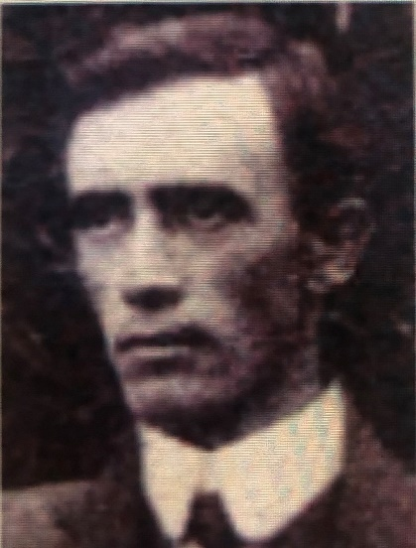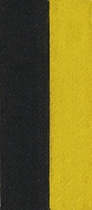

Private Terence Maguire Beckett, No. 4246, 29th Infantry Battalion 11th/Reinforcement, ‘A’ Company, A.I.F. embarked from Sydney on the troop ship HMAT A19 Afric on 03rd November 1916. He enlisted in the A.I.F. on 30th June 1916 at Victoria Barracks, N.S.W, and was discharged on 18th May 1919.
His battalion was disbanded and amalgamated with the 32nd Battalion due to mounting casualties at 11.00am on 12th October 1918, four weeks prior to armistice day on 11th November 1918. Terence was transferred to the 5th Infantry Brigade.
Terence was the son of James Charles and Mary Winifred Buckett, of Pambula N.S.W., he had one sister and eight brothers.
He was born in Eden, N.S.W. on 24th October 1883 and died in Balmain N.S.W. on 08th February 1957 at the age of 73.
Terence changed his family name of BUCKETT, to BECKETT on 27th May 1908 with consent and approval of his then employer, the Department of Public Instruction of N.S.W.
In honour of all who served their county – “Lest We Forget”

