James Edward FARRELLY folio

Born: 1892
Fought in western front
Lance Sergeant – moved between rank of corporal and sergeant

Web 1: https://www.aif.adfa.edu.au/search
Service number – unique code each soldier has to define them – James no. was 3743
This tells us when James embarked on a ship, he departed Australia at the age of 23
Enlistment Date is the date of when James signed up to go to war this tells us that he enlisted in 1915
Tells us where he left on ship and what ship he boarded on and when
Tells us where he fought and what medals he won
This highlights that he survived the war

Regimental number | 3743
Place of birth | Port Broughton South Australia
Religion | Roman Catholic
Occupation | Butcher
Address | Port Broughton, South Australia
Marital status | Single
Age at embarkation | 23
Next of kin | Mother, Mrs M A Farrelly, Port Broughton, South Australia
Enlistment date | 11 August 1915
Rank on enlistment | Private
Unit name | 10th Battalion, 12th Reinforcement
AWM Embarkation Roll number | 23/27/3
Embarkation details | Unit embarked from Adelaide, South Australia, on board RMS Malwa on 2 December 1915
Rank from Nominal Roll | Lance Sergeant
Unit from Nominal Roll | 10th Battalion
Fate | Returned to Australia 19 August 1919
Other details | War service: Egypt, Western Front  Medals: 1914-15 Star, British War Medal, Victory Medal
Date of death | 23 October 1965
Place of burial | Centennial Park Cemetery

Web 2: https://www.awm.gov.au/advanced-search/people
This was his first rank when he joined the army, private is the lowest rank
The unit James was in – the 10th battalion, which is a unit for South Australians
Details of his embarkment
James embarked on the 2nd of December 1915 in Adelaide onto the ship RMS Malwa
Service number | 3743
Rank | Private
Roll title | 10 Infantry Battalion - 9 to 12 Reinforcements (September-December 1915)
Conflict/Operation | First World War, 1914-1918
Date of Embarkation | 02 December 1915
Place of embarkation | Adelaide
Ship Embarked On | RMS Malwa

Web 4: https://recordsearch.naa.gov.au/SearchNRetrieve/Interface/SearchScreens/NameSearch.aspx

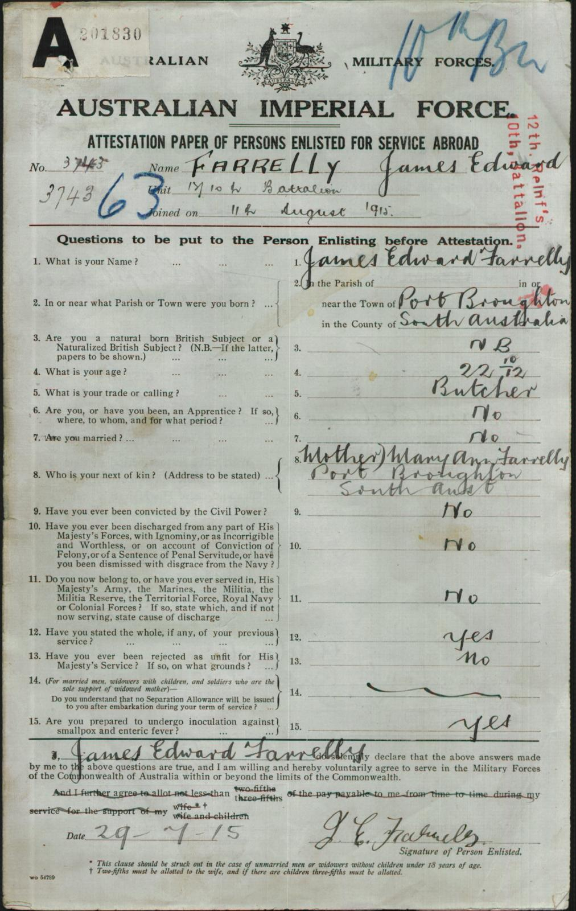
Service number
Name
Date of enlistment
Unit – battalion and reinforcement

Natural born meaning born in Australia
His age of enlistment
His occupation before enlisting which was a butcher
His relative (mother) who receives any news about soldier

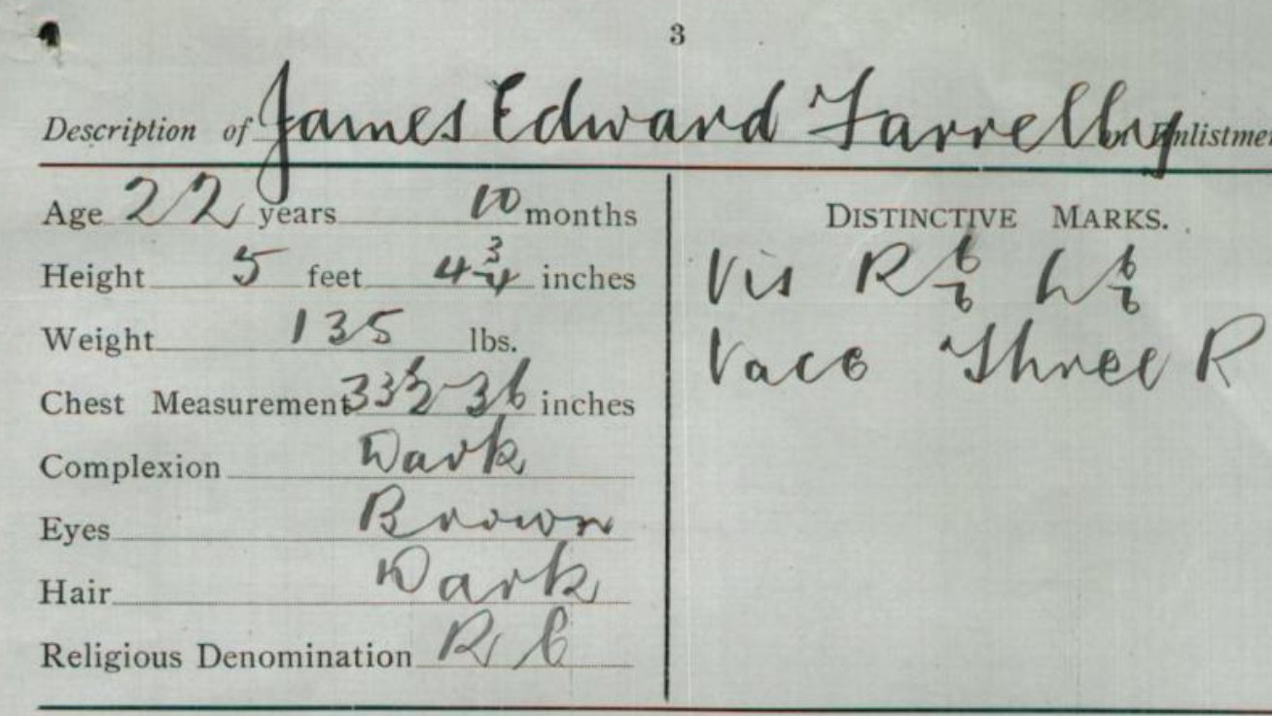
Tells us his age
Description of his body and appearance
His religion – roman catholic
Unique marks on body
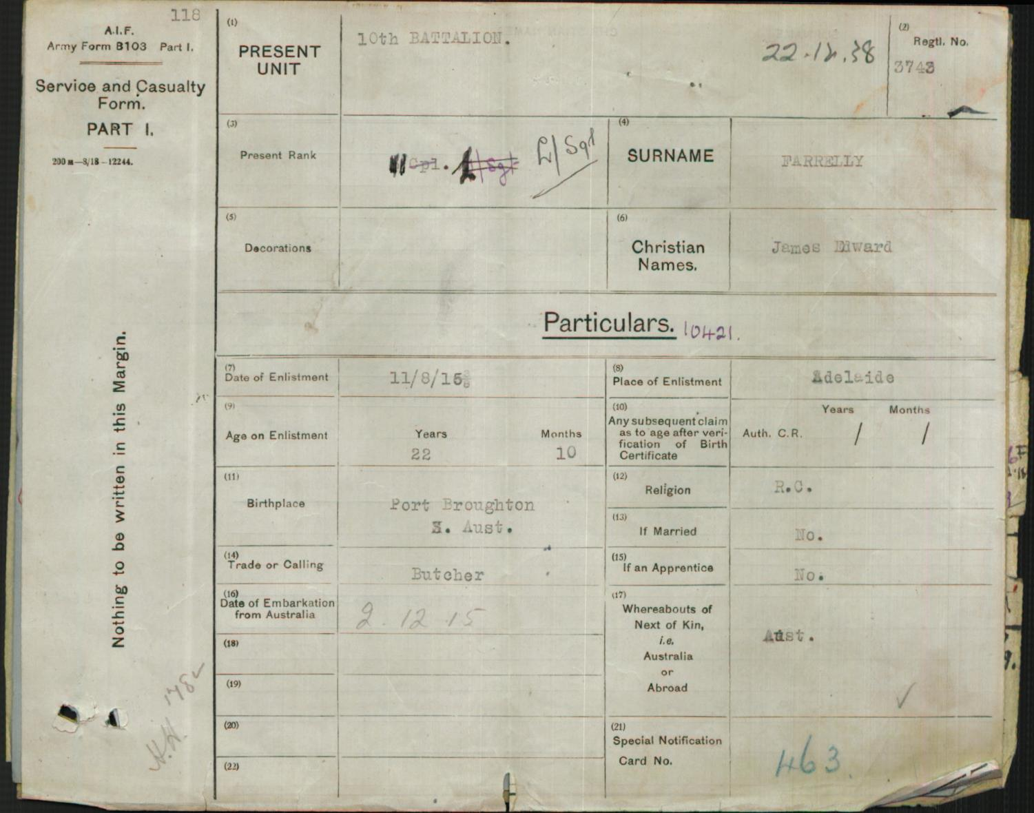
Present rank, Lance sergeant tells us his rank amongst the ranking system
Where he was born: Port Boughton SA
Occupation before soldier – butcher

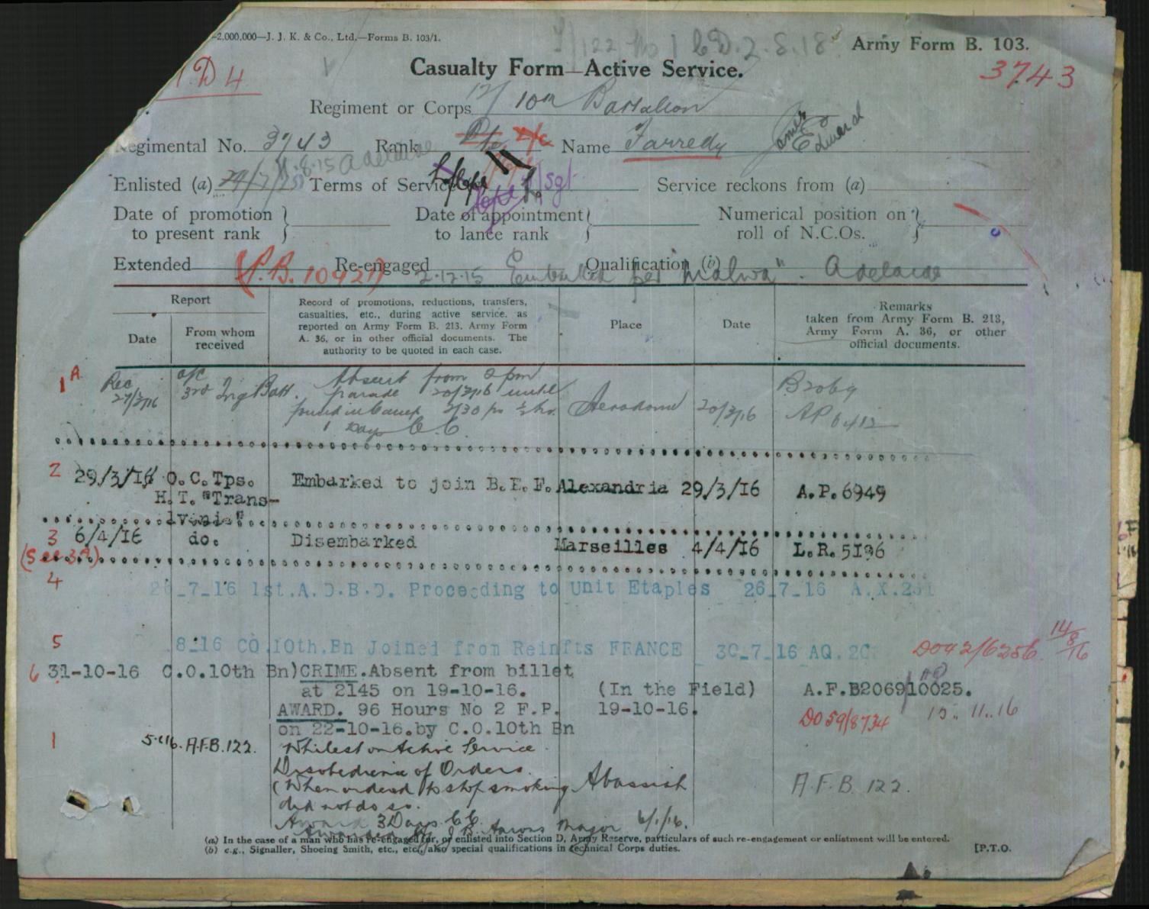
Casualty form: movements of soldier in war
Embarked at Alexandria (place in Egypt) on 29/3/1916
Disembarked at Marseilles (city in France) on 4/4/16

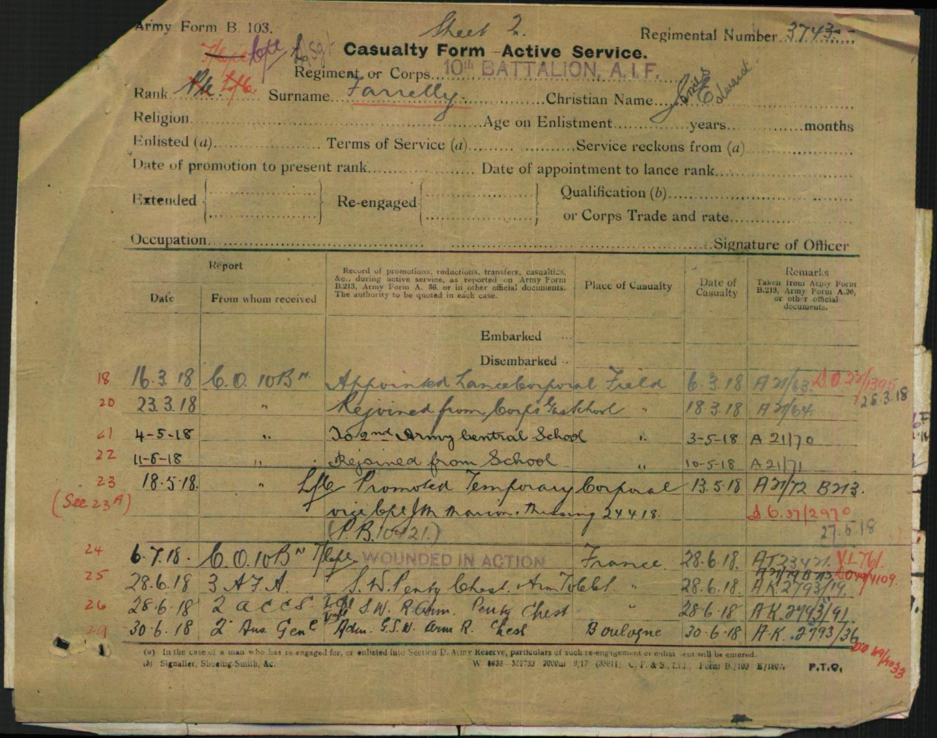
Appointed lance sergeant on 6th of March 1918 in France
Rejoined from school
Wounded in action on 28/6/18: western front

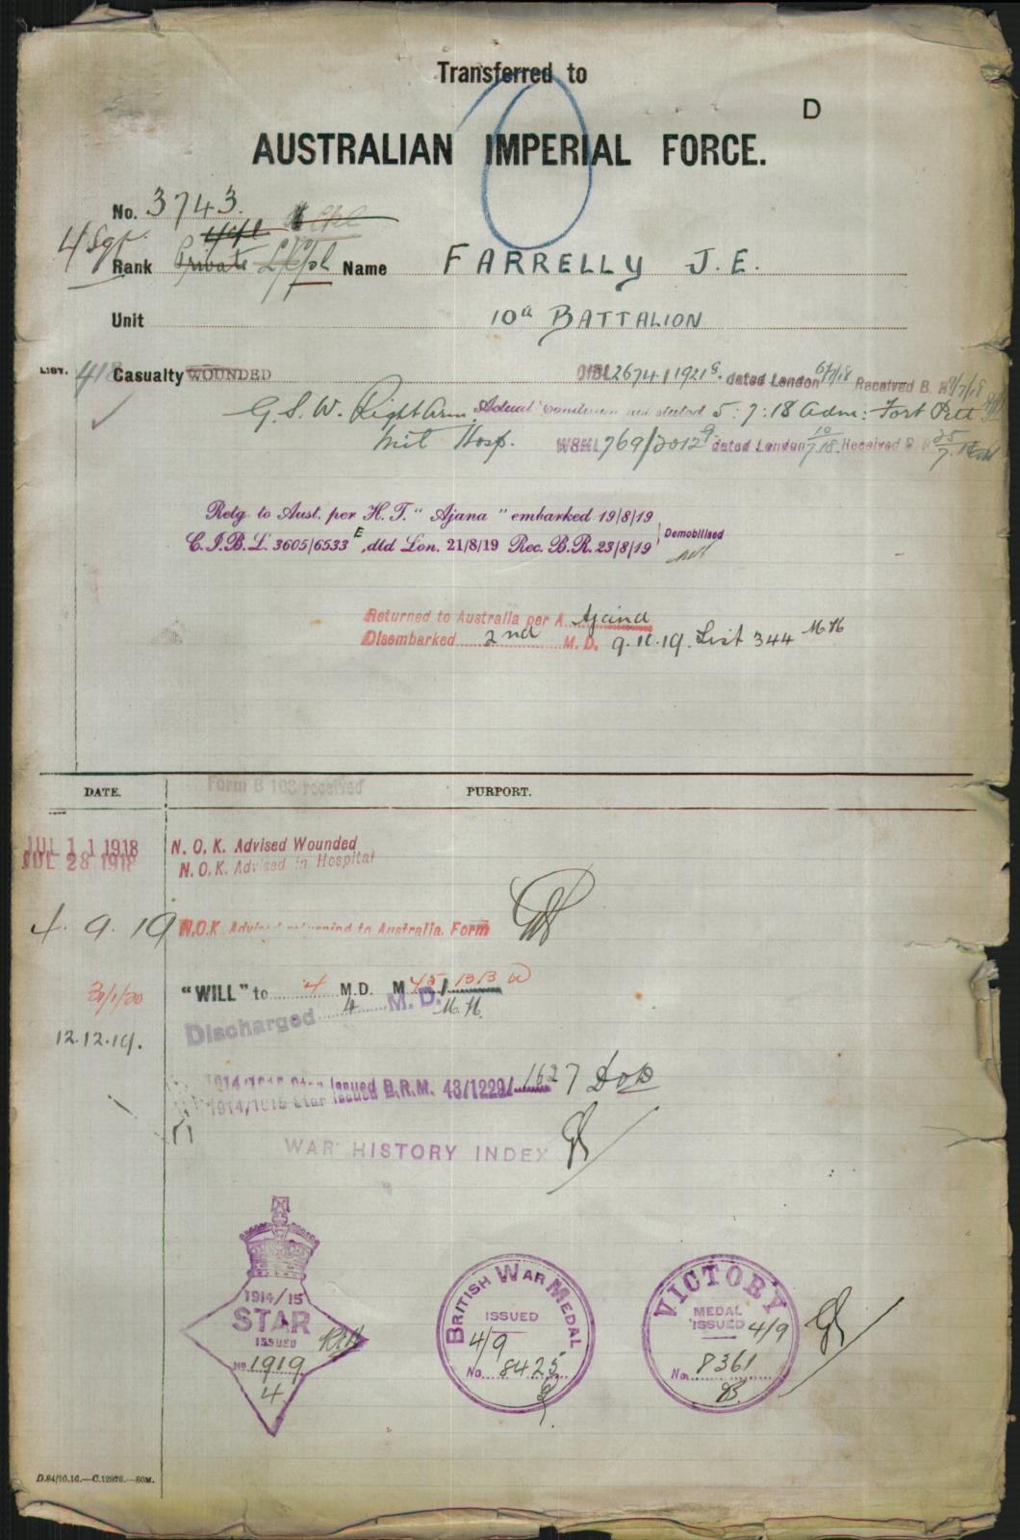
Embarked to leave for home
Disembarked in Australia
NOK: next of kin (mother) – advised that soldier was wounded and in hospital / arrived in Australia
Medals:
Star medal
British war medal
victory medal

Web 7: https://www.awm.gov.au/advanced-search
Soldier’s final ranking at end of war
What unit he was in
Timeline: date of enlisting for war till returning back home

Service number 3743
Final Rank Lance Sergeant
Unit 10th Australian Infantry Battalion
Conflict/Operation First World War, 1914-1918
Rolls
First World War Nominal Roll:
Unit
10th Australian Infantry Battalion
Conflict
First World War, 1914-1918
Rank
Lance Sergeant
Timeline
Date of enlistment 11 August 1915
Date returned to Australia 19 August 1919

Web: unit diary
James Farrelly got wounded on 28/6/18 – he was part of a minor operation
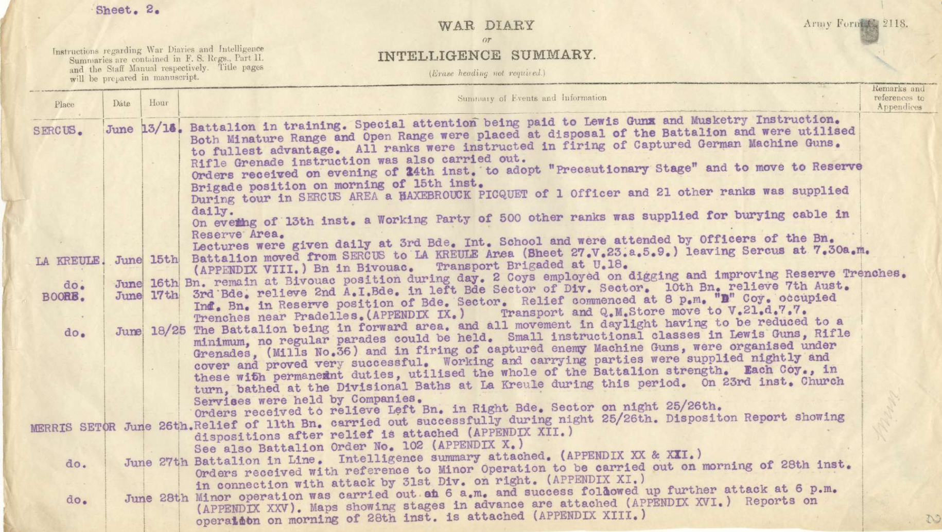
Orders of attack was made on Merris (place in France) to be stimulated in conjunction with the main attack
Rifle grenades, smoke bombs and gun fire were used to divert attention and fire from being directed at the main attacking forces

Web: trove
After war, the 10th battalion had their 5th anniversary of the embarkment of SA’s first battalion
