1908 Australian University Championships—
Port River Adelaide SA
Again the Sydney crew were pushed but won by a margin of 2 lengths over the 3 mile course at Port Adelaide. The Sydney crew went on to win in an even better way in 1909.
The Sydney crew contained coxswain Robert Waley and the Melbourne crew contained Harry Ross-Soden and Simon Fraser who were to row in the 1912 Olympic eight.
The race was conducted on 6th June 1908.

Men's Eight
Time:15 mins 45 secs
Margins:
2 lengths
6 lengths
1st Sydney University - Bow: William K Inglis, 2: Kenneth Smith, 3: Llewellyn Bissett Rudder, 4: Allan Worsley Holmes a'Court, 5: Charles N Smith, 6: Max E Bedford, 7: Oscar A Ireland, Str: Thomas S Dixson, Cox: Robert G K Waley, Cch: Rowan R Hickson
2nd Melbourne University - Bow: Frederick L Apperly, 2: Sydney James Campbell, 3: Harry Ross-Soden, 4: James Hemery Lindon, 5: Charles W B Littlejohn, 6: Frank Aurley Henry Boynton, 7: Francis Ernest Dosseter, Str: Simon Fraser, Cox: John Dow, Cch: Henry Joseph Whiting
3rd Adelaide University - Bow: Frederick Brune Frinsdorf, 2: Charles Lempriere Abbott, 3: Glen Howard Burnell, 4: Lancelot Waring Gill, 5: Ronald Melville Scott, 6: Robert Wilson Tassie, 7: Arthur Lorimer Kennedy, Str: Charles Archibald Hamilton, Cox: Angus Salier Ferguson, Cch: William Henry Savigny
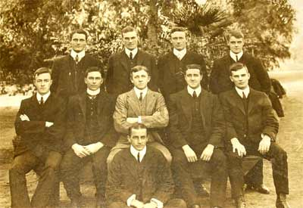
Melbourne University
Back row: Harry Ross-Soden, J H Linden, F H Boynton, C W B Littlejohn
Front row: F L Apperley, F E Dosseter, Simon Fraser, H J Whiting, S J Campbell
In front: J Dow

