John Dow – Melbourne University Intervarsity Boat Race 1908

I have consulted my MUBC records and have ascertained that John Dow did not hold any administrative positions (Captain, Secretary or Treasurer) at the club.

My Inter-Collegiate Boat Race records (annual races between the residential colleges of Melbourne University) to do not show that John competed in any of these races between 1900 and 1914 so I have concluded that while he attended the university he did reside on the campus.

However, at the conclusion of the annual college boat race there was a race between the winning college crew and one selected from students who were not in residence at the university (known as extra collegiate). They competed for the John Lang Cup. Unfortunately, the crew records for this competition are scarce so I am unable to see if John competed in this event. This might have given me good insight into how he came to cox the 1908 Intervarsity VIII.

John’s rise to fame within MUBC seems to have begun in 1907 when he steered the winning maiden eight at the Australian Henley Regatta on the Yarra. Simon Fraser who was also stroke of the 1908 Intervarsity crew stroked the crew. In those days, the Henley Regatta was held in November so it’s reasonable to assume that members of this crew would have wanted to stay together for the next year.

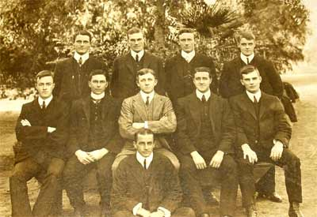

This is a photo of the 1908 crew and it contains some very interesting individuals. John Dow is seated in the front and it seems obvious that he is a bit older. Perhaps he started his university career a little later. Simon Fraser is in the front in the light jacket. Behind him on the far left is Harry Ross-Soden. These gentlemen were our first ever Olympic Games representatives, rowing in the VIII at Stockholm in 1912. Prior to the Games they won the Grand Challenge Cup at the Henley Royal Regatta on the Thames.

The extra member in the photo is the crew’s coach. He is seated to the right of Fraser and his name was Henry Whiting.

Adrian Maginn

