World war 1 essay By Alie Hughes

World war 1 was the first time ordinary men were asked to fight above and beyond their call of duty as soldiers. World war 1 fell upon 1914 July 28th and ended 1918 November 11^{th.} Percy wade was an Australian soldier who did not make it out of world war 1 alive, as well as many other soldiers.

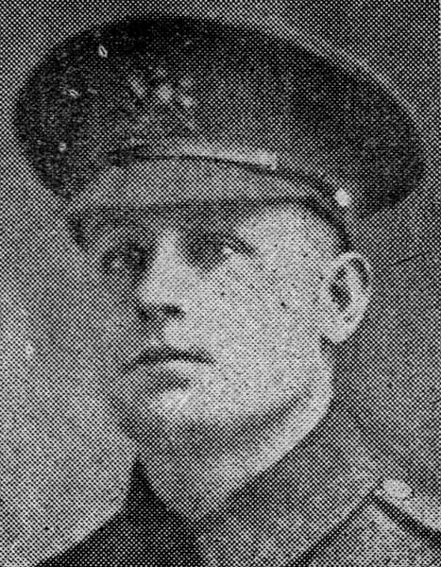
Percy Wade was born in blackwood, South Australia, he lived on wade street Eden hills in a house that still stands today. Percy wade was a part of the blackwood football club and the Coromandel 2nd XL cricket team. He enlisted on the 19th of October 1916 and was 29 when he embarked, Percy became a privet. Percy was part of the 43d Battalion, 6th Reinforcement, the 43d Battalion was South Australia’s contribution to the strength of the division, along with the 41st, 42nd and 44th Battalions. Privet Percy had a brother named Alfred Wade who served with the 51st battalion and survived the war, Percy and Alfred enlisted together on the 19th of October 1916. Whilst he was with the 43d battalion, he helped stop the German spring offence at Villers-B retonneux in April 1918, took part in the battle of hamel in July 1918, and in August 1918 helped drive the Germans back to the Hindenburg line. Percy was hit by machinegun fire and died before one of his mates finished dressing his wounds. He was buried where he fell but sadly the burial place could not be located after the battle.

World war 1 did not only have an impact on Percy wade and his family. During and after the first world war Australia changed significantly. Australia’s economy and government greatly changed during world war 1. Since almost all the Australian men went to war, woman where left having to work in factories and shops to keep Australia running, but they were underpaid. World war 1 helped establish Australia as a nation and shaped us into what we are today.
“happen what may, the Australians who fought at Gallipoli will bequeath a heritage of honour to their children’s children.” – General Sir Ian Hamilton, November 1915.
The ANZAC legend, in theory is that Australian and New Zealander troops helped to establish their countries reputations. The legend of our men at war has given Australia and New Zealand something to be proud of. The ANZAC legend is so important for us Australians because it encourages all Australians remember the soldiers who sacrificed their lives for our country. The impact made from the legend has made a such a great impression of Australians, and we will continue to celebrate and commemorate the ANZAC soldiers landing and fighting in Gallipoli for years to come. World war 1 helped establish Australia as a nation and shaped us into what we are today

World war 1 was a massive part of history, it helped shape countries, economy’s and governments and now the world has learnt that violence is not the answer. Many lives were lost like young Privet Percy wade, and we will always hold them in our hearts for being so brave and noble, and risking their lives for Australia. Lest we forget.

Bibliography:
2009, Blackwood Soldiers Project: Private Percy Wade, Blackwoodsoldiersproject.blogspot.com.au 17th/6/2016-http://blackwoodsoldiersproject.blogspot.com.au/2009/10/private-percy-wade.html
2016, 23/6/2016 -http://www.citethisforme.com/cite/website/autocite
2016, The Anzac legend, Gallipoli and the ANZACs, Australia and World War I, History Year 9, NSW | Online Education Home Schooling Skwirk Australia, Skwirk.com, 23/6/2016 http://www.skwirk.com/p-c_s-14_u-42_t-46_c-136/the-anzac-legend/nsw/the-anzac-legend/australia-and-world-war-i/gallipoli-and-the-anzacs
2012, The ANZAC Legend, Australian stories, yarns and myths, 23/6/2016https://australianyarns.wordpress.com/the-anzac-legend/
2016, Private Percy Wade | Australian War Memorial, Awm.gov.au, 14/6/2016https://www.awm.gov.au/people/P10271817/
2009, Blackwood Soldiers Project: Private Percy Wade:, Blackwoodsoldiersproject.blogspot.com.au 14/6/2016http://blackwoodsoldiersproject.blogspot.com.au/2009/10/private-percy-wade.html
2016, Details, Aif.adfa.edu.au 14/6/2016https://aif.adfa.edu.au/showPerson?pid=309812

