Bob Heard Baker
Service Number: 2445
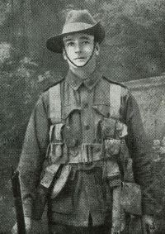
Bob Heard Baker was a private in the 16th Australian infantry battalion. He was admitted to the 1st Australian stationary hospital, Mudros, 9th August 1915 and then transferred to St. David’s hospital, Malta on the 21st if august 1915 because of a gunshot wound, a shrapnel wound and deafness. He was then moved to the 2nd London General Hospital, England, 25th August 1915.
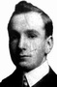
Bob Heard Baker was born in Spreyton, Devonshire, England, he Moved to Australia at the age of 19 to Springton, Clydesdale Street, Victoria park, Western Australia, he enlisted in Perth, Western Australia, on the 24th of May 1915. When he enlisted he was 5’7.5” and weighed 135 lbs. he disembarked from Fremantle, Western Australia on board the HMAS A51 Chilka on the 18th of June 1915
Bob Heard Baker was in the 16th battalion as a private, he trained in Victoria and survived the attack on the bloody angle and was taken back to Egypt, the battalion then he sailed to france in 1916 but was killed in Mouquet farm, Pozieres. He has no known grave and was commemorated at the Australian National Memorial, Villers-Bretonneux, France. Private baker became missing in action on the 31st of August 1916 and was found to be Killed in action on the same day.
Before the war Bob Heard Baker was a Steward, he was married to Mrs Florence Baker who lived in Springton, Clydesdale street, Victoria park, Western Australia.

Baker, B. (2016). Roll of Honour: Bob Heard Baker | Australian War Memorial. [online] Awm.gov.au. Available at: https://www.awm.gov.au/people/rolls/R1730937/ [Accessed 9 May 2016].
Aif.adfa.edu.au. (2016). Details. [online] Available at: https://www.aif.adfa.edu.au/showPerson?pid=11088 [Accessed 9 May 2016].
Awm.gov.au. (2016). Australian War Memorial. [online] Available at: https://www.awm.gov.au/unit/U51456/ [Accessed8 May 2016].
Awm.gov.au. (2016). Australian War Memorial. [online] Available at: https://www.awm.gov.au/unit/U51456/ [Accessed 10 May 2016].

