Victor David O’Connor
4 June 1896 – 2 Sept. 1918

1904 Sgt 1915
5948 CSM 1916-18

War Record Highlights
Photographs
1915 Diary
Letters Home

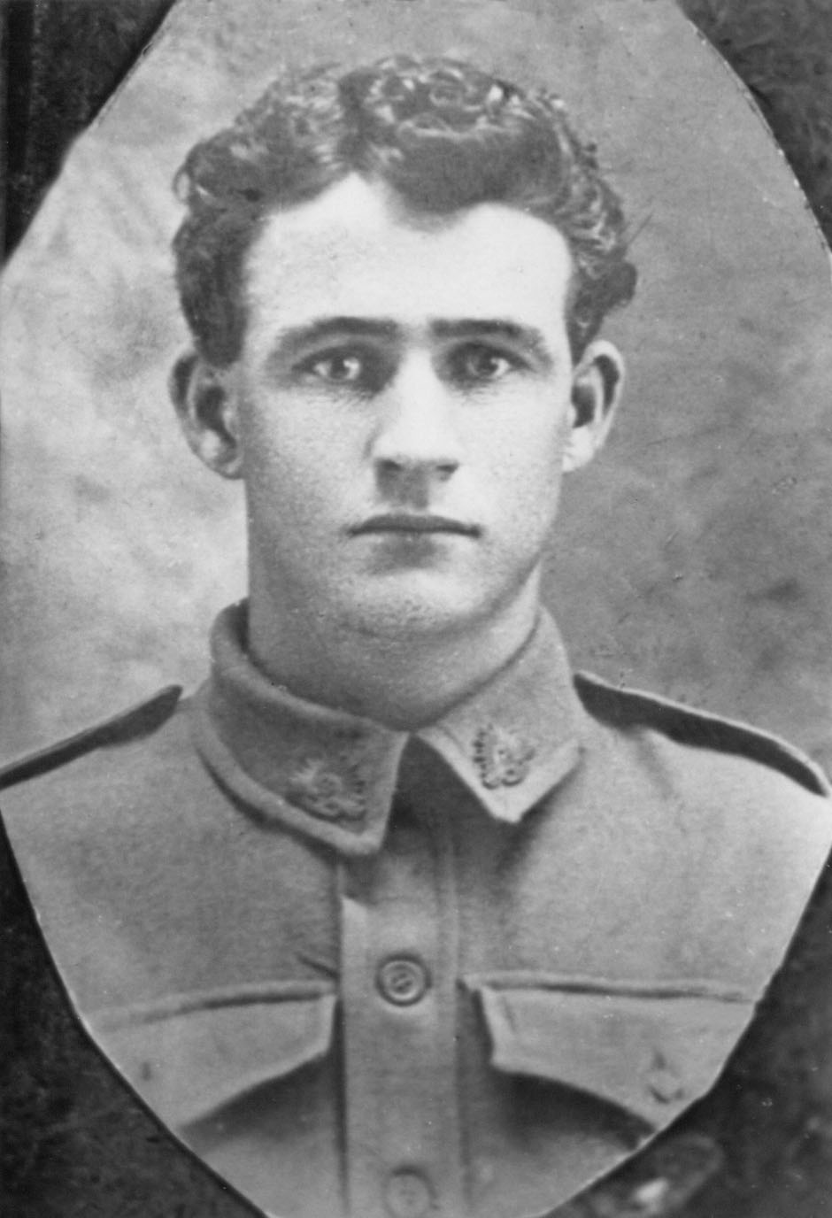

Victor 3 June 1916, eve of his 20th birthday
Re-enlists two days later.

Diary 1915

Sergeant Victor David O’Connor
9th Battalion AIF

Monday 28 May 1915 – Tuesday 7 December 1915

The diary had been transcribed, as written, with the following exceptions:

- Editorial additions in the body of the diary are shown in [square brackets] to amplify or clarify information.

- The date for each day is presented in full rather than, e.g. “Tuesday 1st” as written.

- Unclear writing or indecipherable omissions are indicated by “?”.

- Photographs representative of Vic’s experiences have been copied from two editions of the British weekly, The Sphere: An Illustrated Newspaper for the Home, published respectively on 6 and 13 November 1915. These carried a two-part story titled “The Wounded in Egypt” and featured soldiers being evacuated from the Dardanelles to Egypt. Photographs included are of places often noted by Vic in his diary.

The diary manuscript was typed by Leigh Owen. Terry Scott also transcribed the diary and added footnotes identifying Vic’s colleagues, which are incorporated here. Interpretation of unclear writing was cross-checked between the two versions and against enlarged scans of the original. Additional material, including information from Vic’s War Records, was added by Barrie O’Connor in April 2003. The diary has also been scanned electronically in its original format and is available on CD Rom.

© Barrie O’Connor 2003 for the O’Connor family.
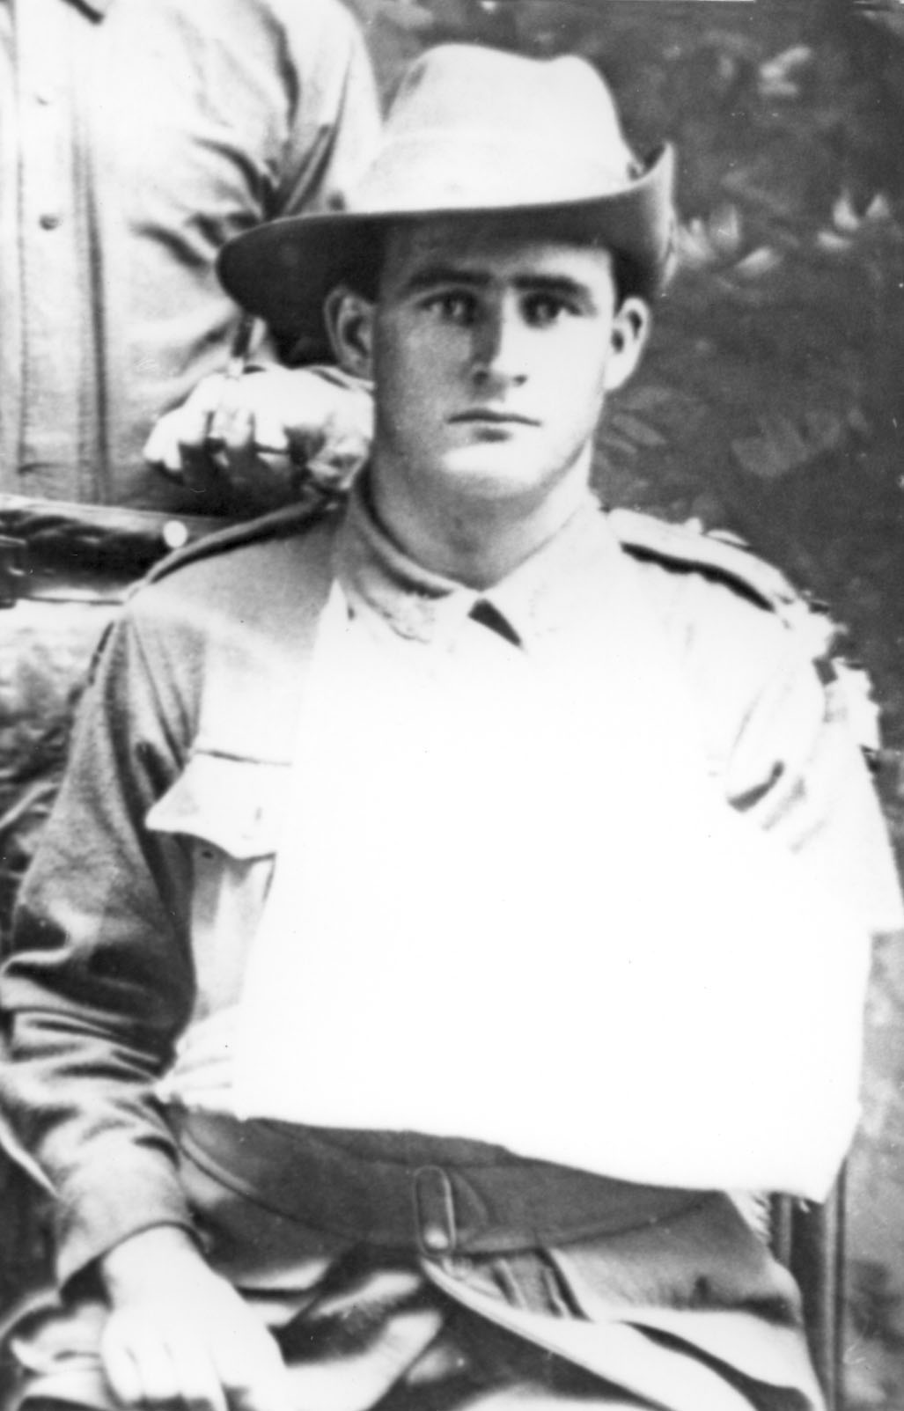

Sgt. Victor David O’Connor, circa late 1915

Victor David O’Connor

Born: 4 June 1896
Died: 2 Sept. 1918 (Killed in Action, Mont St Quentin, France)
Burial: Peronne Communal Cemetery Extention France

Parents: Thomas Bartholomew O’Connor
Hannah (nee Thomas) O’Connor
Address: Millchester Road, Queenton, Charters Towers, Queensland
Former trade or occupation: Fitter; Engineers Apprentice

Final Rank: Warrant Officer (Class II) promoted 19 Oct 1917

Medals:
1914/15 Star (No. 2673)
British War Medal (No. 10377)
Victory Medal (No. 10333)

Military Service

No. 1904: Enlisted 6.1.15; Rank of Sgt; Served in 9th Battalion. in Egypt & Gallipoli; Returned to Australia wounded; Discharged on medical grounds 3.2.16

No. 5948 Re-enlisted 5.6.16; Served with 25th Battalion. in France; promoted to Company Sergeant Major (Warrant Officer Class II) on 19.10.17; wounded on four occasions; Killed in Action 2.9.18

Key Dates: (WR: War Record source)

Date | Event | Page
2 ½ years | Junior cadets
3 years | Senior Cadets
111 days | Citizens forces on active Service Thursday Island (Corporal) Thursday Island
Date | Event | Page
6 January 1915 | 1st enlisted
16 April 1915 | Embarked at Brisbane on H.M.A.T. A55 “Kyarra”
Fri 28 May 1915 | Dairy begins: Arr. Suez 2pm. Cairo 8.30 pm, Zeitoun Camp 9.15 pm | 1
4 June 1915 | 19th birthday; Admitted No. 1 General Hospital Cairo; operated on ingrown toenail | 2
16 June 1915 | Sought inclusion in troop movements to Gallipoli | 2
2 July 1915 | Offered to be reduced in ranks to serve in Gallipoli | 4
8 July 1915 | Sought to go, denied but reinstated on promise | 5
9 July 1915 | Departed Zeitoun for Gallipoli on troopship A!11 “Minnewash” | 7
13 July 1915 | Joined Uni; reduced in ranks | 5.
14 July 1915 | 1st night in the trenches | 6
5 August 1915 | Shot in left arm | 13
8 August 1915 | Arrived Alexandria per “Sicilia” | WR
13 August 1915 | Admitted No. 3 Aux. Hospital, Cairo | 10
20 September 1915 | Shrapnel wound left forearm Admitted 1st Australian General Hospital (A.G.H.), Cairo | 17
28 September 1915 | Admitted No. 2 Aux. Hospital Cairo | 18
1 October 1915 | Transferred to Al Hayat H, Helouan  Admitted C.C. (Conversion Camp) Helouan | 18
6 October 1915 | Influenza. Admitted No. 2 Aux Hospital, Cairo | 19
6 October 1915 | Admitted to 1st AGH, Cairo; Transferred to No. 2 Aux Hospital, Cairo | 19
9 October 1915 | Operation on left arm | 21
11 October 1915 | Col Ryan passed me for Australia – [Ward Record shows “Invalided to Australia; Malunited Fracture of L. Radius”) | 19
13 October 1915 | Left Atelier for Cairo; to Suez via Ismalia | 20
25 October 1915 | Visited slaughter yards | 21
30 October 1915 | Embarked Z66 “Aeneas” from Port Tewfik Suez | 21
3 November 1915 | Passed Aden overnight | 22
19 November 1915 | Arrived Fremantle | 23
26 November 1915 | Arrived Melbourne | 24

Date | Event | Page
29 November 1915 | Arrived Sydney | 24
29 November 1915 | Dept Syd: Train to Brisbane via Newcastle, Armidale, Guyra, Wallangarra, Warwick, Toowoomba, Helidon | 24
 | Arrives Brisbane | 24
2 December 1915 | Transferred to No. 1 Aux Hospital “Rosemount” | 25
7 December 1915 | Final entry: Diary ends | 25
3 February 1916 | War Records show: Granted as £35 p.a. as from 3-2-16  Increased to £1-14-6 p.f. as from 3.2.1916

Second Enlistment (key dates and events from War Records)

Date | Event
5 June 1916 | Re-enlisted Allot. No. 5948 16/25th Battalion
21 October 1916 | Embarked “A36” “Boonah” from Brisbane
10 January 1917 | Disembarked Plymouth
15 February 1917 | Proceeding O/seas to France from Folkstone per S.S. “Victoria”
16 February 1917 | Admitted from England
3 March 1917 | Proceeded to join Unit in 25th Battn.
3 & 4 May 1917 | Wounded in Action
4 May 1917 | A.F.A. Admitted and to C.C.S.
5 May 1917 | To ambulance train
7 May 1917 | No. 5 General Hospital
10 May 1917 | To Base Depot Etaples
13 May 1917 | Proceeded to join unit – rejoined 25th Battalion
31 May 1917 | To be Acting Company Sergeant Major
5 June 1917 | Reverts to Sergeant at own request
19 October 1917 | To be C.S.M. (W.O. Class II) Commissioned by General Birdwood (certificate signed 4 July 1918)
6 October 1917 | Wounded in Action (2nd occ.)  5th Field Ambulance – Gassed, transferred
7 November 1917 | Transferred 20th Gen Hosp Camiers
Date | Event
9 November 1917 | Transferred to England; Embarked “Newhaven” for England
10 November 1917 | Adm. 1st Southern General Hospital, Edgbaston, Birmingham. GASSED severe
27 November 1917 | Trans: to 3rd A.A.H. Dartford, Admitted
7-21 December 1917 | 3rd A.A.H. Dartford: Granted furlough – to report to No. 1 A.(?)D. Sutton Veny
21 December 1917 | M/I from A.H.Q. London ex furlo and Class A3. Sutton Veny
24 December 1917 | M/I from No. 1 Com: Depot Sutton Veny. Longbridge
3 January 1918 | Proceeded overseas to France ex Longbridge Deverill via Southampton
5 January 1918 | Admitted from England - Havre
7 January 1918 | Proceeded to join Unit
9 January 1918 | Rejoined Battalion [25th]
15 January 1918 | Sick to Hospital; Tfd to C.C.S.
16 January 1918 | Transferred to Amb. Train
19 January 1918 | 39th Gen. Hosp. Discharged to duty V.D. Total period 29 days
13 February 1918 | Joined from Hospital
14 February 1918 | Proceeded to join Unit
17 February 1918 | Rejoined Bn [25th]
27 June 1918 | Wounded in Action (3rd occ.) remaining at duty
17 July 1918 | Wounded in Action (4th occ.)
18 July 1918 | Adm: & Trans to C.C.S.
19 July 1918 | Adm: & Trans to A.T.
20 July 1918 | Adm:. S.W. Arm R.
3 August 1918 | Tfd to 39th Gen Hsp. (Scabies); Adm:
7 August 1918 | Dis. to Base; Scabies
18 August 1918 | Proceeded to join Unit
20 August 1918 | Rejoined Battn
2 September 1918 | Wounded in Action and Died of Wounds in the Field
21 February 1919 | Buried Isolated Grave in B3377 Shell Hole Near Barbed Wire Mount St Quentin, 1¼ mls North of Peronne D.G.R.E. L.S.5/5685
2 December 1919 | Re-Buried Peronne Communal Cemetery Extention D.G.R.E. L.S.5.3906

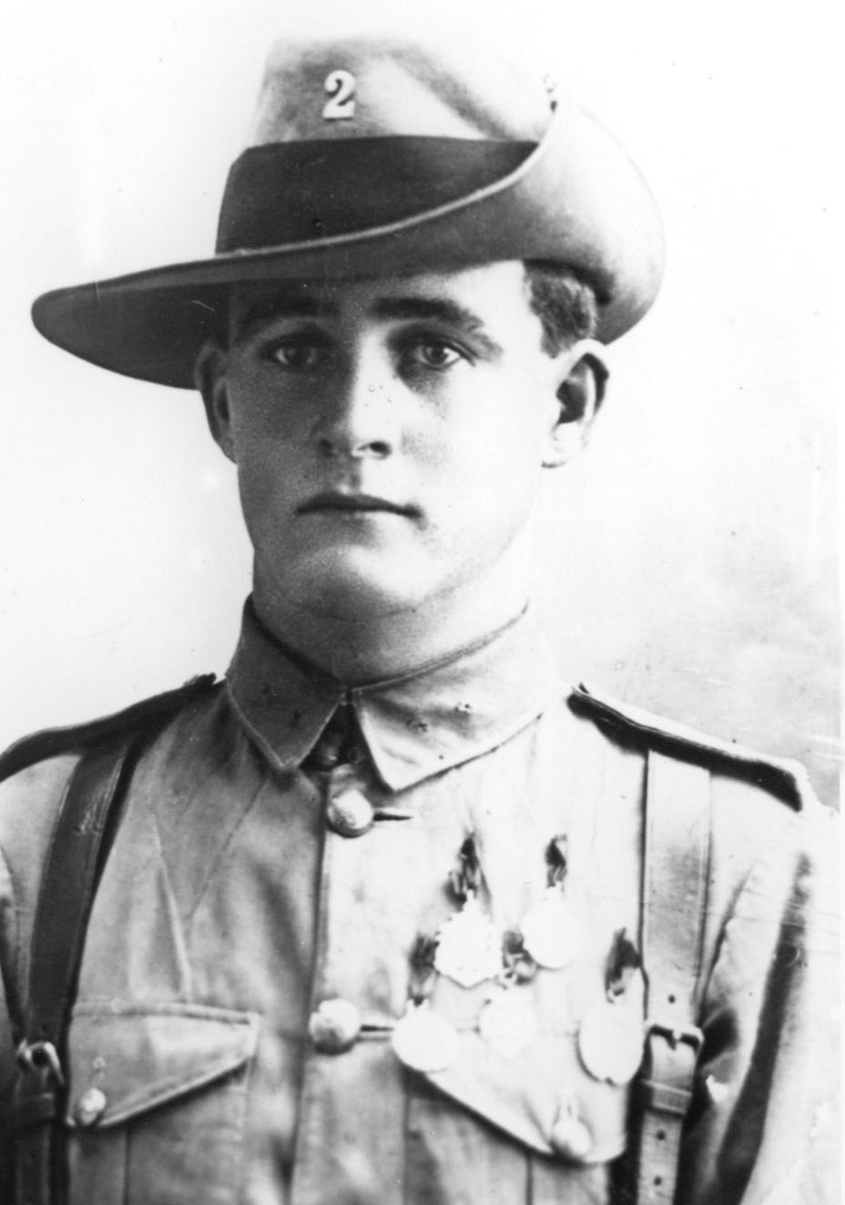

Vic – 10 January 1915 – departed for Egypt on 16 April 1915

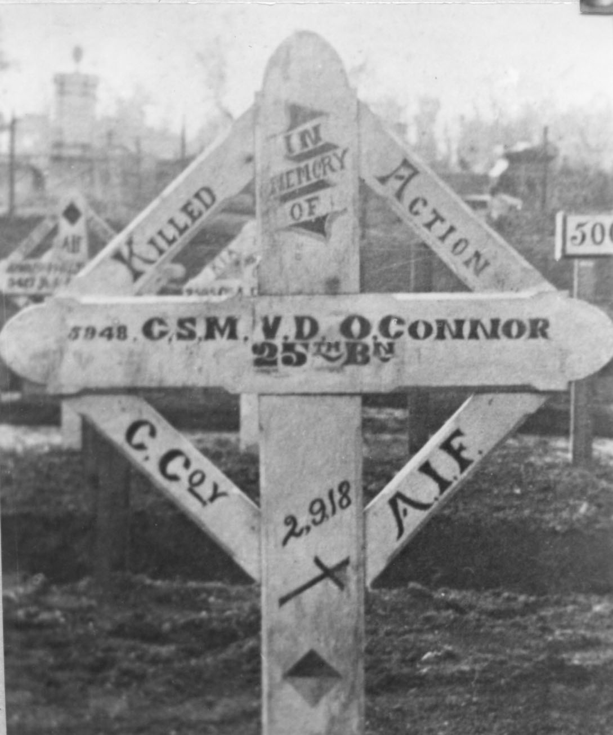

“Buried Isolated Grave in B3377 Shell Hole Near Barbed Wire
Mount St Quentin, 1¼ mls. North of Peronne D.G.R.E. L.S.5/5685”
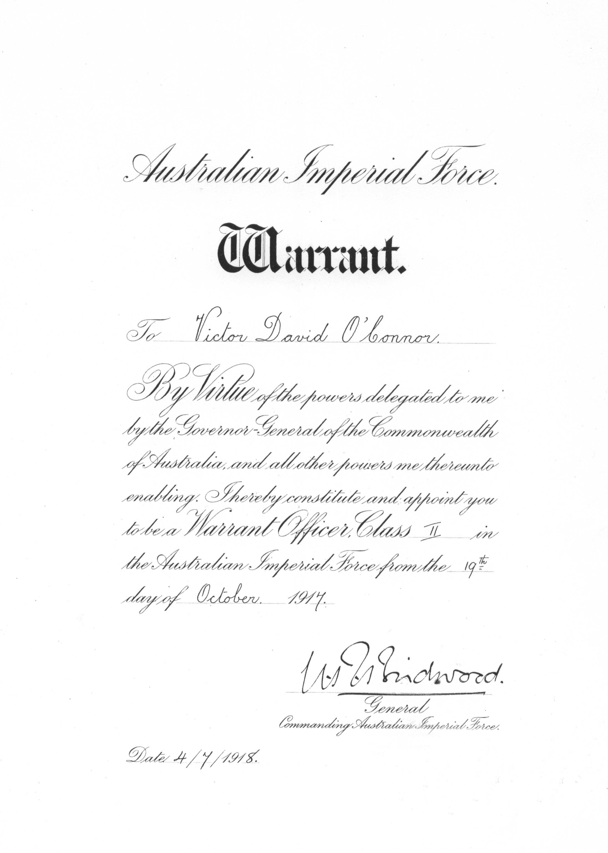
Field Warrant issued by General Birdwood 19 October 1917

Victory Medal

Victory Medal

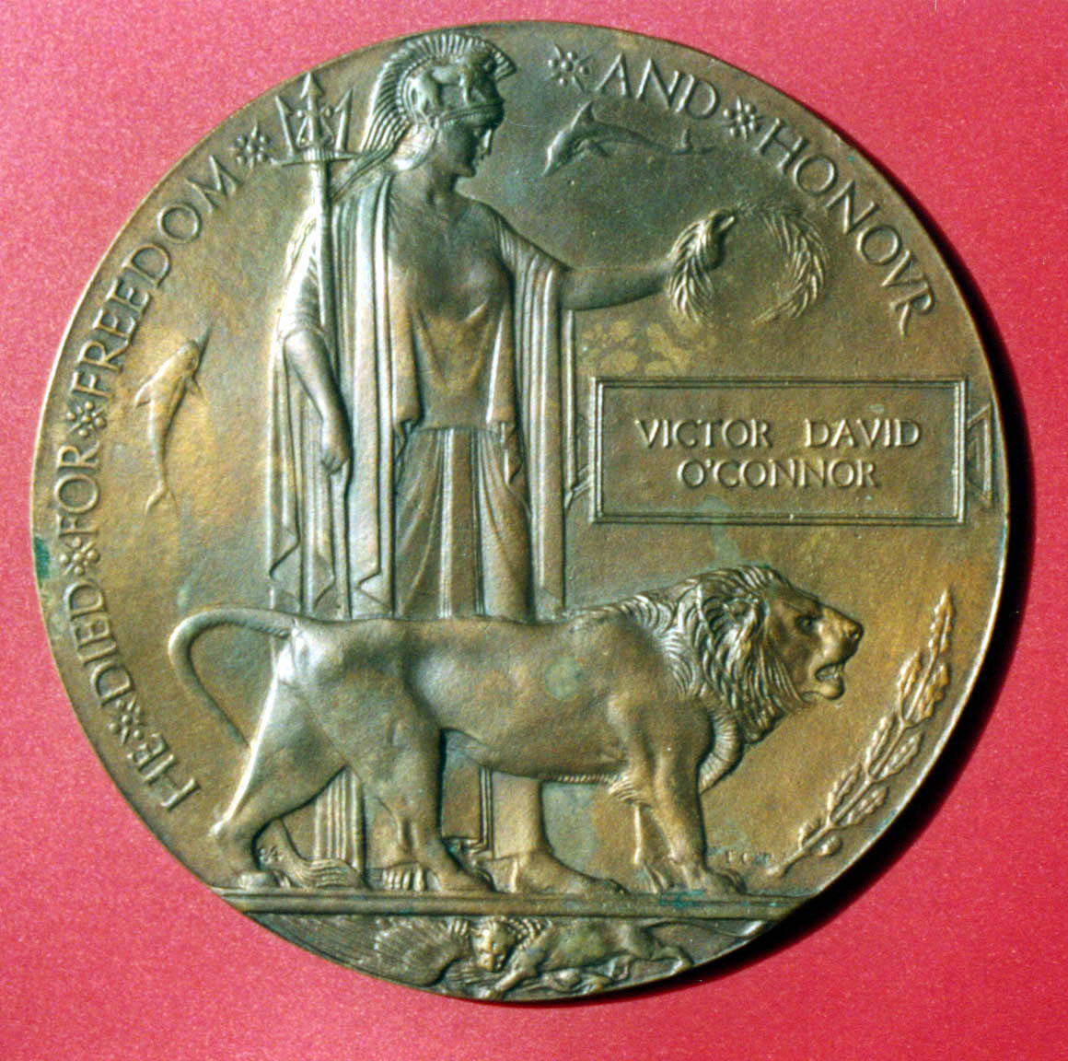
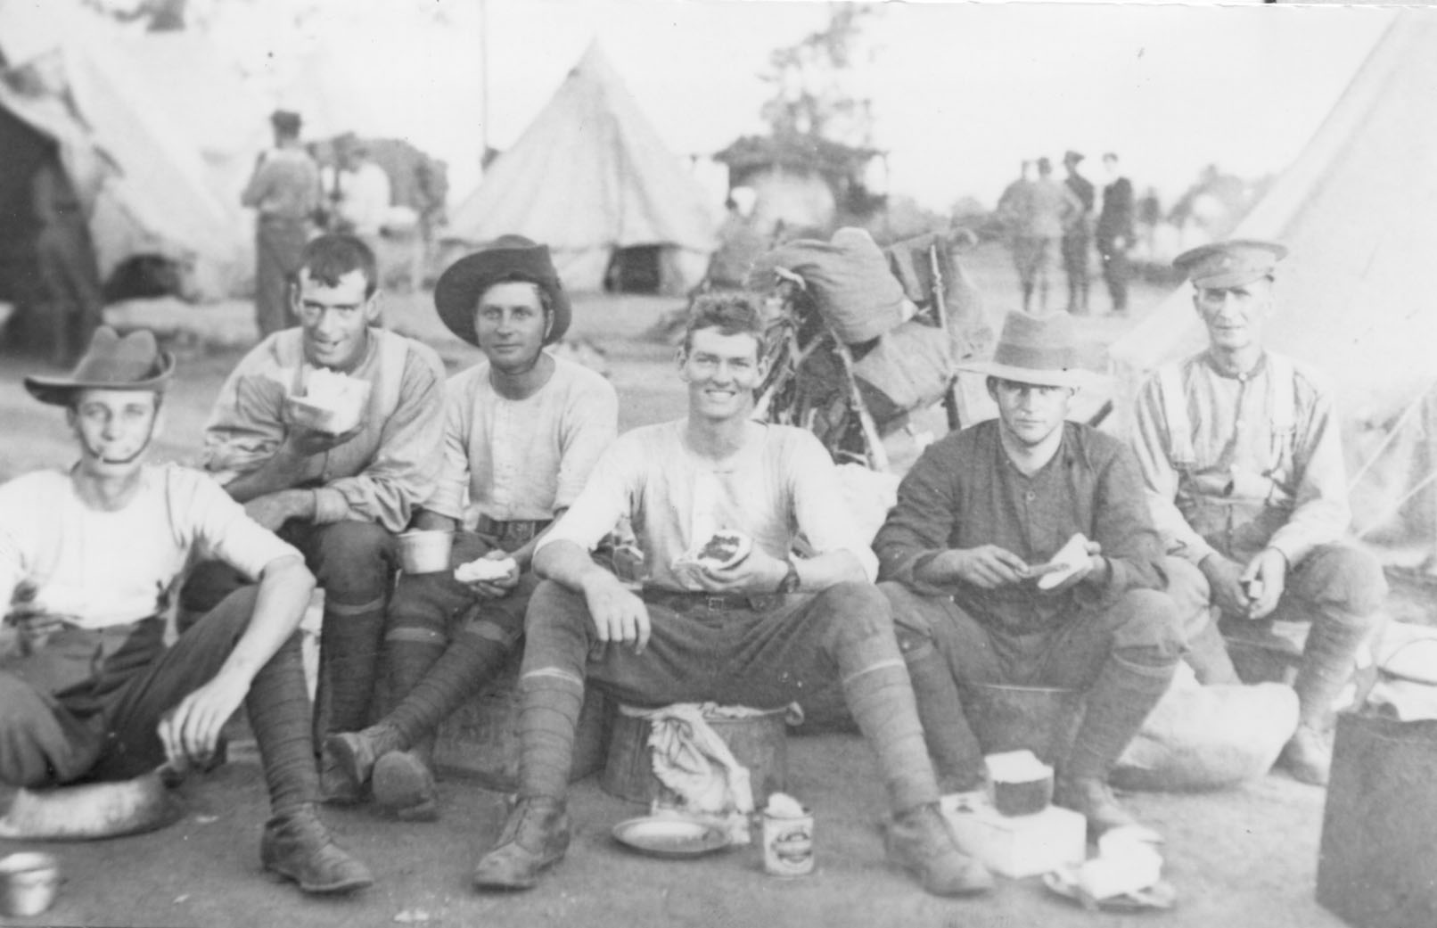
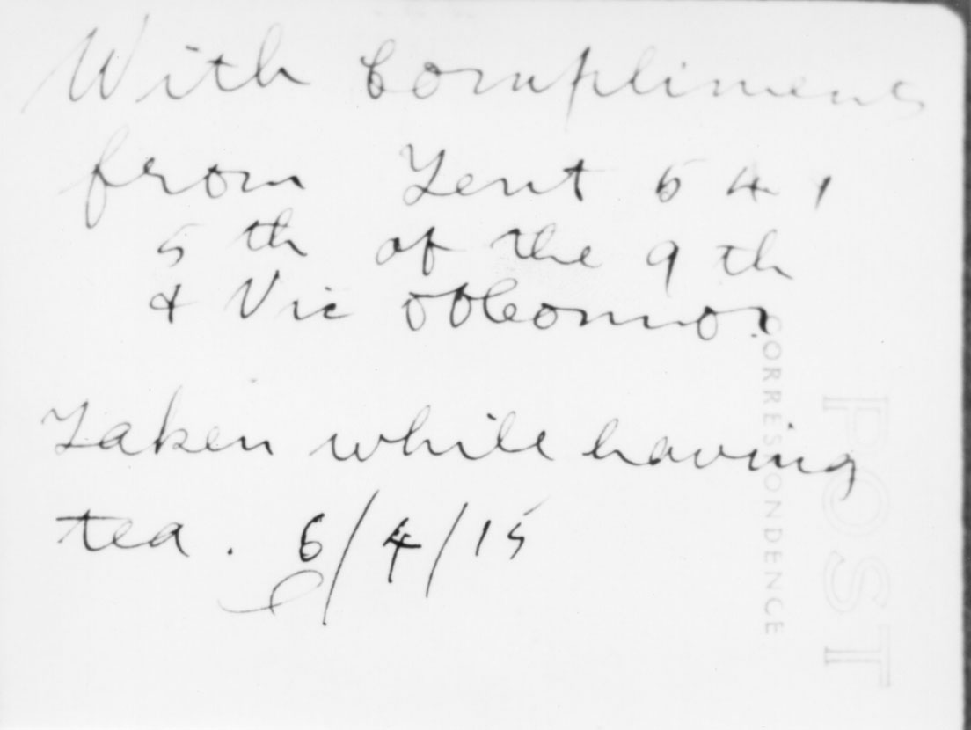
Vic, 2nd right, Enoggera Army Camp, prior to departure for Egypt 10 days later
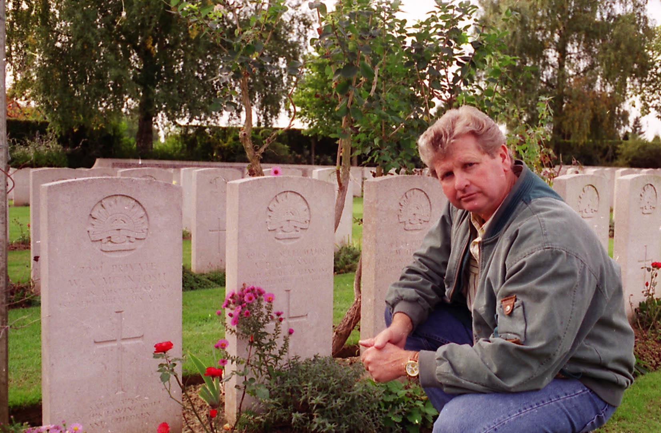
(Above) Ray O’Connor (grandson of Alfred Llewellyn who was Vic’s younger brother) at 5948 CSM V.D. O’Connor grave – Died of Wounds 2.9.1918 Mt St Quentin.
(Below) 25th Battalion Roll of Honour, War Memorial, Canberra

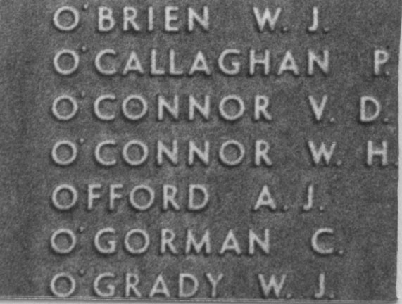

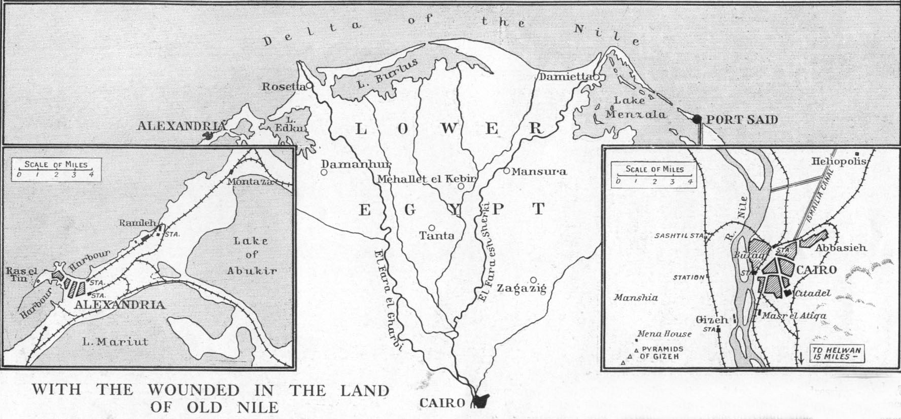

List of Abbreviations used in Footnotes:

DOW: Died of Wounds
KIA: Killed in Action
NCO: Non Commissioned Officer
RTA: Returned to Australia

[Diary begins:]
[Inside front cover:]

No. 1904 Sgt. Vic D. O'Connor
9th Battalion AIF
Zeitoun Camp
Via Cairo
EGYPT

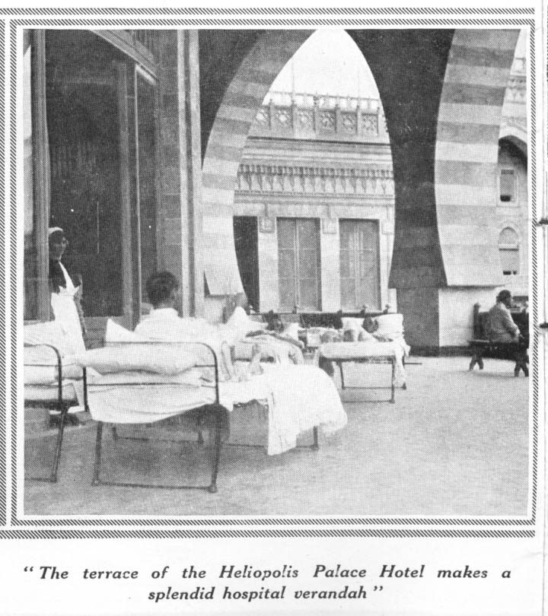
Friday 28 May 1915
Arrived Suez. Disembarked 2 PM. Left for Cairo 2.30. Had a yarn with Terriers. Hot, blinding wind blowing. Arrived Cairo 8.30 PM. Arrived Zeitoun 9.15 PM. Camp 9.45 very tired. Hot coffee was issued. No blankets. Slept on rifle case. Camp very dusty like TI [Thursday Island]

Saturday 29 May 1915
Revellie 5 am. Got up 6.30. Bully and biscuits for breakfast. Met George Davison?, Jack Peace who gave Captain Campbell bad name. 10.30 am inspection. Dinner Sergeants' Mess. Went to Cairo with a “Tommy” fine chap. Native quarters Rotten with disease. Got home broke.

Sunday 30 May 1915
Church parade 9.30. Missed it. Rowe/Rome? preached. wrote home. Great tales told by wounded soldiers, very interesting. Met Charlie Pieniger. Had a long yarn.

Monday 31 May 1915
7.30 am General's Inspection. General Spens [?] lectured. 10.30 lecture in Mess room. After dinner no parade till 6.30. Route march. 2 PM went to Heliopolis. Very fine place and splendid buildings. Palace Hotel now No. 1 Base Hospital, largest hotel in world. Had a look through Luna Park Hospital. Arrived home and detailed for town picquet. Had Westralians and New Zealanders on picquets. Arrived in town. Dismissed till 10.30 PM. 11 PM fell in accompanied by "Red Caps" and Native Police went parading streets. Our picquet patrolled aristocratic quarters (Dancing and Music Halls) till 2 am. Lovely sight Cairo by night. Got 37 prisoners. Slept on concrete floor. No blankets or food.

Tuesday 1 June 1915
Left Cairo 7.30 am for Camp with 37 prisoners. Arrived Camp 8.15
very tired. Dismissed 8.30 am. Had breakfast and slept till 4 PM. After Tea went to Heliopolis and into Town had a good time A.M.C. Captain showed us round and gave us advice, home 10 PM & to bed.

Wednesday 2 June 1915
Revellie 5 AM, fall in 6 am. three hours drill till 9 am. Wheeled before O.C. re-parade states, got off. Six other of our NCO's got Severe Reps. Broke leave went to town dined Shepherds Hotel (25 piastres). After dinner went to pyramids very interesting. Had photos taken on Camels. Arrived home 6.45 PM put on Camp orderly Sgt. roused but had to do it. Kept going till 11 PM then visited rounds. Got to bed 12.30. Orderly Officer Tea planter nice chap.

Thursday 3 June 1915
Going like fun all day till 12.30 PM. 10.30 PM had to take prisoner to aerodrome Camp. arrived back 12.30 am very tired and feet very sore.

Friday 4 June 1915
Birthday [his 19th] but had to go like fun till 11 am and reported sick with ingrowing toenail. Sent to Hospital No. 1 General. Arrived 3 PM. Sisters very nice. Went to bed and stayed there.

Saturday 5 June 1915
In Hospital, saw some very bad wounds.

Sunday 6 June 1915
Operated on toe. Hurt a bit but not too bad. Nell's birthday. Couldn't write had no paper.

7th till 15th still in Hospital. Having a good time. On 8th was told our Coy. went away tried to sneak out but toe to sore. Very disappointed. 6 Train loads of wounded arrived in two days. “Tommy” in our ward gave Australians great name. On 15th "Titch" Redfern came to see me & said going away next morning. Greatly Surprised, thought they had gone. Asked Sister Gibbon to see Doctor. Sent for him at 5.30 PM came up at 9.30 PM. Said I could go next morning. Very restless, wanted to go. Left Hospital 8 am 16th got a car and drove to Almeih Siding but Commandant would not let me go. The chaps roared at Sgt Major, Adjutant Commandant and General but was no good. very disappointed. Train steamed out 9 am. Adjutant (Capt. Cooper) promised to send me with the next company to leave irrespective of what they were. Went to Detention Barracks and found Sgt Duff and 20 men including George Wigley and Nean Murchison. Very pleased they were left too. stayed all day

Thursday 17 June 1915
Saw Lieut Cook & got paid & told to be ready by 22nd to go to Lemnos, went to Detention Barracks & with Snowy Muir went to town. sent money home & had good time. Arrived home 10.30 went to bed.

Friday 18 June 1915
Slept in. Off duty. Writing letters in YMCA saw S. Allwright just out of Hospital. Went to Detention Barracks with him. He handed a prisoner a packet of smokes and nearly got pinched. Went to town & only paid half fare because we stood up. Bit of a scene but niggers were frightened. Heard orchestra in Egyptian Cafe. Very good. Got home 10 PM went to bed.

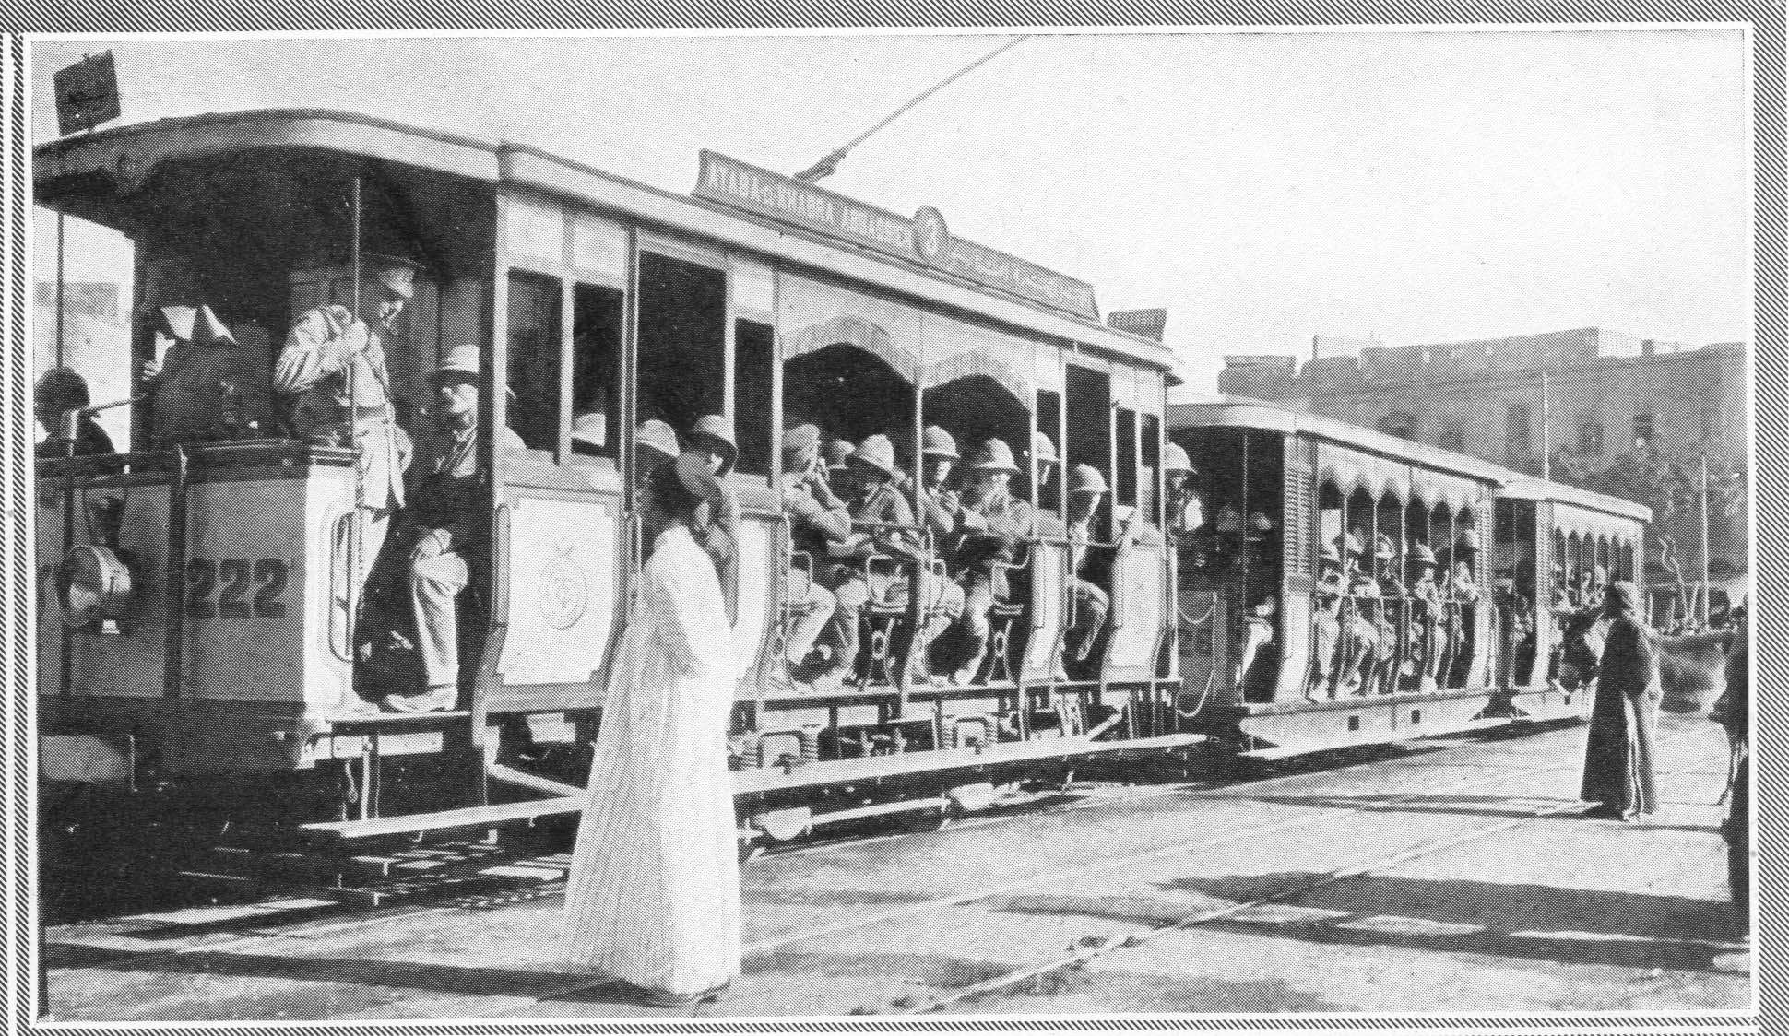

Saturday 19 June 1915
With Allwright went to YMCA and played piano till dinner. After dinner practise with bugle & played piano in YMCA. On inlying picquet going till 2 am at Zeitoun station. dance on. Still going when I left.

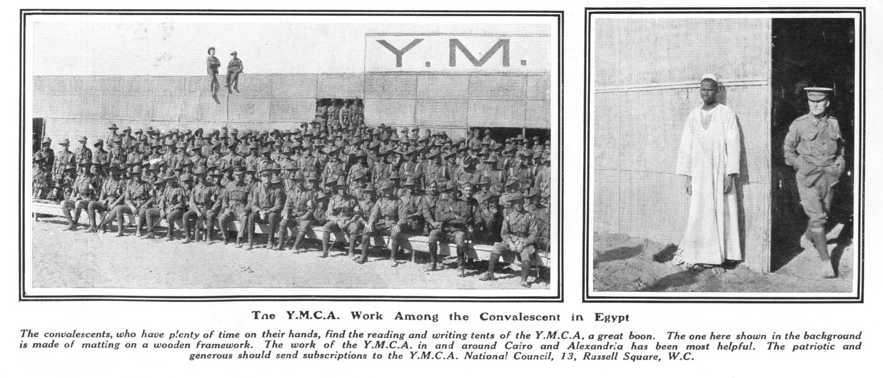
Sunday 20 June 1915
Slept till 9.30. After breakfast wrote letters. Allwright and I had concert on our own in YMCA. Dead broke. Crook with no money.

Monday 21 June 1915
Writing letters met Jack Peace and went to Detention Barracks but our Guard was relieved & went to Palace Hospital & had a yarn. Got home & loafed around. After Tea a concert in New Zealands Sgts. Mess. Didn't go as I was broke but went to pictures at Zeitoun. Came home & our chaps detailed for fatigue. Went off a packet but was no good had to obey orders.

Tuesday 22 June 1915
Done nothing till 3.50 then guard fell & mounted 4.30. All except myself were 10th South Australians. Decent lot of fellows. Received letter from B.M. First since leaving Brisbane. Delighted, read it a dozen times, was so pleased. Letters are as important as food to a soldier. Nobody in clink so went to bed 12 midnight.

Wednesday 23 June 1915
Still on guard (main camp). Come down for dinner and got a letter from Amy. Highly pleased and learnt it off by heart. Couldn't make it out, a letter every day for two days. Guard dismounted at 4.30 & we got paid. Also got paybook. went to town. Met Allwright & Ball both very drunk. Allwright played piano very good. Had a feed about 9.30 PM & Ball wanted another drink, but I got them both into a cab & drove home to camp. Had a hard job to keep them in but managed it.

Thursday 24 June 1915
Drill 6 am till 9 am. Lecture 10.30 by Capt. Bellfield of the Devons on Entrenchments. Told tale about German bullet going down a Tommies barrel & exploding cartridge in his chambers. Took it with a grain of salt. Lecture very good. 5.30 PM six of us on parade rest in town (French leave). Cook our boss roared & we went out digging a trench till 8.30 PM. Came home and went to bed.

Friday 25 June 1915
6 am continued with trench till 9 am. After breakfast our chaps were wheeled before O.C. and their sentences varied from 1 days pay to 7 days C.C. & and pay.

Saturday 26 June 1915
Trench 6 am till 9 am. Went to town before dinner came home & mounted guard at 4.30 PM. Nean Murchison smashed to ranks. Roared at by Colonel Bailey.

Sunday 27 June 1915
Still on Guard, nothing eventful. dismounted wrote to Amy, F.N., G.W.[?] and others. Went to town and heard orchestra in Cafe Egyptian very good.

Monday 28 June 1915
Usual daily routine, nothing eventful.

Tuesday 29 June 1915
Picked an argument with Coy S-M. He threatened me with arrest. I defyed him and told him what I thought of him.

Wednesday 30 June 1915
Expecting to be crimed but the S.M. took a tumble and did not do it. Row with another Sgt. & threatened to punch him but he shut up. On Inlying picquet, reported 5.15 PM dismissed till 8.45 PM. Report again 8.45 and went to Zeitoun and had a row with officious Corp. of Police & told him off & he quietened down. Roumers of going away on 3 July. Got home at 12.30.

Thursday 1 July 1915
Reported sick with boil on lip. got paid and told going away on Saturday. Highly pleased & went to town. Arrived home 10 PM very tired went to bed. Mum and Amy's birthday.

Friday 2 July 1915
Got my gear together, kit packed. All ready for going away when Lieut. Cook called me in and said no 9th NCO's were wanted and I had to stop. Could have died with shock. Wanted to reduce to ranks but Cook would not let me. Saw Commandant at Orderly Room. Recommended me to Col. Bailey and he recommend me to Capt. Philips. Philips would not see me so I had to stop. Very disappointed especially after Commandants promise a fortnight previous. Went to town. Played old Harry till Red Caps dispersed us. Had dinner and went to sleep and then to Cafe Egyptian. Wigley and Allwright very drunk got them home 10.30 and to bed. Very tired and disappointed.

Saturday 3 July 1915
Woke 6 am & fell the 9th in, proved them & got them ready & marched them to Aelmeih [Almeih] Siding to entrain. Duff & I jumped train with them & went to Alexandria & saw them off & had a look round & jumped 6 PM train home. Arrived 10 PM. Lines deserted. Kit & equipment gone. Pinched blankets & went to bed.

Sunday 4 July 1915
Woke 9 am. found kit & Equipment also J. Liddle. After dinner, was talking with some 15th chaps & was told 25th Batt. was at Abbassieh. Went over to find Will, but found 26th Batt. who said 25th would be a fortnight. Saw Mick Dunn who told me about Labour victory in State elections. Very pleased. Mick went to drill & I saw Burly Caless & a lot of other Towers chaps. Had a long yarn & came home. Toe very sore. Transferred to A Coy 1st Training Batt. composed of N.S.W. chaps 17th Batt 1st Rein.

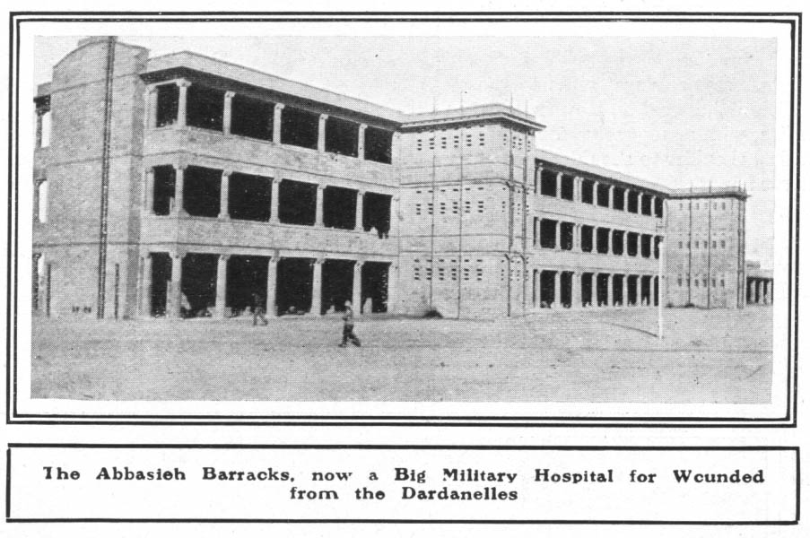
Monday 5 July 1915
Report sick with toe. Reported to A Coy. Real nice chaps, much better than 10th South Australians. Off duty with toe very sore. Sixth Reinforcements of 11th Westralians arrived and formed B Coy. 1st Train.

Tuesday 6 July 1915
Toe pretty crook. Met Galway who was sent back with interric fever. Said he met some of our fellows over there & gave the place a great name. Heard that Achi Baba was captured. Went to New Zealand pictures.

Wednesday 7 July 1915
Toe much better. Nothing much doing. Received letter from home. Learnt of Jack's new adventure. Wrote home. Heard Col. Onsworth give a lecture very interesting.

Thursday 8 July 1915
Heard some men were going away on Friday so Duff & I paraded before Adjutant of Battalion. He was sorry, but we were too late as only 3 n.c.o.'s were wanted from the ninth. Col. Bailey, Batt Commander then came in & found out what we wanted & remembered the promise the General made me & told Adjutant that I must go & to put one of the others out & send me. Very pleased. Fixed up allocation papers & could not draw any money. It was a bit awkward but I didn't mind. Went to Zeitoun pictures.

Friday 9 July 1915
Revellie 4 am. Got into equipment lively fell in 5.30 am. Left Zeitoun Camp 6 am. Left station Almeih Siding 8 am. Slept most of the way to Alexandria. Arrived Alexandria 2 PM. Went aboard Troopship "A11" Minnewash (14,316 tons) 2.30. Left wharf 7 PM with 1800 aboard. Dropped anchor in harbour 7.30 PM. Had to scrap for tea. Sergeants quarters very dirty, & on cattle deck. Went to bed 8 pm. 8.30 PM was awakened & warned for submarine guard. Dismounted at 4.30 am the following morning. Went to sleep again.

Saturday 10 July 1915
Woke 4 am and mounted guard 4.30 with 1 corporal 10 men from 2nd L[ight]horse. 8 am guard was strengthened to myself, 3 cpls and 40 men with 8 sentries. Ammunition placed all round deck. Guard consisted of 2nd L.Horse 6th Inf, 8th Inf, 9th, 12th, 13th, 14th, 15th and 16th inf. Very good job for me. Issued with 24 hours rations. 1 tin bully, some small round biscuits, & tea & sugar and two "oxo" soup tubes. Visited sentries 2.30 PM. In the "Mediterranean", lovely weather and nice cool head wind blowing over a very blue sea. Wrote home and to Selwyn. Made soup for tea which was real good. Sailed at night with lights out. Wind blowing very strong at night.

Sunday 11 July 1915
Grecian Archipelago in sight. Wind still blowing strong. Church parade 10.15. Did not go as I was still on guard. Iron rations issued 11 am. Now in danger zone. Played whist euchre & German whist all afternoon. After tea had a game of bridge. Full guard on all night with all lights out. Was called at 7.30 PM to see a dissappearing light away to starboard. Sentry thought it might be signalling but it proved to be a lighthouse. Didn't get dark till 9 PM. At 9.30 was called to see a dim light away ahead which was another lighthouse. Ship slowed down & I went to bed.

Monday 12 July 1915
Guard stood to arms at 3.30 am. Daylight 4 am. Lemnos in Sight 8.30 arrived in Harbour 10.30. Passed "Mauritania" 35,000 tons & a number of battleships in harbour also a shipload of French & Algerians who cheered & clapped us as we sailed by. 10.30 Submarine guard dismounted after passing two rows of mines into harbour but I had to keep 12 men & a corporal to guard gang way. 5 PM got ready to go to Gallipoli & 8 PM went aboard the destroyer "Renard" & went straight away to the peninsula arriving there about 11 PM. Went ashore on a Minesweeper at 2 AM.

Tuesday 13 July 1915
Reported Brigade Hd.Qtrs 3 am & Batt. Hd.Qtrs 3.30 am. Was showed a place to sleep & told to report 7 am. Went to sleep at 4 am feeling very tired after carrying heavy pack. Just got to sleep & was awakened by gunboat bombarding Turkish trenches. Reported 7 am & put in C Coy. Met all old 5th, 9th & was welcomed. Was reduced to ranks. Very tired all day. Had a look all over trenches. Harry Meyers, Fred Martin & Jim McConnell all bomb throwers in B Coy. & wanted me to transfer to them & go bomb-throwing. Couldn't manage it & went to find Reg Brooker & Charlie Pienniger. Reg was asleep & couldn't find Charlie. Had a letter from Nell & Ruth which was very welcome. Had a swim under shrapnel at night & slept on road. Turks massed at night to our right but their attack was spoiled by our star shells which showed their position.

Wednesday 14 July 1915
Woke 8 am & drew rations. Met Reg Brooker, but did not have time to have a pitch. Met Dick Tambling & had a yarn. Knocked about all day & had dinner of fried bacon, boiled potatoes & fried onions, bread & jam. Could get no water. Warned for firing line to be ready at 7.45. Met Lou Jackson & had a pitch then got equipment ready & cleaned rifle for first night in trenches. 7.45 went as bomb thrower into firing trench & was on 3rd relief from 12 PM to 2 am & 6 am to 8 am. Did first watch at 12 in bomb throwers pit which was 30 yds in front of firing trench. Bullets were whizzing all round for a while then died off till 1.30 & then enemy's guns opened fire with high explosive & shrapnel. Had Got issued with gas respirator. A lively time for a while. Then died off. A sniper was sniping about 50 yds to our left front. Wasn't allowed to shoot at him. Came off at 2 am. Had to "stand to" from 3 am till 4 am (daylight) then slept till 8 am.

Thursday 15 July 1915
Innoculated against Cholera. Shrapnel began bursting on road. One got two chaps & while I was looking at them another burst alongside of me. I crept into my dugout. On short rations, no potatoes or onions & very little water. Slept all afternoon & after tea was wanted for sapping but objected on account of innoculation. Not feeling too good. Had a long talk with Reg Brooker & went to bed.

Friday 16 July 1915
Started sapping at 5 am & worked till 9 am without water or breakfast. Knocked off feeling very tired & came to get breakfast & the tea was cut out but got a dixie full of water. Had a good feed. Three strange chaps in my "posie" with me. Slept till 4 PM & missed issue of water & dinner. Had tea & went to work, sapping from 5 PM till 9 PM. Toe very sore again but worked on. Got more water about 6 PM. Went to bed about 9.30 PM but did not go to sleep till well after midnight as my toe was very sore & inflamed.

Saturday 17 July 1915
Woke 5 am & toe was much better having burst itself during the night, & went to work till 9 am. Had breakfast & got rations, bacon, cheese & biscuits. Went down to the pier for a bottle of water, about 2 miles away. Sihks gave us some curry & rice & a drink of water, very fine chaps. Tried to sleep but couldn't for flies. Biscuits & jam for dinner also a little bit of Indian butter made from Camel fat which was very good. Tea, had some bread & jam the bread being left over from the previous day & tea with no sugar. Had a little boiled rice which was good. Went to work in sap from 5 pm till 9 PM. 8 PM our candle burnt out & we thought we would be knocked off, but they found us some more candle & we had to work till 9 PM. Hardly a shot was fired all day. Write PC home & a field PC to Aunt Lizzie & Aunt Mary. About 6 am a German Taube Aeroplane hovered over us & dropped two bombs, one of which failed to explode, the other doing no damage

Sunday 18 July 1915
Woke half hour late and went to work but work was off as candles were cut out. Got rations early (Half a loaf of bread, cheese & bacon, 1/4 lb jam) & had early breakfast got 1 pint of water for 24 hrs. 8 am one of our Aeroplanes hovering overhead & dropped bombs on Turks trenches. Howitzer battery nearby fired about six shots. Rifle fire very silent. Hardly a shot fired all the week except for a night or two at Quinns Post & Achi Baba. Went down to beach with Fred Martin for a bottle of water & on way down had a look at a "Long Tom" a 4.7” naval gun recently installed. Had fried bacon & fried cheese with bread & jam for tea then went to work. Violent Artillery dual between howitzers & Indian M B an Olive Grove or Turkish fort, which lasted about an hour. Heavy rifle Machine Gun firing all night on right & Achi Baba.

Monday 19 July 1915
Sick all night & up & to work at 5 AM, knocked off at 9 am very tired.
Drew rations jam & biscuits later in day, some steak. Slept all morning. Breakfast, biscuits & jam, dinner same, tea, fried steak bread & jam. Slept all afternoon till 4 PM then cooked tea & went to work Got issued with new gas respirator & sunshade. 5 PM. Fleet of ships in harbour & I thought there was going to be a bombardment, then two Monitors sailed in & four of our aeroplanes flew over Turks trenches & Achi Baba & dropped bombs but eventually they all went & nothing came of it. Had to cease work at 7.30 as Turks were bombarding us pretty hard. Started again at 8 PM & knocked off at 9 PM. Had some biscuits & jam & went to bed. Destroyer commenced bombarding Achi Baba which lasted an hour. Had a letter from Mag & was very glad to get it. Issued with 15 cigarettes & a box of matches. Jack Lowe made corporal.

Tuesday 20 July 1915
Work 5 am. Lot of talk as to how Greece would decide as parliament meets to-day. Bet another chap that she would remain neutral & he said she would come in with us. Knocked off at 9 am & drew rations bread, Jam, bacon, cheese & onions. Had bread, jam, cheese & onions for breakfast. Couldn't sleep for flies. Dinner, bread & jam. Laid down all afternoon & had forty winks. Boiled bacon, bread, jam & onions for tea. Went to work 5 PM. Had to stop at six during heavy bombardment by Turks. one of our Aeroplanes hovering round for about 2 hours laying eggs on Turks, who fired about 30 shots at her & never went near her. Resumed work at 6.45 & knocked off at 9 PM. Jim Gilmour & Dad [Dud?] Townsend promoted to Corporal. Heavy rifle & machine gun fire from Turks all night.

Wednesday 21 July 1915
5 am went to work & knocked off at nine feeling very tired & hungry. Drew rations, biscuits, bacon, cheese & jam. Had biscuits, cheese & jam for breakfast & wrote to Mag & Mum & Jack. Slept all day till 3.30. Fried some bacon & onion for tea & then had tea & went to work at 5 PM. Read letter from Herb Jones & M.F. Worked hard till 9 PM filling up bombpits expecting an attack. Heard that the Turks had 100,000 reinforcements were going to attack us. Violent artillery dual between 5.30 & 7.30. Had some narrow escapes as shrapnel was bursting all round me. Never got hit. One of our aeroplanes up for 2 hours & Turks fired about 3 or 4 dozen shots at it but never got near it. Went to bed at 9.45 feeling tired & toe sore. Heavy rifle & machine gun fire all night.

Thursday 22 July 1915
Slept in till 8.30 then got rations, bread, jam & rice but no cheese or bacon. Had breakfast of bread & jam & then wrote field P.C. to H.D.J. & D.J.R. Indian doctor dressed my toe & I showed him some photos & he was delighted. Then wrote letters to H.D.J., D.D.F, M.F, E.E. & B.M. & had dinner. Laid down all afternoon till 3.30 then boiled rice for tea & had it. 5.45 Rifle & respirator inspection. Heavy bombardment by both sides & we were expecting an attack during night. Went to bed 9 PM. Heavy rifle fire all night.

Friday 23 July 1915
Woke 7.30 & drew rations, biscuits, bacon, cheese & jam & later in day fresh meat & two potatoes. Had biscuits, cheese & jam for breakfast & same for dinner. After breakfast shifted to a new "posie" & got innoculated again. Reading all morning. Indian doctor dressed toe after dinner. Turks sent us a few shrapnel one of which burst over my "posie". Fried steak, bacon, potatoes & onions biscuits & bread (which was left over from yesterday). Had a rattling good feed. Got more water & had a pitch with "Titch" Redfern & Billy Cooper on road, but shrapnel got to hot so we went into "Titch"'s posie. Retired at 9.30 PM.

Saturday 24 July 1915
Woke 6 am & drew rations, bread, cheese & jam & had breakfast. Had surplus water & was meditating having a wash & a shave with it but another chap was short, so I gave it to him. Slept all afternoon & had bread, cheese & jam for tea, had a yarn & went to bed.
Sunday 25 July 1915
Three months since landing. Woke 6.30 & got ready for work as we were starting a new sap. Drew rations, biscuits, cheese & had milk in our tea all day. Rested all morning & started work 1 PM after biscuits, cheese & jam for dinner. Worked very hard till 5 PM. Knocked off, had tea & read some papers & went to bed. Demonstration to draw Turks fire but they didn't bite. Didn't sleep much as my toe was sore.

Monday 26 July 1915
Started work 1 am & knocked off at 5 am. Much easier shift but toe was still sore. Drew rations bread, bacon, cheese & jam. Had milk in tea for breakfast but then it cut out. Had bread, cheese, biscuits & jam for breakfast & reported sick with toe & put off duty. Bully, onions & bread for dinner. Done nothing all afternoon & had toe dressed at 6.30 PM. Strolled around & went to bed 9 PM.

Tuesday 27 July 1915
Woke 7.30 & drew rations, biscuits, cheese & bacon, onions & potatoes, also fresh meat, had some lovely steak for breakfast. Duff & Liddle arrived also Colonel Bailey. Battleship sent Baloon up. Doctor had a look at toe & said I shouldn't be here & kept me off duty. Got tobacco & was offered from 2/- to 4/- for it but I gave it to Jack Lowe & Jim McConnell. Went down to beach after dinner & got 2 tins milk for 1/6 each, 5 tins of sardines 1/- each & 1 tin salmon 1/9, 1 packet of cigarettes & 7 small threepenny chocolates for 10/- all for Jack Lowe. Had a fine tea, sardines & biscuits & boiled rice with milk & chocolates & milk in tea. Warned for work at 1 am. Turks shelled for a while & I went to bed.

Wednesday 28 July 1915
Worked from 1 am till 5 am constant rifle fire all morning & at 4 am, Turkish bugle sounded the charge up at Quinn's Post & they commenced a charge but our rifle fire soon put them back. A German flew over Turks lines, but wasn't game to come near us. I knocked off at 5 am feeling tired after a hard shift & drew rations, bread, jam, bacon & cheese. Had breakfast of biscuits, cheese, jam. Slept till 11 am then got toe dressed & had dinner & went to work at 1 PM. Had a much easier shift & saw some new Turkish bombs thrown. They were black & 18 inches long & about 2 or 3 ins in diameter & exploded into a cloud of white smoke. Knocked off at 5 PM & had tea. Bread, sardines & jam. Had a yarn & went to bed.

Thursday 29 July 1915
Woke 1 am and went to work. Had a fair shift. Destroyers and monitors fired at intervals. I knocked off at 5 am and had a sleep before breakfast. Drew rations, biscuits, bacon, cheese and fresh meat. Had biscuits, cheese and jam for breakfast. Made a stew for dinner and was very good. Wrote home. Went to work at 1 PM. This sapping was getting monotonous and no fighting doing and roumers were going around as to troops landing and a big charge to be made. Very anxious to have a go. Got eight letters, very much relieved and pleased. One from H.D.J. Two from Selwyn and five from home. Knocked off at 5 PM. Poor Jim Gilmour was killed in the morning. Went to bed about 8.30 PM.

Friday 30 July 1915
Woke 1 am & went to work. Had a fair shift. Destroyers done a bit of firing. The best part of these early morning shifts was the lovely daybreak. Knocked off at 5 am. Drew rations, bread, jam, cheese, bacon. Slept all morning. Had biscuits & jam for dinner & went to work at 1 PM. A number of destroyers, monitors & cruisers also a baloon ship lay off Achi Baba. Baloon went up & a little later a big battleship hopped in sight & quickly came in, got into position, let go three or four broadsides & pieces of Achi Baba were flying everywhere. It didn't last long. Knocked off at 5 PM & had tea. About six o'clock a monitor opened fire & kept up for a while. Had a yarn with Titch Redfern & decided to try for a transfer to D. Coy. Got news of victory near Persian Gulf & our chaps cheered & when Turks heard them, they thought it was another demonstration & cheered also.

Saturday 31 July 1915
Woke 1 am & went to work. Had a good shift but could get no water. Knocked off at 5 am & slept till 7 am. Drew rations, biscuits, bacon, cheese & thought it was Christmas when later in the day we got fresh meat, flour, rice currants & lime juice. Had a great feed for dinner. Stewed the meat & onions but had no potatoes so made some dough ones which do as well. A tube of oxo made a delicious stew (which also used all my water). Went to work a 1 PM & still no water in sap which was a very bad state of affairs. Roumers of an attack on Turks trenches by 10th & 12th Batts. Got some water at 4.30 PM & knocked off at 5 PM. Heavy bombardment at Achi Baba all day by fleet. Our Aeroplane dropped some eggs on Turks & howitzers gave them some lyddite which did a deal of harm to their trenches. A taube (German) flew over our lines this morning & dropped some spiral arrows which did no damage. Wrote a letter home. Had a walk around & at 9 PM had to "stand to" as reserves. 11th Batt. attacked & captured a new trench which Turks had made. Engineers laid mines & at 11.30, blew mines up in Turks trench & 11th Batt. charged under cover of smoke & gave Abdul the shock of his life with the bayonet. They were supported by 1 platoon each from A, B, C & D Coys., 9th Batt. Went to bed 1.30 AM.

Sunday 1 August 1915
Slept in equipment as reserves. Turks made four counter attacks to get trench back & the shells & bullets put me in mind of a hailstorm with thunder & lightning. 11th captured 1 machine gun & blew four up, also captured a good deal of ammunition. Our casualties last night totalled 70 all along the line. Woke 7 am & drew rations, bread, cheese & Jam. Wrote home, Mag, Amy, Tops, Dan, Aunt L[izzie] & H.D.J. & Nell. Had dinner, a wash & a shave. Slept till 3.30 then made & cooked rissoles. Flour, bully & onions mixed stiff & fried in fat. Hadn't finished cooking them when I had to go to work at 5 PM. Had some that were cooked & put some away for morning. Worked till 9 PM & had a good shift. Our "buzzer" was up & what appeared to be a "Taube" came up & we were expecting to see a scrap but it proved to be a "Frenchie" bringing our chap a message. Went to bed 9.30 PM. Rum was issued after tea.

Monday 2 August 1915
Went to work at 5 am with a rissole in my hand & worked till 9 am with no water. Fair shift. Drew rations biscuits, cheese, bacon & fresh meat. Had a yarn to Titch Redfern in firing line till dinner time. Fried meat for dinner which was good. Slept till 4 PM then had tea & went to work 5 PM. Heavy bombardment at Achi Baba all day. German aeroplane dropped spears. Knocked off at 9 PM & had a fair shift. Another issue of rum at 7 PM.

Tuesday 3 August 1915
Woke 5 am & went to work, weather getting cold. Worked till 9 am & put in a fair shift. Drew rations, bread & some very good bacon, cheese, onions & potatoes. Had breakfast & got a pass & went down to the beach. Got some water & was coming home when “Beachy Bill” opened fire & had to take cover for an hour. Got home at 3.30. Had dinner with Jack Lowe. Boiled some potatoes & had fried bacon & mashed potatoes for tea & went to work at 5 PM. Aeroplane (German) dropped bombs & went to Achi Baba & one of ours came & dropped bombs on Turks trenches. Heavy bombardment at Achi Baba. Knocked off at 9 PM after a hard shift. Another issue of rum & lime juice. Was a bit sick during night. “Beachy Bill” & “Abdul” firing on beach all night. Demonstration of flares & rapid fire to draw Turks fire.

Wednesday 4 August 1915
Too sick to work. Chaps going crook about no tobacco. Sixth of the Ninth & two brigades of "Tommies" landed during night. Drew rations biscuits, bacon. Met Roy Benjamin & had a talk till dinner time. Slept till 5 PM then went to work. Had a solid shift till nine. German Aeroplane above our lines but scooted when our chap approached. Roumers as to a big move brewing on our side. Heavy Artillery duel & rifle fire all night. Issue of more rum.

Thursday 5 August 1915
Woke 5 am & went to work till 9 am. Very hard shift. More roumers about something doing. 10,000 more "Tommies" landed during night. Drew rations, biscuit, bacon & cheese. Issued with two white calico bands to sow on our arms & a white patch for our backs. Wrote home but missed mail. Talk of a big move being brought about soon. Slept during afternoon & went to work 5 PM. Had a fair shift & got more rum, tobacco & matches. Knocked off 8.20 & went to bed. German Taube flying around & mountain battery fired two shots but missed. Our chaps appeared & German dissappeared. Artillery duel all night also rifle fire. Turks recaptured trenches, which they lost on 31st, driving 11th Batt. out & a little later the 11 Batt. came back & drove the Turks back again & occupied trench. Turks counter attacked twice but failed.

Friday 6 August 1915
Woke 7 am. no work so drew rations, bacon & biscuits. Got ordered to pack up all loose gear & get supplied 200 rounds & at 4 PM we would get Iron rations & water for 24 hours. Sapping ceased at 10 am. [handwriting changes, presumably recorded following the wounding of his left arm] Getting things packed for big attack when [wham?] a shrapnel burst over possie & one pellet fell at my feet & another hit my oil sheet & turned off my head. Five minutes later was shaking my tunic & got one through left forearm which I think broke bone. Very sore. Went on hospital ship & went to Heliopolis No 5 Aux. arriving a week later.

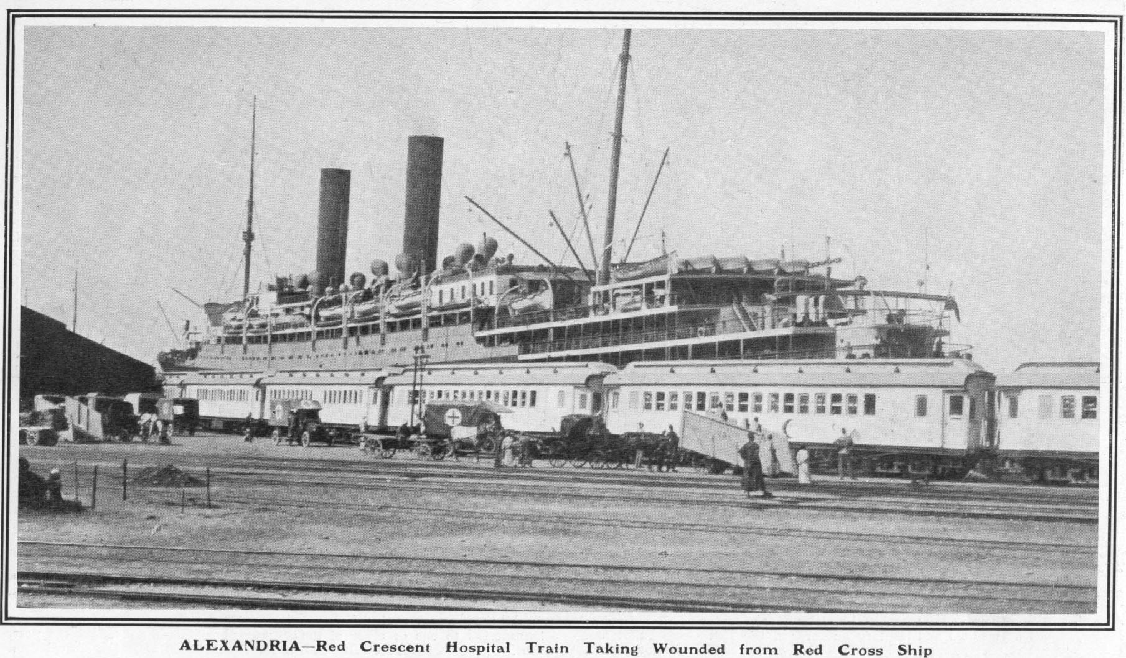

7 to 13 August 1915
On Hospital Ship "S[i]cilian". Pretty crook. Temp up to 105 & pulse up to 112. Orderlies, Sisters & Doctors all very nice & very good. Had dysentry, fever, two pellet wounds & a broken arm. Had a bad time. Boarded Hospital train 10 am at Alexandria & after a very comfortable & enjoyable ride arrived Palace about 3.30 PM. Sent to No 3 Aux. Hosp. about 1/4 mile from Palace. Was carried to dressing room on stretcher for three or four days then began to walk. Will visited every day & I got plenty others beside. Will brought grapes & gave me 20 piastres very acceptable. In hospital till 23rd but unable to write diary.

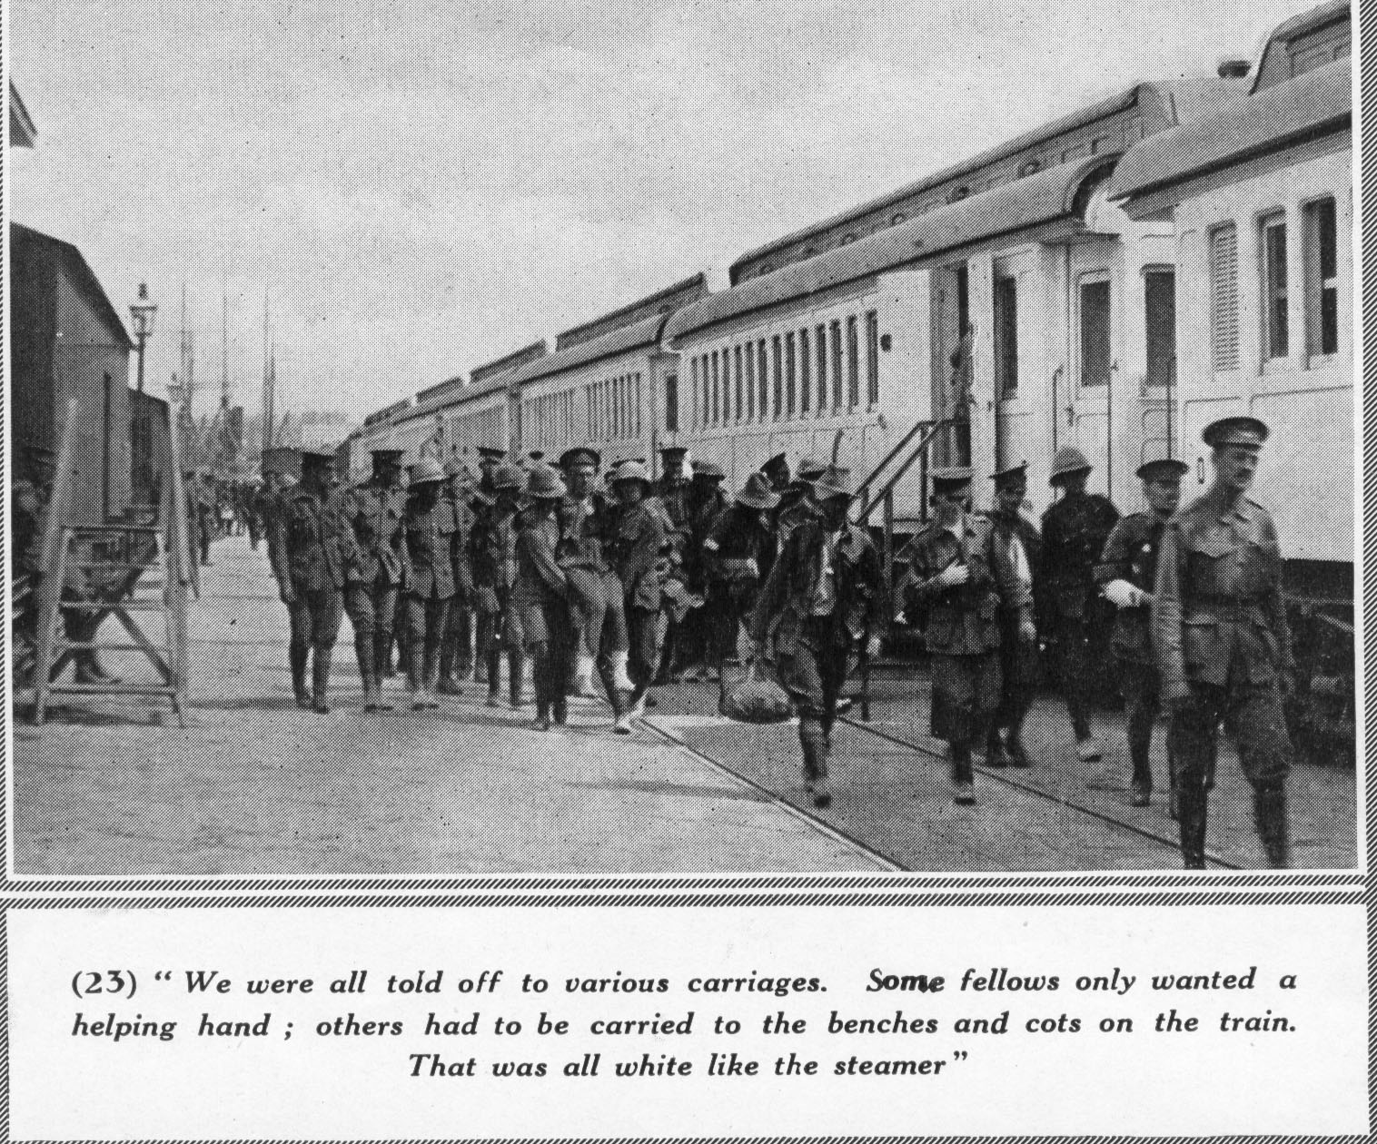

Monday 23 August 1915
Hot foment on wounds 6 am & then orderly washed me. Took temp & pulse. Laid down & read magazine till breakfast. Porridge (with no milk) then egg (fried tough) with bread & butter & cup of tea. Dressing 10 am, syringed wound & brought out a lot of discharge. Laid down till dinner. Chicken & vegetables then rice custard & tinned pears. Tried to have a sleep after dinner but couldn't for flies. Will came & stopped for about 1½ hours. Dress. 4 PM. More syringe & shifted a lot more discharge. Had a walk after sundown for about an hour & came home feeling tired but much better. Got some lemons off orderly & sugar & ice from the kitchen. Three of us had some fine lemon squash & went to bed. Arm dressed at midnight. (As soon as I came here I had hives with dysentry etc. & they found I had two compound fractures in my arm.)

Tuesday 24 August 1915
Wound dressed 6 am & splint shifted. Arm uncomfortable all morning. Breakfast, porridge with no milk & bread & butter & hard fried egg & cup of tea. Dressing 10 am. Syringed & splint put right. Dinner, Mutton & vegetables, but did not feel like it, rice custard, gave to my mate. Tried to sleep but couldn't so wrote home & to M.H. GPO. re letters. Dress. 4 PM. No syringe just squeeze & foment. Bought tomatoes for tea. Had tea, custard & tinned pineapple then bread & butter & sliced tomatoes with pepper & salt & nice cup of tea. Went very well. Went for a walk at sunset & went to bed. Woke about 11 PM when Sister came down but too early for dressing. Went to sleep & slept till daylight. Missed midnight dressing as Sister wouldn't wake me.

Wednesday 25 August 1915
Dressing 6 am. Breakfast fresh fish boiled with bread & butter & a cup of tea. Very nice. Dressing 10 am. Very little discharge. More Syringing done it good. Laid down till dinner time. Meat & vegetables with rice & pineapple for dessert, couldn't eat it. Bought some apples which were very good. Read a magazine & went to sleep. Will came about 3 PM & stayed till four when I went for dressing. Two Hospital Trains arrived. Tea, rice & milk, gave it away. After Sunset went for a walk. Had a cup of cocoa & went to bed. Arm dressed at midnight.

Thursday 26 August 1915
Arm dressed at daybreak. Night orderly's last night. Very sorry as he was a real nice chap. Had breakfast & went to buy some apples but could get none. Dressing 10 am. Syringe & foment. Day orderly left us at 10 am. Wasn't much loss. Had dinner & was told to go to surgical ward. Didn't like it but had to go. Went there about 3 PM. Flies & sun very bad. New Sister dressed my arm. Didn't like her style & she bandaged me very loosely. I was afraid of splint shifting & showed it to my old Sister & laid a long list of complaints & told her I wanted to get back. She promised me the first vacant bed in the ward as she had filled up after I left. Will brought some envelopes & had a talk. Night sister dressed me & forgot my sling which Will put on for me. Had two boiled eggs & bread & butter for tea. Went to sleep very discontented.
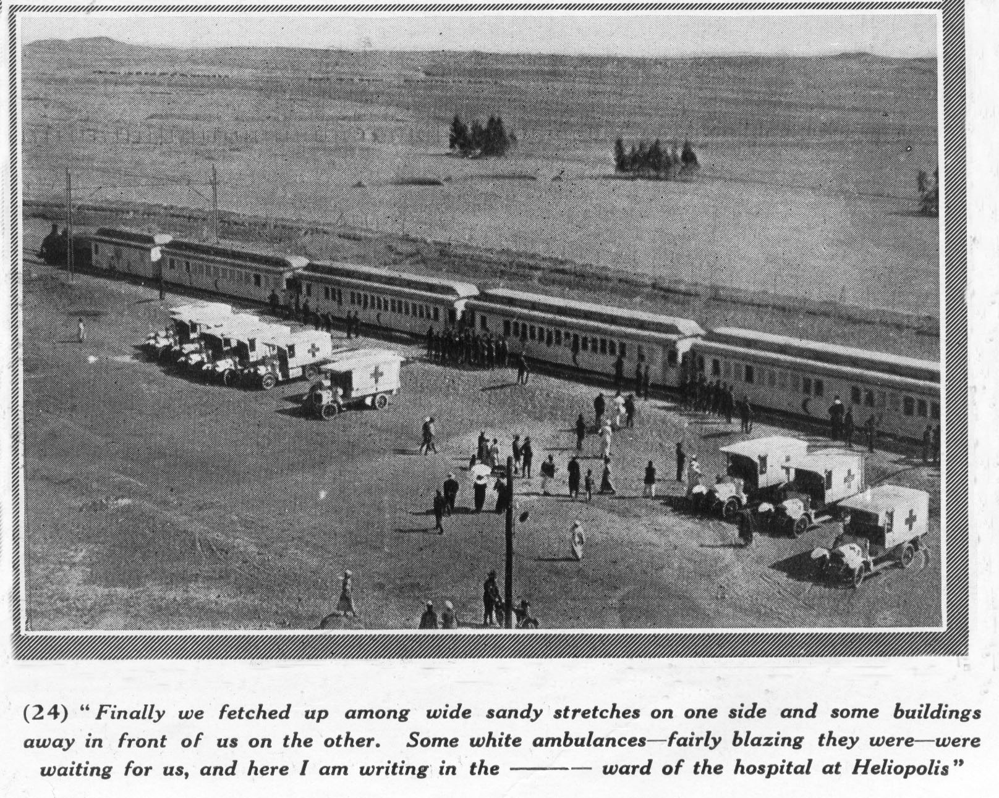

Friday 27 August 1915
Woke daylight but could get no wash. Breakfast time, could get no breakfast till night sister roused. Sun rose & shone on my bed till about 9.30 am. 10 am Doctor came & stripped my arm & had a look at it, twisted my hand, squeezed my wounds & other things which hurts. Then he ordered dry dressing & came back later & tied me up (with a lot of discharge in my arm). Very dissatisfied about my arm & complained to my old Sister & she promised to get me back as soon as possible. Came over to old ward after getting no tea & orderly there made me come & have tea with him & told me that he had three vacant beds. He spread the mattress out on bed to make it look occupied. Night Sister (in old ward) came on & I told her what we had done. She laughed & put some clean sheets on the bed & told me to "pop in" while she went & got the doctor's permission for me to sleep in the ward. Will came & had a talk & went early. I waited till lights out but Sister never came back so I went to new ward before it got too late.

Saturday 28 August 1915
Woke daylight & night Sister (New Ward) told me that my bed was ready in the old ward. I shifted immediately & made sure of getting my temp. chart. The night Sister (old ward) went crook (jokingly) about me scooting so quick saying she had got permission for me to sleep in the old ward. Had a good breakfast & bought some apples. Dressing 10 am. (Old Sister) Syringe very clean no discharge so she changed dressing & put wet picric acid on in place of foments. Read till dinner time. Usual dinner. Sister came & told me that Capt. East (New Ward) said that I had to go back to his ward at once. A little later Sister Taylor (New Ward) came in & wanted me to go back as soon as possible, but I objected till I saw Capt. East. I went three times to see him during afternoon but couldn't find him. Later in afternoon a hospital train came in & filled his ward up. During afternoon Lieut. Gartrell & Billy Carruthers came to see me. Had tomatoes with bread & butter for tea. After tea had a stroll & a cup of cocoa then to bed about 9 PM.

Sunday 29 August 1915
Woke daylight. Flies very bad. Usual breakfast. Dressing 10 am.
Syringed very clean. Wound looking very healthy & clean. Dressing, dry with boracic powder. Laid down till dinner. Usual dinner. Read all afternoon & Will came about 3 PM. Had a yarn & he left me his fountain pen. Went down to fence & met Davie Baxter got an introduction to Sgt. Simpson, Bandmaster, 25th Batt. Band. He promised to come & play for us on Wed. or Thur. night & told me to come & have a pitch with him. Met Jim Horrigan. He had been over to the front twice & has six wounds altogether but is ready to go back again. Bought tomatoes for tea. Had a good tea with tomatoes. Went for a walk after sunset & felt real good. Had a cup of cocoa & went to bed. Went to C.E. Church.

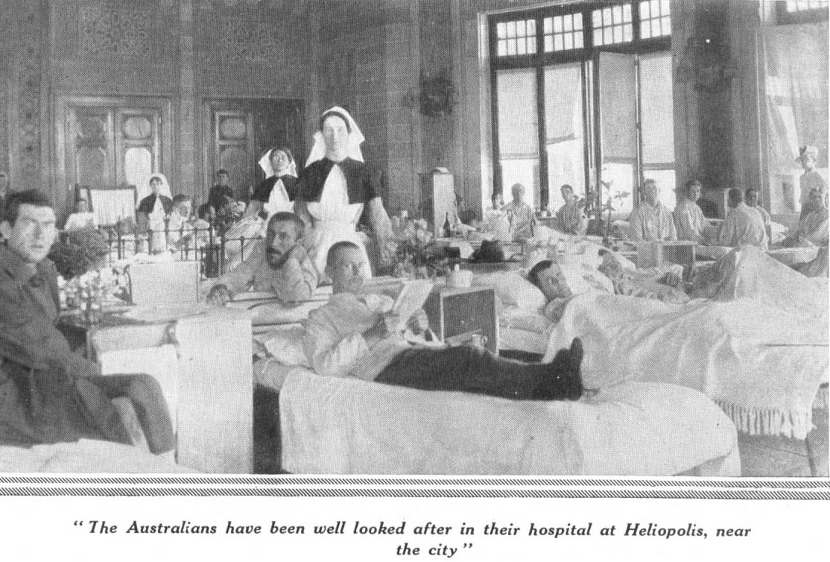
Monday 30 August 1915
Woke daybreak & orderly washed me. First for three or four days. Flies
still very bad. Usual breakfast. Dressing 10 am. No discharge at all so no syringing & dry boracic dressing. Wounds looking very clean & healthy. Went to dentist & had four teeth drawn. By heavens he hacked at them, pulling one out in four peices, two others in two peices & the other one whole. Usual dinner. After dinner slept till about 3.30 after gargling my mouth with a gargle the Sister gave me. Had tomatoes & tinned Gooseberries for tea after which Will came in with some letters from home & said that he was leaving on Wednesday. Very pleased to read letters & to read of dad's [aged 63 years] promotions to J.P. & President of the Lodge. Had a talk with some cobbers till 8.30, then a cup of cocoa & went to bed.

Tuesday 31 August 1915
Woke daybreak & had a wash. Flies very bad. Night Sister came to me & asked me if I came from Charters Towers. I told her that I did. She then told me that she had been talking to Sister De Vis who was inquiring after Towers chaps & found out that I was here & told our night Sister that she was coming to see me, the first chance she got. Usual breakfast. Laid down & read till dressing time. Arm looking real well, and no discharge. Dry dressing of boracic. Slept till dinner. Usual dinner. After dinner Will came & brought some clothes. Got a pass from Doctor & went to 25th Batt. camp. Met Harry Goodin, Davie Baxter & Jack Nix & a host of old "B" Coy., unallotted. Had a long talk with Jack Nix who heard that I was killed, as soon as he arrived in Egypt. Was introduced to nearly every officer in 25th Batt. Came home about 5.30 PM & had tea of fresh herrings & tomatoes. Felt real good after walk. Sat round & gossiped till 8.30 PM then a cup of cocoa & to bed.

Wednesday 1 September 1915
Woke about 6.30 am. Loafed around till breakfast. Porridge & fresh fried fish for breakfast. Change was very good. Dressing 10 am. Wound looking very good. Usual dry, healing dressing. Reading till dinner. Usual dinner. Slept till 8.30 PM. Had a walk & bought some tomatoes & apples for tea. Sister De Vis came in about 4.30 but did not stay long as it was tea time. Was very pleased to see her. Had a good tea after another chap & I went for a walk & saw a game of tennis & a game of polo. Got home about dark, gossiped till 8.30 PM, a cup of cocoa & to bed.

Thursday 2 September 1915
Woke 7 am. Flies very bad. Breakfast, porridge, sausages & bread & butter. Had a good appetite & made use of it. Dressing, usual time. Doctor had a look at arm & was very pleased with its condition. Usual healing dressing. Reading till dinner time. Usual dinner after which Will came in for a while. After he went, had a read till 4 PM then a walk round till tea time. Canteen open but bought nothing. Tomatoes & bread & butter for tea also custard. After tea a mate & I went for our usual walk, watched a game of tennis then went for a stroll up behind the Palace, arriving home after dark. Had a talk till 8.30 then a cup of cocoa & to bed.

Friday 3 September 1915
Woke 6.30 am. Flies very bad. Read till breakfast. Eggs & cold meat for
breakfast. Had a game of crib till dressing time. Usual dressing. Our ward's turn for hospital gramophone. It played all day & I enjoyed it very much. Very good stew for dinner. Canteen open & I bought 3 large tins of fruit & some biscuits. Will & four others from 25th Batt. came in to say "Good-bye" as they were leaving at 4 P.M. & later in afternoon, Scotty Carruthers came in on the same errand. Usual tea. Concert in surgical ward after tea given by visitors which was very enjoyable. Usual gossip till 8.30 PM, cup of cocoa & to bed 9 PM.

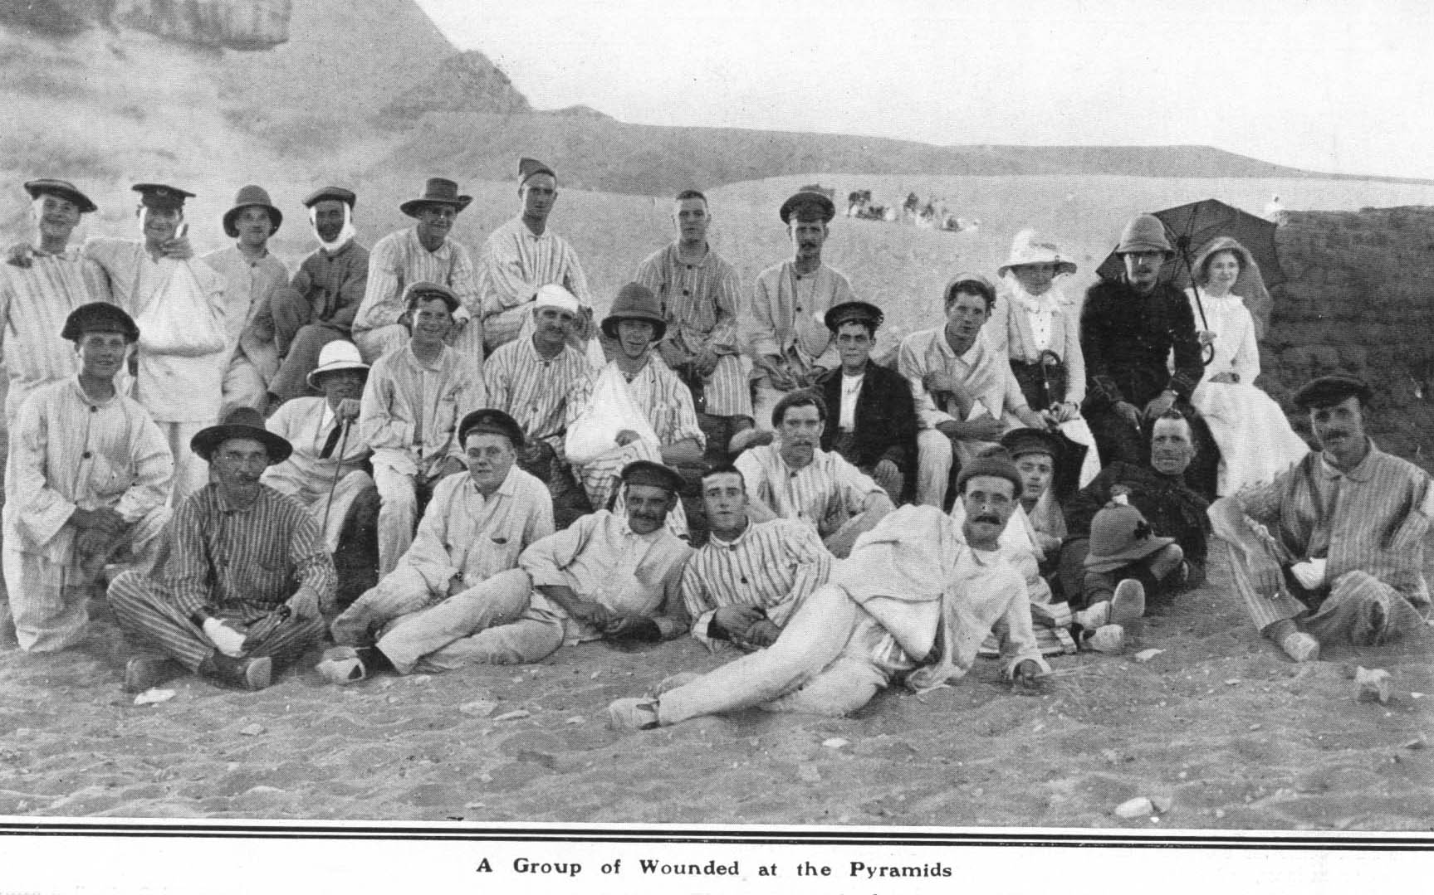
Saturday 4 September 1915
Woke 7 am. Flies extra bad. Had a wash & went to sleep again till breakfast. Very poor breakfast of scrambled eggs & by cripes they were scrambled. Dressing 10 a.m. Sister stripped my arm right down, splint included. Could move fingers but not grip. Moved wrist a little. Arm washed & fresh wool & bandages put on. Usual dressing on wounds. Sister very pleased with its condition. Read till dinner. Curry & rice for dinner which was very good. Wrote home & to Mag & Amy. Had custard & tinned peaches for tea. After tea went for a walk round Heliopolis. Usual gossip till 8.30 then cup of cocoa & to bed.

Sunday 5 September 1915
Woke 6.30 am. Flies still bad. Breakfast 7.30 am. Slept till dressing. Usual dressing. Read till dinner. Usual dinner. Read till 2 PM. Tried to sleep till 4 PM but couldn't for heat & flies. Custard & tinned apricots for tea. After tea went to surgical ward & had a concert on our own at the piano. Got home 8.30 PM. Three hospital trains arrived during afternoon. Went to bed 9 PM.

Monday 6 September 1915
Woke 6 am. Breakfast mince & rice at 7.30. Dressing usual time. Had finger lanced & dressed. Usual dinner. Flies very bad. Mate played piano in surgical ward & we had a bit of a sing. Strolled round till tea time. Custard & tinned peaches for tea. Had a walk after tea getting home about 7.30. Usual gossip till 8.30, then a cup of cocoa & to bed.

Tuesday 7 September 1915
Woke 6 am. Flies extra bad. Usual breakfast. Read till dressing. Arm looking well. Went over to piano till dinner. Stew & rice custard for dinner. Played euchre for a while. Another hospital train arrived. Went to have a look at the patients but they were all walking cases & train was empty when we got there. Bought tomatoes for tea. Bread & butter & tomatoes, custard & pears for tea. Concert in surgical ward after tea, which was good. Got home 8.45, had cocoa & to bed.

Wednesday 8 September 1915
Woke 6.30. Breakfast 7.30. Porridge with milk & eggs for breakfast. Dressing usual time. Wounds almost healed. Dressing to be changed every 48 hours instead of 24 hours. Read till dinner. After dinner, got a pass & went to Palace to see Charlie Pieniger but he was transferred to No. 2 Aux. Met a chap I knew at Enoggera, then went to No. 1 Aux. (Luna Park) but didn't know anyone. Too late to go to No. 2 Aux. so came home for tea. Went to bed early.

Thursday 9 September 1915
Woke 6.30 am. Flies bad. Same old breakfast of porridge & scattered
eggs. No dressing so played euchre all morning. Usual dinner. Played crib all afternoon. Custard & apricots for tea. Went for a stroll round Heliopolis. Got home 8.30, a cup of cocoa & to bed. Hospital train arrived. Got no new patients.

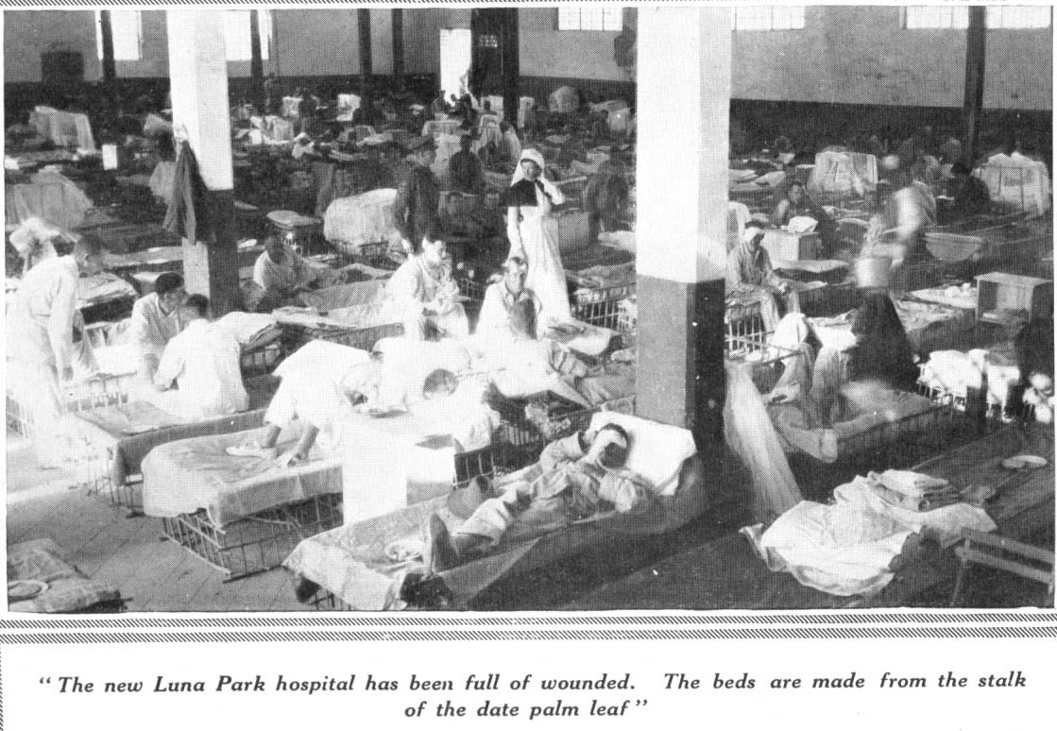

Friday 10 September 1915
Woke 6 am. Had a walk before breakfast. Fried (fresh) fish for breakfast. Dressing 9 am. Wounds healed & quite dry. Doctor had a look & took splint off for good, also bandage off lower fracture. Gramaphone in our ward. Curry & rice for dinner. Played euchre in afternoon & went for a walk & bought tomatoes for tea with last piastre. Custard & peaches & tomatoes for tea. Met Layne of our Coy. He is here sick. Listened to Gramaphone till bed time. New night sister on. Arm aching (after coming off splint).

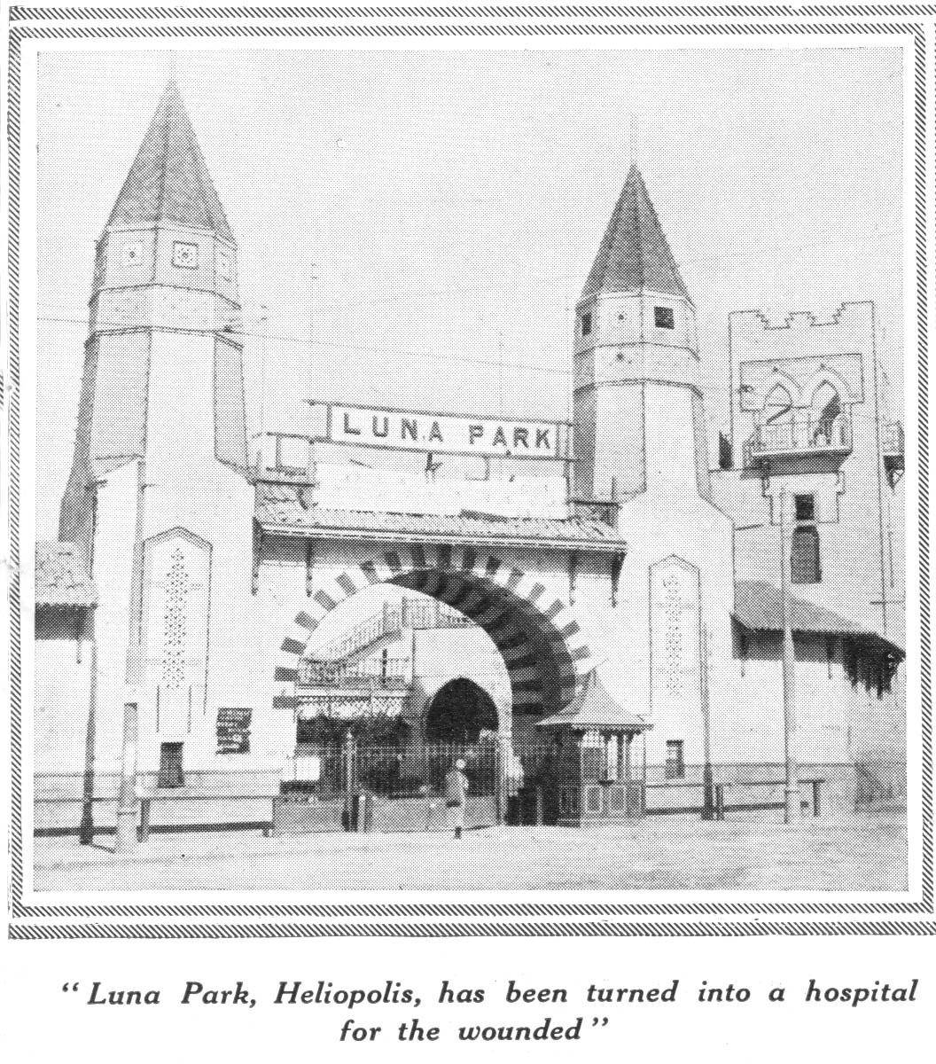

Saturday 11 September 1915
Woke 6 am. Flies very bad. Breakfast of cold meat & eggs not too bad. Met Harry Hawkins of our Coy. & had a yarn. Dinner roast meat & vegetables. Wrote home, Nell & Ruth & Eileen & Jack Lowe. Played euchre, got new card table. Tried arm without sling. Hurt getting it down but when down was all O.K., but had a bit of a bow at elbow. Curry & rice for dinner. Had a game of cards & a sleep till tea time. Had Custard & apples, tinned & fresh tomatoes for tea. Went for a walk & when I got home, I shifted back into my old bed (the one which I had when I first came in).

Sunday 12 September 1915
Woke 6 am & had a wash. Had a walk before breakfast, with arm out of
sling. Hurt a bit but did it good. Sausages & eggs for breakfast. Dressing usual time. Dressing left off & doctor told me to use it as much as possible. Meat & vegetables for dinner. Got a pass & went to No. 2 Aux. & saw some chaps out of our Coy., then went to Zeitoun Camp. Couldn't find anyone whom I knew, so came home again. It took me all my time to get home as Zeitoun is about three-quarters of an hour's walk from here. Was very tired & shaky but was fit for another walk after tea, but went to church instead.

Monday 13 September 1915
Woke 5.30 & had a wash. Curry & rice for breakfast. Went for a stroll after breakfast, after which played whist till dinner. Meat & vegetables for dinner. Played euchre & had a stroll till tea. Gossiping till 8.30 then a cup of cocoa & to bed.

Tuesday 14 September 1915
Woke 5.30 & had a talk with orderly then went for a walk & run. Run about ¼ mile & knocked up. Cold meat & eggs for breakfast. Laid down & read till dinner. Slept all afternoon & woke up for tea. Met Titch Thompson who was returned to hospital from base details. Had a yarn & then strolled around till 8.30. Yarned some more & went to bed. Arm a bit sore.
Wednesday 15 September 1915
Woke 5.30 & went for a long walk. Scattered eggs for breakfast. Got some tinned fruit from canteen & had a tin of green gages between three of us, for dinner. Wrote to Herb Jones & D.D.F. Slept till tea time. Usual tea & a stroll afterwards. Gossiping till 8.30, then cocoa & to bed.

Thursday 16 September 1915
Woke 6 am, had a wash & went for a long walk, arriving back in time for breakfast. Fried liver for breakfast. After breakfast wrote to Aunt Liz & Ikey Evans. Usual dinner and a sleep afterwards. Custard & fruit for tea. Colodion dressings came off my arm & a blister was under one, full of discharge. Arm a bit sore. Went to bed 9 PM.

Friday 17 September 1915
Woke 6.30 am. Laid down till breakfast. Fried eggs for breakfast. Dressing time, went to dressing room & had blister opened & discharge squeezed out. Told doctor about my wrist being stiff & that when I moved it I felt it in the bone which was fractured. He told me he would send me to get it x-rayed. After dinner, slept till tea. Custard & stewed apples for tea. Had a stroll & a yarn & went to bed 8.30 PM.

Saturday 18 September 1915
Woke 5 am & went for a walk. Breakfast 7.30. Dressing 8.30. Went to Palace 9 am & had arm x-rayed. Wrote to home. After dinner Sam Marshall & Snowy Johnson came in to see me. Was very pleased to see them. Said they were coming in next day as well. After tea went for a stroll, had a yarn & went to bed.

Sunday 19 September 1915
Woke 6 am & laid in till 7 am. Fried eggs & sausages for breakfast. Dressing usual time. Arm very sore. Went for X-Ray report which stated that there was an ununited bone & lead fragments in my arm. After dinner doctor came & said he would send me to the Palace for an operation. Had a read & got my pack. After tea (of custard, blanc mange & stewed apples) went for a walk & then to church.

Monday 20 September 1915
Woke 6 am & had a stroll. Curried sausages for breakfast. Dressing usual time. Blue stone dressing. 11 am transferred to Palace & put in same bed as I had some 3½ months previous. After dinner was put in another room. Doctor came in 3 PM & ordered hot foments. Had a game of euchre till dark. Went to bed 7.30 PM.

Tuesday 21 September 1915
Woke 5.30 & had arm dressed, read till breakfast. Doctor came in 10 am & probed my arm & got a very small piece of bone out of it, which was keeping the wound open. Reading till dinner. After dinner tried to sleep but couldn't for flies. Strolling around all afternoon till tea. Two eggs & bread & butter for tea. Had a look round for any of our chaps who may be in here & found four. Went to bed 7.30.

Wednesday 22 September 1915
Woke 4 am & had a cup of cocoa. Slept again till 5.30 am then had arm dressed. Had a walk round till breakfast. Dressing at 9.30 am. Doctor visited 10.30 & told me that he was going to send me to Australia to get my arm done. After dinner went to Sporting Club for a stroll. After tea went to see our sick chaps & went to bed 7.30 PM.

Thursday 23 September 1915
Woke 4 am & had cocoa. Slept till 5.30 & had dressing done. Watched a game of cricket till breakfast. Dressing 9.30 am. Doctor's rounds 10.30 & fill in forms for Medical Board. After dinner went to Sporting Club visiting. After tea went for a stroll. Hospital life very monotus. Went to bed 8 PM.

Friday 24 September 1915
Woke 6 am & had a stroll around ground before breakfast. Arm dressed 10 am. Doctor's visit 11 am. After dinner saw Sister De Vis. Frank Piggot came about 3 PM & wanted me to come to town but I had no money, leave or clothes (only pyjamas) so couldn't. He stayed till tea then went on his own. After tea, went visiting sick chaps in other wards. Retired 8 PM.

Saturday 25 September 1915
Had a stroll before breakfast. Dressing 9 AM, Doctor 10 am. After dinner had photo taken in ward then went to Sporting Club & missed Medical Board. After tea, went & saw sick chaps & went to bed 8 PM.

Sunday 26 September 1915
Arm swollen a good deal. Usual breakfast. 9 am dressing, 10 am Doctor's rounds. Ordered a hot foment for my arm from wrist to elbow. Wait for Medical Board all afternoon but they did not come. Went to bed 7.30.

Monday 27 September 1915
Had a walk before breakfast. Dressing 9 am, Doctor's rounds 10 am, then helped orderlies to draw rations. After while having a game of cards, the Medical Board came round & passed me for Aus. After Medical Board went, I went down to the Sporting Club & drew 50 piastres. Had a look at sick chaps after tea & went to bed 8 PM.

Tuesday 28 September 1915
Arm very sore & stiff. Dressing 9 am, doctor 10 am who transferred to No. 2 Auxilliary. After dinner went to No. 2 Aux, Atelier to wait for a boat. Arrived there 2.15 & put in Y section. After tea went to Sporting Club. Went to bed 9 PM.

Wednesday 29 September 1915
Woke 6.30. Met Charlie Pieniger & had a long yarn. After breakfast
doctor came round & when he found out where I came from, he roused like fun & would not look at my arm saying I would have to go back to where I cam from. After dinner, I got dressed & went to Sporting Club & then to town. Met Frank Piggot & we had tea. Went to Grand Cafe Egyptian to hear orchestra, then to Esbekia skating Rink & saw pictures & a boxing exhibition. Had a feed & came home. Went to bed 10 PM.

Thursday 30 September 1915
After breakfast while talking to Charlie P. my name was called out for Helouan, but I knew nothing about it & had no clothes so couldn't go. Doctor came round & again refused to see my arm & also refused a pass for money. I was going to complain to the Major about him but on second thought it wasn't worth bothering as I am going to Helouan tomorrow. After dinner, took French leave & went to Racecourse camp & saw Sam Marshall, Jim Lawrence, Bert Kay & some other Towersites. Came home for tea & went out again to Sports Club & Heliopolis. Came home & to bed 9.30.

Friday 1 October 1915
Woke 6 am & packed kit. After breakfast got dressed for Helouan. Left hospital about 9 am & went to Cairo per Motor Ambulance arriving there 9.30. Train left for Helouan 10.15. Arriving there about 11 am. Inspected by medical officer & admitted to Al Hayat Hotel. Met a few cobbers & had a glorious dinner. Some musicians came out after dinner & gave a concert which I enjoyed very much. After tea had my arm massaged then went to concert. Bed 9 am. [pm]

Saturday 2 October 1915
Woke 6 am, folded bed & went down on piazza to wait for breakfast. After breakfast, parade before doctor 9 am. Played games till dinner. After dinner was reading till tea. Arm massaged then saw pictures & a good concert. Met Harold Johnson & had a yarn, & went to bed 9.45. bugs are plentiful in our room.

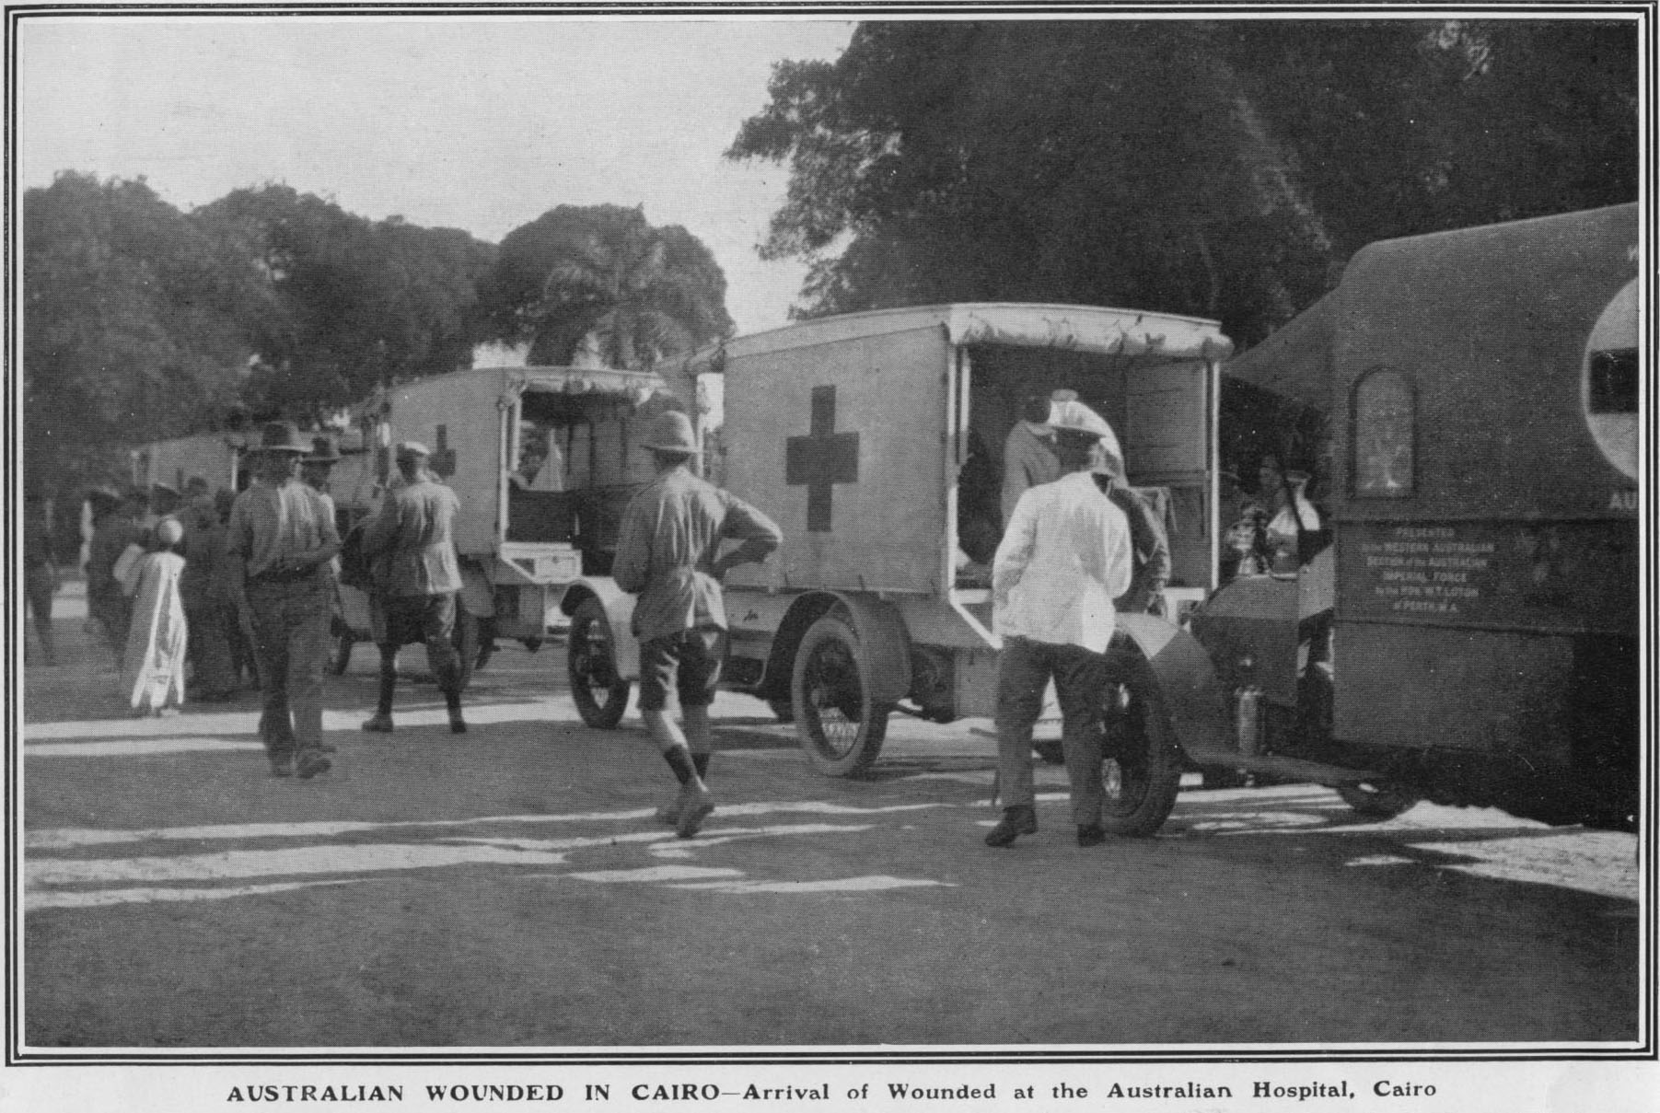

Sunday 3 October 1915
Woke 6 am. Breakfast 7.30. Doctor 9 am. All men who were boarded for Australia were to parade 11 am. Fell in 11 am & roll called & told to fall in again 2 PM for Colonel’s inspection. Col. Ryan came at 2 PM & was (or as it seemed to me) slightly intoxicated. He put back about 90% of wounded patients for duties & sent sick men home & a few wounded. He put me down for a months massage & then for lines of communication. After tea, church parade. Missed massage.

Monday 4 October 1915
Woke 7 am. Breakfast 7.30. Doctor 9 am. Crowd left for Australia 7.30. I asked doctor to send me back to Palace to have my arm fixed & he said he would. Wounds began to break out again. After dinner, wrote home. After tea missed massage & went to pictures. Massaging was making me worse as the bones were disturbed.

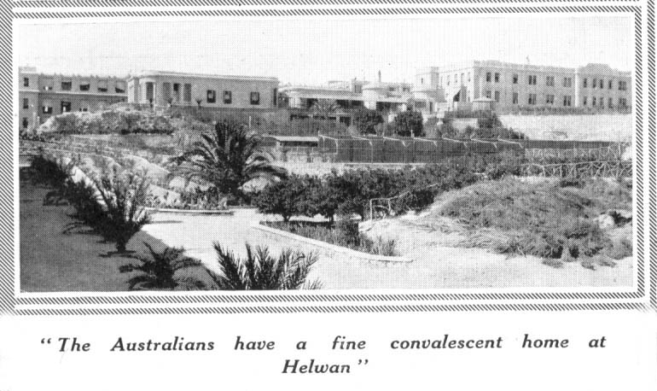

Tuesday 5 October 1915
Woke 6.30. Breakfast 7.30. Doctor 9 am. Again asked him about palace & I was told to parade at surgery 11 am. Got up to surgery in time to see all the niggers, who worked about the place, being innoculated which was very funny. Got papers fixed up for transfer to Palace. After tea there was a concert which was fairly good.

Wednesday 6 October 1915
Woke 6 am & got things ready for going away. Left Al Hayat to catch 9.45 train from Helouan to Cairo arriving at Bab el Louk Station 10.45 & caught train to Cairo then another to Heliopolis, arriving there 11.30.

From Palace was sent to No. 2 Aux. Atelier. After dinner went to Sporting Club to see a mate & didn't get home till 7 PM & sister went crook because the doctor had been three times to see me. Some visitors came & gave us a concert which was good.

Thursday 7 October 1915
Woke 6 am & had a bath. Breakfast 7.30. Had a yarn to Charlie Pieniger. Doctor came at 10 am & had a look at my wing & probed it & said he would see x-ray report before doing anything & put a dry dressing on. After dinner Harold Johnson came in & we had a yarn. Went to bed 7.30.

Friday 8 October 1915
Woke 6.30. Breakfast 7.30. Doctor came 10 am & told sister to have me ready for an anaesthetic tomorrow. Read all day till four oclock then had arm shaved & washed thoroughly clean. Reading till lights out.

Saturday 9 October 1915
Had no breakfast & arm washed again & was then ready for the slaughter which came at 11.45 am. Went through all right & woke 12.30. At one oclock had a plate of rice & read all afternoon. After tea went to Sporting Club. Came home 8 PM & went to bed.

Sunday 10 October 1915
Woke 7 am. After breakfast had arm dressed. It was sore when the gauze was coming out also when putting it back, otherwise it was good. Doctor told me that it would want another operation. After dinner wrote home to H.D.J. & M.B. Was reading till lights out.

Monday 11 October 1915
Woke 6.30. After breakfast had arm dressed. It looked very healthy. Got a pass from Doctor to visit Zeitoun for cash, but on arriving there could get none as paymaster was on a court-martial. Was examined by Colonel Ryan again & this time he passed me for Australia. Went to bed 9.30.

Tuesday 12 October 1915
Arm a bit sore & swollen. After breakfast had dressing done & got a pay
pass for £10 . Went to Cairo after dinner & drew only £8 as it is the limit. Bought a few things & came home. On arriving home, was told that I was to go to Suez tomorrow to catch boat for home. Chap in next bed drew my clothing & pack from quarter master. Went to bed 9.30 PM.

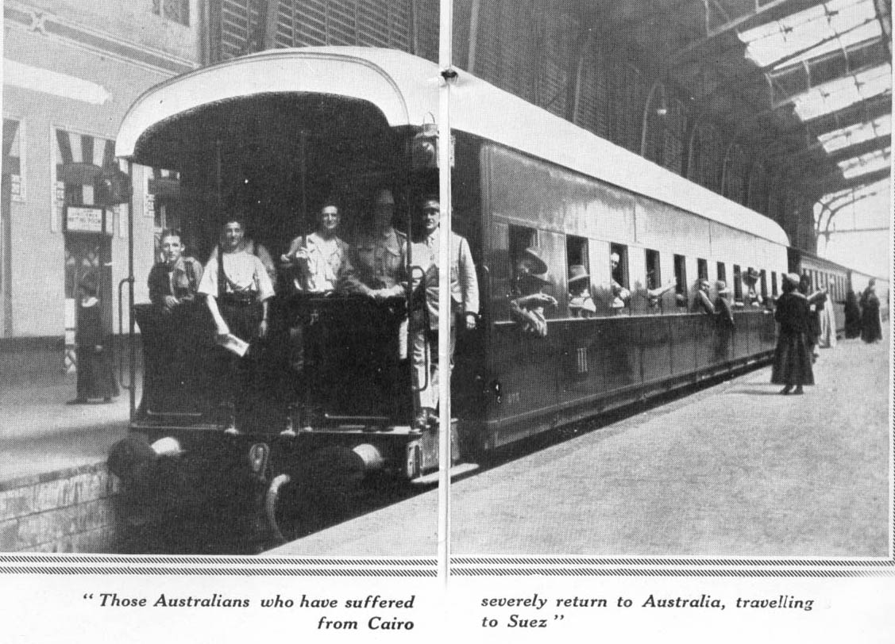
Wednesday 13 October 1915
Woke 6.30 am & packed kit & got dressed (uniform). After breakfast went to Sporting Club & then came home & had dressing done. Left Atelier, per motor ambulance, 10.15 for Cairo. Left Cairo 11 am for Suez. Arrived Ismalia 2.30 & changed trains & left for Suez at 3 PM. Saw an armoured train manned by Indians. Arrived Suez 4.45 PM & went to Concentration Camp per motor ambulance arriving there 5 PM. Had tea 5.30 & then had a look round & went to bed 7.30 PM.
Thursday 14 October 1915
Woke 7 am. Am mess orderly Breakfast 8.30. After breakfast tidied up & while waiting for doctors, mended tunic. Doctor came & gave me a coupon for dressing. After telling orderlie how my arm was dressed, he couldn't put draining gauze in so I had to do it myself. After dinner went to town with Alex Wright & went aboard the battleship "Jupiter". Got home 10.30 PM.

Friday 15 October 1915
Woke 7 am. breakfast 8.30. Dressing 10.30. Roumers about going home, all untrue. Slept all afternoon. After tea "City of London Roughriders" held a concert in mess hut which was very good.

Saturday 16 October 1915
Woke 7.30 am. Breakfast 8.30. Dressing 10.30. After dinner went to town & down to the boats. Town very quiet. Came home 8.30 PM & heard roumer of going away on Tuesday. Went to bed 9.30.

Sunday 17 October 1915
Woke 7.30. Bad eggs for breakfast. Dressing 10.30. After dinner went to town to get watch repaired. Came home 8.30. Sick during night.

Monday 18 October 1915
Woke 6 am. Not feeling too good. Breakfast 8.30. Dressing 10.30. After dinner went to sleep. After tea went for a walk to Indians camp on our left & had a yarn with them

Tuesday 19 October 1915
Woke 7 am. Breakfast 8.30. Four men out of our tent with fourteen
others from the camp were told to be ready to go to Port Tewfik at 12 noon, to embark on Kanowna for Australia. Dressing 10.30. After dressing went for a walk to beach & saw a fight between some Egyptian women. After tea had a yarn with some Indians.

Wednesday 20 October 1915
Usual daily routine, nothing sensational.

Thursday 21 October 1915
Usual daily routine. Three new boarders arrived in our tent about 6.30 PM.

Friday 22 October 1915
Mess orderlie. Doctor 10 am. Dress 10.30 am. Warned to fall in at 2 PM. Tent Commander paraded 2 PM & attention was drawn to row in camp after dark & were told that that on that account, passes were limited. Went to town to put in time & returned to bed 7.30 PM.

Saturday 23 October 1915
Woke 7 am. Breakfast 8.30. Doctor 10.30. Dress 10.45. Read & slept all afternoon. After tea, saw Indians play football & was talking to them till 7.30, then to bed.

Sunday 24 October 1915
Woke 7.30. Breakfast 8.30. Church parade 9.30 which was a very poor one. Doctor 10.30. Dress 10.45. Arm a bit swollen. Slept all afternoon. After tea had a yarn with Indians & went to bed.

Monday 25 October 1915
Woke 7.30. Breakfast 8.30. Doctor 10.30. Dress 10.45. Arm looking better. Roumers of boat going in two days. After dinner went to slaughter yard. The style of killing cattle is to floor them & cut their throats then blow them up with bellows. After tea had a game of cards & went to bed.

Tuesday 26 October 1915
Woke 7 am. Breakfast 8.30. Doctor 10.30. Dress 10.45. After dinner went to town. Missed three trains during afternoon. After tea had a yarn to Indians & went to bed.

Wednesday 27 October 1915
Woke 7.30. Breakfast 8.30. Doctor 10.30. Dress 10.45. Arm looking
better. After dinner went down to Port Tewfik & hear roumers of boat going on Friday. After tea had a game of cards & went to bed.

Thursday 28 October 1915
Woke 6.30. Breakfast 8.30. Doctor 10.30. Dress 10.45. After dinner,
read till tea. After went to see some Indians & was invited to a spread held to commemorate a victory gained by them in France twelve months ago, also in memory of a Lt. Col. & 6 other officers who fell during the charge. Had a good time. Went to bed 9.30.

Friday 29 October 1915
Woke 7 am. Breakfast 8 am. Colonel Ryan's inspection 9 am. He passed about 50 men back to their units. After dinner had sleep. After tea had a pitch with Indians. Retired 9.30.

Saturday 30 October 1915
Woke 7 am. Breakfast 8.30. Doctor 10 am & told to be ready for embarkation at 2 PM. Got arm dressed & packed bag. 2 PM fell in & entrained in Goods trucks & proceeded to Port Tewfik & embarked on Z66 "Aeneas". 7 PM were issued with mess utensils. 7.30 drew bread. 7.45 drew butter & jam. 8 PM drew tea & had tea. 8.45 drew blankets for mess. 9.30 drew hammocks for mess. 10 PM went to bed. Slept on bathroom roof forward.

Sunday 31 October 1915
Woke 6.30 am. Mess orderly today. Drew breakfast 8 am. Pulled out from Tewfik wharf 8 am & 8.30 was in Gulf of Suez. After breakfast scrubbed table & washed up & tidied up. Dinner Sargeant's mess. After dinner had walk around & a sleep. 4.30 had dressing done. After tea went aft & had a yarn to firemen & heard Gramaphone. Passed two ships during day. Went to bed 8.30.

Monday 1 November 1915
Woke 6.30. Breakfast 7.30. After breakfast had a game of cards. Issue of cigarettes & tobacco 11 am. After dinner went up on forecastle head to get a breeze & to read. About 2 hours later a picquet was put on up there & I had to come down. Weather very hot, now in Red Sea. Had a sleep before tea. After tea passed three ships & had a game of cards. Had a bath & went to bed. Steaming about 13 or 14 knots.

Tuesday 2 November 1915
Woke 7 am. Breakfast 7.30. Dressing 9 am. Very hot. Main topic of conversation, Melbourne Cup, Mountain Knight is favourite. Weather very hot with no breeze. Sea very calm. Now in Red Sea. After dinner passed Troopship A71 bound for Suez. Passed P & O light about 2 PM. Paid 10/-. After tea went aft & hear Gramaphone & sat Talking till 9.30 then to bed.

Wednesday 3 November 1915
Woke 7 am. Breakfast 7.30. Took bandage off my arm & left it off. Arm looking well but slightly bent. Massaged it at intervals during day. Talking & reading till dinner. Twelve Apostle's sighted 10.30 am & passed them 1 PM. Played cards during afternoon. Hell’s Gates sighted 4.30 & went through them at dusk. Had a game of cards till 8.30. Weather much cooler. Passed Perim midnight & Aden during early hrs of next morning. Passed about four ships during day & one at night.

Thursday 4 November 1915
Woke 6.30. Breakfast 7.30. Passed Troopship A41, bound for Australia, at 8 oclock. Out of sight of land 11 am in Gulf of Aden with a good breeze blowing & much cooler. Sea calm. After dinner played crib & had a sleep. Passed two ships after dark, bed 10 PM.

Friday 5 November 1915
Woke 6 am. Breakfast 7.30. After breakfast land sighted. 2 PM fire alarm. 3 PM passed Cape Guardfui. After tea played crib & went to bed 8.30.

Saturday 6 November 1915
Woke 5.30. After breakfast passed a ship going opposite direction. After
dinner played cards. 4 PM it rained. After tea a concert was held on starboard promenade deck. After concert went to bed on deck. During the night it rained & I had to shift to Sgts mess.

Sunday 7 November 1915
Woke 7 am & missed breakfast. Sea a bit rough & boat pitching a little. 10.30 am. went to church. After dinner tried to sleep but couldn't. After tea went to church on 'E' deck. After church went to bed, on deck. Rained a good deal during day & boat was rolling & pitching a good deal at night.

Monday 8 November 1915
Woke 6.30. Breakfast 7.30. Slept for a couple of hours before dinner. Was to have photo taken with Sgts mess at 11.30 but it rained instead. Weather very squally & sea a bit rough. After dinner copied Turkish Proclamation. After tea played cards & went to bed 8.30.

Tuesday 9 November 1915
Crossed line during night. Up till now the ship averaged 353 miles per 24 hours. After breakfast had a sleep. After dinner copied reply to Turkish Proclamation. After tea played crib & went to bed.

Wednesday 10 November 1915
Woke 7 am, breakfast 7.30. Read till dinner time. After dinner was paid 10/-. After tea talking till 8.30 & went to bed. Very heavy swell on all day otherwise weather good.
Thursday 11 November 1915
Woke 6.30, breakfast 7.30. After breakfast slept till dinner. After dinner played draughts. After tea had a yarn to "Scottie" Wright & "Swinger" Ellery. 9.30 went to bed.

Friday 12 November 1915
Woke 6.30, breakfast 7.30. Yarning till dinner. After dinner played cards after tea concert which was good, bed 9.30.

Saturday 13 November 1915
Woke 6 am. Ships Orderly Sgt. 7.30 breakfast. After breakfast played draughts. Inspection 11 am. Did not attend. After dinner slept till 4 PM. tea 5 PM. played cards after tea. Boat alarm 8 PM. Bed 9.30. .

Sunday 14 November 1915
Woke 6.30. Heavy swell on a deep blue water. Breakfast 8 am. Church parade 10.50 am. After dinner slept till tea. tea 5 PM. Went to church 7.30, bed 9.30.

Monday 15 November 1915
Woke 7 am. Breakfast 7.30. Slept till dinner. After dinner had a game of cards. Sea much calmer with less wind. Bed 9.30.

Tuesday 16 November 1915
Woke 6.30 am. After breakfast wind began blow fairly strong an sea got rough. After dinner waves breaking over bridge. Issued with three handkerchieves & cigarettes. Copied poems from the Peninsular. After tea sea very rough & wind blowing a gale. Went to bed 9 PM.

Wednesday 17 November 1915
Woke 7 am. Weather a little better but very cold. Slept in sun all morning. After dinner got paid 10/- & slept rest of afternoon. After tea had a yarn on deck till cold drove me to bed at 9.30.

Thursday 18 November 1915
Woke 7 am. Breakfast 7.30. Still very cold. After dinner had a sleep. Sighted P & O boat bound for Colombo before tea & passed it tea time. The first since Cape Guardfui. After tea a concert was held on E Troop deck. Parson got rats with "rubber dolly". Bed 9.30.

Friday 19 November 1915
Woke 7 am. Ships orderly Sgt. 160 miles from Freemantle at noon. After dinner Westralians prepared for disembarkation. Sea very rough &
wind blowing a gale. After a concert on E Troop deck, 8 PM inspected police & guard. Bed 9.30. Wind blowing a gale. Sea breaking over bridge & very cold.

Saturday 20 November 1915
Woke 5.30. Anchored off Freemantle 7 am. Health Officer came aboard 8 am, pulled in alongside the wharf (No Leave). Got latest war news & result of Melbourne Cup. People on wharf threw fruit, cigarettes etc. up to us & a little later the ladies of the Perth Red Cross (reception branch) came aboard & distributed papers, fruit, cake, lollies, cigarettes, etc. 11 am Westralians disembarked. After dinner an impromptu concert was given by ladies, but was brought to a regrettable close by the announcement that the ship was to sail at 2 PM. At that hour we pulled out, after having an excellent reception. After tea sea was rough & wind blowing hard. Went to bed 8.30.

Sunday 21 November 1915
Woke 7 am. Very cold, rounded Cape Leewin after breakfast, cold all day. Passed two boats during day. "Mooltan" which we sighted behind us at daybreak, passed us at dusk. Passed Albany 7 PM saw lighthouse. bed 8 PM.

Monday 22 November 1915
In "Australian Bight" sea calm but for a swell. Very cold with a strong wind. After dinner had a sleep. Bed 8 PM.

Tuesday 23 November 1915
Woke 7.30. After breakfast had a walk. After dinner had a game of cards & a sleep. Still very cold. bed 8 PM.

Wednesday 24 November 1915
Woke 7.30. Passed a boat during morning. Still cold. After dinner had a sleep. After tea an impromptu concert was held. Two artists were counted out. Bed 9.30.

Thursday 25 November 1915
Woke 7.30. Cape Nelson sighted. After breakfast got kit ready for fumigation. Cape Otway passed at dinner time. Melbourne Heads sighted about 4 oclock. Passed through rip & heads 7 oclock. Rip rough, water like as if boiling. Lights of Melbourne sighted 8.30. Dropped anchor off Port Melbourne 10.30.

Friday 26 November 1915
Inspection of troops disembarking at 8 am by medical board. Pulled into town pier 12.30. Some 30 motor cars were on wharf but public were not allowed on. Victorians, Tasmanians & South Australians disembarked & as soon as the[y] came off boat, were put into motor cars & driven away. 4 PM. Crowd were let on wharf & we pulled out into bay & unloaded kits. Men aboard were very disappointed at not seeing anyone. Got a letter from home. Highly pleased. Learned it off by heart (almost). Learned of Nell's marriage. Very pleased. Passed through heads 7 PM, bed 9.30.

Saturday 27 November 1915
Boat going slow (about 8 knots) passed Wilson's Promontory 7.30 am. Out of sight of land 8.30. Ship going slow. Cutting time out so as not to get to Sydney before Monday. Slept after dinner, bed 8.30.
Sunday 28 November 1915
Woke 7.30. After breakfast cleaned wash-house & B & C troop decks. After dinner made kit bag & packed kit. Passed Jervis Bay 5.30. Paid 7.30. Bed 8.30.

Monday 29 November 1915
Woke 6 am. Just passing through Sydney heads. Dropped anchor 7 am.
9.30 pulled into wharf. While approaching wharf faint sounds of a band playing "Home Sweet Home" were heard which grew more distinct as we got nearer. Very touching. 10 am Queenslanders disembarked & were taken charge of by Red Cross ladies who put us in motor cars & drove to Soldiers Club. Put our kits away & was going out when I met Bobby Rees & his intended & Lieut. Miss -- was very pleased to see them. Had a cup of tea & then went to Manly by ferry which is a very pretty place. Had dinner. Caught tram & went to the Spit, then by tram to Cremorne then by ferry back to Sydney. Had a look through Anthony Horderns, fine big place returned Soldiers Club 3 PM. 3.30 were driven to station in cars & caught the 4 PM Brisbane Express. We were put in 1st Class sleepers. Ladies on platform gave us cigars, cigarettes fruit flowers etc. All the way up the country was looking well. Arrived Newcastle 7 PM & had tea "Buchees". Red Cross ladies gave us fruit, cigarettes, lollies, flowers etc. Nice people. After leaving Newcastle, went to bed which was very comfortable.

Tuesday 30 November 1915
Arrived Armidale 6.30 & had a cup of tea. Buchees & cigarettes fruit etc. Arrived Glen Innes 8 am & had breakfast. "Buchees". Cigarettes, fruit, flowers & nice girls. Had a good time. Arrived WallanGarra 11 am & had dinner "Buchees" & changed trains. Now in Queensland. Met C. McDonald (Speaker) & had a talk. Arrived Warwick 1.45 & got a can of soup & cakes which were nice. Arrived Toowoomba 4 PM & had tea. More cigarettes, fruit, etc. Rained like fun between Warwick & Toowoomba. Arrived Helidon 6 PM got fruit cakes tea cigarettes etc.
Arrived Ipswich 7.30 met Henry Jones & Mrs Gilmour. Got cigarettes etc. Arrived Brisbane 8.30. Hunter M.P. & Mayor of Brisbane welcomed us. Met J.W. Ward, Capt. Mills, Lt. Skewes, Scottie, Miss Raymond, Miss Christie, Stump Thompson & a host of others got a bag of cherries & apples from Miss Raymond. Went to Kangaroo Point Hospital & put in No. 2 ward. Had a good wash before tea & a bath before bed. Met Lt. Christie. Went bed 10.30.

Wednesday 1 December 1915
Doctor 9.15. Got a pass & was instructed to wait 14 days for a Medical Board. Went to Brisbane. 10.30 am Went to Exhibition Grounds but could see no Towers chaps. Met M. Hall 1.30 & Went to Pictures after dinner. After tea met Scottie & went to C.H. Jones Stanley Street. Got home 10.30.

Thursday 2 December 1915
After breakfast was transferred to No. 1 Auxillary "Rosemount". Arrived there about 10.30. Had arm massaged. After dinner met Henry Otto. Went to pictures. Met a lot of Towers chaps during day. After tea went to Jones’ & met Ethel Elliott & later went to see the Miechel’s. Got home 11 PM.

Friday 3 December 1915
Breakfast 8 am. After breakfast wrote home. Massage 10 am. 12 noon doctor. Writing letters & missed dinner. After dinner motor cars came & took us down to the river, then we went for a motor boat trip up the river. Arrived back for tea. After tea went to town. Met Scottie 7 PM. Met a host of Towers chaps. Home 11 PM.

Saturday 4 December 1915
After breakfast, massage. Went to Exhibition Grounds for dinner with Scott. Met Ned Millican & other Towers chaps. After dinner went to continuous pictures. Had tea P.P. & went to "Cingalee". Home 11 PM.
Sunday 5 December 1915
No massage. After dinner met Scott & went to Thompsons paddock then to Raymond's for tea then to Church. Home 10.30.

Monday 6 December 1915
After breakfast, massage. After dinner, went to No. 6 A.G.H. Had a yarn with Lt. Christie & got an order for clothes from Red Cross. Home for tea & got two letters, one from Mr Winstanley inviting me to Parliament House last Friday afternoon & the other from "Stump" Thompson inviting me to tea on Friday afternoon last. After tea went to Organ Recital at Exhibition Hall & met Norman Law who invited me to dinner same night this week. Was sorry but this week was all engaged with me. Enjoyed Recital very much. Home 10.30.

Tuesday 7 December 1915
After breakfast doctor came & gave my wing a gruelling.

[End of Diary]
[Notes on Last page of Diary]

2 Light Horse
No. 724 C.R. Price, No. 894 W, Terry prisoners in charge of Submarine Guard on open arrest.

1st Relief Corp. Lewis, Morris, Crocker, Boggs, Bailiff, Baulden, Dunkley, Birmingham, Bourke.

2nd Relief Corp. Dairy, Fox, Barlow, Hayes, Still, McMaster, Andrews, Fahey.

3rd Relief Corp. Smith, Towler, Webber?, Dawson, Jepson, Halliday, Clarke, Richards, Furness.

4th Relief Corp. Lewis, Melrose, Roache, Dove, Burnett, Bowden, Norris, Dewing, Young.

5th Relief Corp. Parry, Deprose, Mulrennan?, Hargraves, Smith, Gloster, McKinnon, Marson, Bradley.

http://www.unsw.adfa.edu.au/~rmallett/Thesis/Chapter2.html

Beachy Bill and Olive Grove

Had the Turks had ample ammunition, Anzac could have been rendered untenable by shelling Anzac Cove. Their first attempts to shell the beach foundered on the angle required to clear the ridges and still hit the beach. Shells either landed out to sea or struck Plugge's Plateau, while high shrapnel bursts had little effect, piles of boxes containing rations, ammunition and stores, and bales of fodder providing sufficient protection for men and animals to continue working under fire. The solution was to avoid the ridges entirely by firing from the south. On 6 May, "Beachy Bill" began shelling the beach. A dud round retrieved from the beach was found to have its fuze set for 5900 metres, which placed the gun that fired it in the olive (actually oak) grove south of Asmak Dere. Artillery and naval guns continually attempted to silence them but the Olive Grove guns continued to fire daily for the rest of the campaign, causing over 1000 casualties on the beach alone, which became one of the most dangerous places. They were not averse to firing on small craft operating off the beach either, often sinking trawlers and barges. The Turks' biggest mistake was in not concentrating all their scarce ammunition on the beach, where every round was bound to hit something.
5th Reinforcement
9th Infantry
Enoggera
12/3/1914

Dear Mag and Amy

Thanks very much for the much looked for letters which I received on Wednesday. My word that storm you had must have been a bonsa. Things must be pretty lively way up in North Queensland with fires & storms & cyclones & oppressive heat. It is pretty warm down here just now too. I am not feeling too good to-night nor have been for the last week or so. I have been very busy with guards & picquets & police patrol and examination all combined with influenza, sore throat & vaccination & it does not tend to make one feel too good, but thanks goodness I am back with my reinforcements where I hope to stay. Up till now I have had no time to worry about vaccination or colds but now I have a little time to attend to them. I must consider myself some pumpkin for being chosen from the whole camp to take charge of Headquarters guard at Victoria Barracks but thank heaven I have finished that job & am back at camp. I hadn’t any time to do any study for myself for the exam last week but managed to get through with 76%. I also coached a friend of mine name Ted Redfern for corporal & the [sic] passed with 71%. My luck is dead out as I will be crook with my arm to-morrow & have been invited to a Garden Fete at the Methodist Church & also to a party in Jack Evan’s tent just my luck. I hope I have better luck in Germany. Tell Herbie Jones to excuse me for missing this mail as my arm is crook but I will write on Monday. Give him my heartiest congratulations on his excellent pass in his exam & tell him he is a fine fellow. Tell Edie Butland I will write to her next week also. Oh well I will have to go to bed now so Good bye and remember me to all the tarts I know & also those I don’t know & will remain your Loving Brother Vic D O’Connor

Tell Nellie Hopper Ted Redfern wants her to write to him.

I could not get leave to come home so have to stay here. If I can get about four days I will go down to Tweed Heads for a dip in the Briny. Vic D O’Connor

[Vic was aged 17 years and 9 months]

C Coy 9th Batt
On active service
Dardenelles
4/9/15

Dear Mag and Amy

Please excuse me for not scribbling to you one together instead of two at a once if you know what that means. (Wait till I brush off or kills these miserable, confounded, cursed, pestering flies). Since my return to the land of the Pharoahs, on holidays, for which terrible duty I receive my full salary, I met Will O’C., Will Gartrell & Jack Nix, and a host of other friends and I may mention in passing that the above mentioned young gentlemen & also the host of other friends mentioned above also met me & I was very glad, so also were they very glad; therefore we were all glad so we wagged our tales. The persons referred to above, at about 4 pm. yesterday, accompanied by the remainder of the 7th Brigade, departed for Anzac Cove to help to defend our little piece of Turkey & when Abdul isn’t looking, or when he is looking, it matters not, will shake some more of Gallipoli Peninsular. If Jacko Abdul Turks doesn’t watch himself, he will have to bow & hoist a white flag, to the persistent onslaught of the French, Tommies, Gurkhas at Achi Baba & Black & White (Austns) Gurkhas & New Zealanders further up the peninsular & become a thing of the past, an extinct nation. I think this month will finish him and I hope so. People may talk as they please, but the Turk is a very fair opponent. In his fighting against us, people may spread roumers as to atrocities committed by him, but you can disbelieve them as he is a brave, game & fair fighter. Their German officers are fairly clever in the way they conceal their guns. One gun, which we call “Beachy Bill” is very cleverly concealed. The navy have tried to get him, but failed, as did also some six batteries of (Scotch) howitzers, an Indian mountain battery and a field battery. He is the gun that got me. The guns at Achi Baba are well concealed are well concealed also & that is why the navy do no damage down there. You must not forget that our guns are well concealed also, considering our position & the narrow strips of land we had. Sister De Vis from the Towers Hospital is nursing in the Palace. She was down to see me on Wednesday afternoon and is coming again. Our Sister is a Queenslander & my word she knows her work. She has my wing in splendid condition just now. You will see about it in Mum’s letter. How are all the tarts getting on now. I haven’t had a letter since about a week before I left Gallipoli. Eh, Mag, Remember me to Paddy & Oscar Jansen, Albert Villiers & all the others chap & give my love to all the steerage, best love to the second class & fondest love to the first saloon. Amy’s turn now. Remember me to old Dake & all the heads & give my love to all the tarts. Eh, Mag Give my love to Bella Mitchell & Ethel Elliott when you write & tell them I will write at first opportunity Fondest loves for yourselves XXXXXX
From Your Loving Brother XXXXXXXXXXX
Vic. D O’Connor XXXXXXXXXXXXXX ----------- XXXXXXXXXXXXXX

Eh Amy, I have a parcel here for you from Will. You will have to wait till I go to Cairo to post it, as we can’t post them here like letters, so I hope you won’t mind waiting.
Vic D. O’Connor

[aged 19 years]
Letterhead:
The Salvation Army
Headquarters: 69 Bourke St., Melbourne
Salvation Army Institute

Military Camp at: “Same as before”

24-9-1916

Dear Mag,

What happened to you, I actually received a letter from you on Thursday & one yesterday (Sat). Well, I am going to answer them two at once. Don’t forget to let me have a photo of the shop girls as soon as you can. E.E. [Ethel Elliott] wants one too. Yes, Herb Cook sailed with the 5th/52nd last Tuesday on the “Seang Choon”. It is a splendid boat. Eh Mag, don’t say you would like to see me kept back in Brisbane as a member of the cold footed brigade because I am sure you would much rather me go over & have another smack at them. It was very kind of A.M.Benjamin to sympathise with us. I had a letter from Miss Raymont who seemed very grieved over Will’s death. It was a strange coincidence for her to meet Alf Kemp’ fiancee wasn’t it. Tell Miss Edwards I will write to her as soon as I get a minute or two to spare. We are very busy just now getting ready for embarkation which we hope, will eventuate early next month. If you are going to send me that cake, Mag, you might send it right away, as we will be going anytime now. The last one you made was a real bonza. Frank Millican said it was one of the best he has tasted for along time, which were my sentiments also. Well Mag, it is raining this afternoon & I am expecting Ethel E. & Lil Jones out at least I was, but I don’t suppose they will come now on account of the rain. Remember me to all the girls in the shop. Best love to all at home.

I remain Your Loving Brother
Vic D. O’Connor

[aged 20 years] [Vic embarked “A36 Boonah” from Brisbane on 21 October 1916]

Possibly John Knox Peace, enlisted 24.12.14
“Don J. Peiniger Photo” is marked on the 1911 O’Connor family portrait taken in Charters Towers
Reps = reprimands. Vic. O’Connor was a sergeant, or NCO
[“The Heliopolis Palace Hotel had been taken over by the Australian military authorities as No. 1 General Hospital earlier in the year” – source: The Sphere, 13 Nov., 1915, p. 148.]
Possibly Private Edwin Redfern, number 1908, 9th Battalion, enlisted 8.1.1915, Returned to Australia 21.3.19.
Sister Beatrice Gibbon, AANC, enlisted 21.11.14 RTA 5.5.19.
George Archibald Wigley 47th Battalion, No 2048, enlisted 6.1.15.
Possibly Lt Ninian Murchison 49th Battalion, enlisted 6.1.15 KIA 1 April 1918.
Possibly John Fraser Muir, No 1991, 9th Battalion enlisted 11.1.15, RTA 17.9.15.
Pte George Arthur Allwright, No 1913, 9th Battalion, enlisted 9.2.15. Roll just marked “discharged 25.8.19”
10th Battalion, South Australians.
His sister, Amy who lived in Charters Towers b. 1.7.1898, d. 27.12.1962.
Possibly George Alfred Ball, No 1923, 49th Battalion, enlisted 2.2.15.
Possibly Lieut. Colonel Percival John Bailey, 11th GH. Enlisted 20.3.1915
Company Sergeant Major
His mother, Hannah O’Connor, b.1.7.1867, d. 18.7.1939, lived on Millchester Road, Charters Towers and was aged 47 years. His sister Amy turned 17 years. Both shared the same birthday.
Probably James Hay Liddle, Pte, 49th Battalion, No 1977, Enlisted 1.2.15, returned to Australia 15.2.18
Captain Frances Burleigh Caless, 26th Battalion, enlisted 19.4.15, KIA 5.8.16.
Probably his brother John Thomas O’Connor, b. 29.12.1885 d. 4.5.1936.
Renard, HMAS. British Destroyer, built 1903, F Class. One of the last coal fired destroyers in the navy.
Captain Richard Tambling, 49th Battalion, enlisted 29.12.14.
Post card
His mother, Hannah Thomas’s older sisters who were aged approx. 51 and 55 years. They are shown as 7 and 11 years respectively on the 22.4.1871 Wales Census and living at No. 25 Lower Mount Pleasant, Troed-y-Rhiw, Glamorgan, Wales. Both by now were living in Charters Towers. Lizzie was married to Timothy Evans, and Mary to William Rees.
[Quinns Post was regarded as one of the most hazardous and notorious positions on Anzac. The trenches at Quinn’s, and the two other posts at the top of the steep slope leading up from Monash Valley - Courtney’s and Steele’s – were just metres from the Turkish front line. They were essential to the safety of the Anzac position. If the Turks could break through here, they could look down upon the heart of the Anzac position, Monash Valley, leading back to Anzac Cove. The fighting for Quinn’s Post –named after Queenslander, Captain Hugh Quinn, 15th Battalion – during the early days at Gallipoli was fierce. http://www.gallipoli.gov.au/5environment/hore.html]
His sister Margaret Anne, b. 4.1.1895 d. 2.10.1969, who was living in Charters Towers.
Pte James Campbell Gilmour, Number 1955, 9th Battalion, enlisted 8.2.15, Killed in Action 29.7.1915. Shown on Honour Roll as Lance Corporal.
Possibly Cpl Percy Patrick Townsend, MM, Number 2028, enlisted 11.1.1915, RTA 20.7.1919.
Possibly Ethel Elliott(see letter on page 30), sister of Harry Elliott who would later marry his sister, Mag. Vic seems to use initials only when referring to female friends.
Possibly Bella Mitchell, mentioned in his letter on p. 30
Possibly Cpl William John Cooper, MM & Bar, DCM, 49th Battalion, No 1736, enlisted 6.1.15, RTA 15.1.19.
Possibly Robert Duff, Number 1907, 9th Battalion, enlisted 11.1.1915, RTA 5.11.1917
James Hay Liddle, No 1977, 49th Battalion. Enlisted 1.2.1915, RTA 15.2.1918.
Possibly Lt Col Percival John Bailey, 11th Battalion. Enlisted 20.3.1915.
Pte James Campbell Gilmour, Number 1955, 9th Battalion, enlisted 8.2.15, Killed in Action 29.7.1915. Shown on Honour Roll as Lance Corporal.
A heavy Turkish gun named by the Australians, located at the Olive Grove. See note at end of diary.
Australian troops wore these so they could be distinguished from the enemy in the approaching darkness (Kyle, R. (2003). An Anzac’s Story. Camberwell, Vic.: Penguin, p. 161.
Presumably the Heliopolis Palace Hotel that had been converted to the Australian Military Hospital, as footnoted on p. 2.
Capt. Edwin Charles East.
S/Nurse Emily Beatrice Taylor. Enlisted 5.5.1915.
Captain William Henry Gartrell, 26th Battalion. KIA 14.11.16.
Later Sgt William McVicar Carruthers, Number 7007, enlisted 17/12/14, returned to Australia 22/7/1919.
Capt, Hon David Russell Baxter MC 25th Battalion, enlisted 8/1/1915, DOW 13/6/1918.
Sister Gertrude Julia DeVis, AANS enlisted 12.6.1915, RTA 3.9.1915.
Private Henry Goodin, Number 104, 25th Battalion, enlisted 11.1.1915 RTA 17.3.1917.
Captain John Edward Nix, 25th Battalion, KIA 5.11.1916.
His brother 194 Cpl William Henry O’Connor,. 25th Battallion. Enlisted 21.12.1914, Died of Wounds received in Action at Poziers, 30.7.1916.Vic was never to see him again. Will departed for Gallipoli on 4.9.15, was made A/Sgt on 13.11.15. He evacuated 30.11.15 with Hepatitis and returned to Cairo. He rejoined his Battalion on 20.1.16, was promoted to Cpl on 1.3.16, proceeded to join the BEF 14.3.16 in Alexandria and disembarked Marseilles 19.3.1916. He took part in successful raid on enemy trenches 28/29.6.16. Wounded in action 29.7.16 and died of wounds 30.7.16.
See letter transcribed on page 30.
His older sisters Helen Mary O’Connor (6.6.1889- 22.6.1971), Ruth Leslie (August 1891- January 1958) and Eileen Elizabeth Wiseman (1887-2.7.1929).
His mother, Hannah’s sister, Lizzie Thomas married Timothy Evans. They adopted brother Isaac Thomas’s son, Isaac (hence Ikey Evans).
Pte Samuel Edward Marshall, Number 1714, 26th Battalion, enlisted 3.6.1915 RTA 1.8.1919.
Pte Frank Piggott, Number 2034, 24th Battalion, enlisted 24.8.1915 RTA 23.7.1919
Pte John Edmond Lawrence, Number 582, 26th Battalion, enlisted 17.5.1915, RTA 21.12.1917.
Colonel Charles Snodgrass Ryan, Australian Medical Corp, (VD, CB, CMG, OBE).
Private Alec Wright, Number 2702, 10th Battalion, enlisted 9.4.1915, RTA 12.4.1916
Aged British pre dreadnought built in 1895. Sistership to the Majestic, which was sunk by a U-Boat off Gallopoli in May 1915.
Patrobas won the Melbourne Cup. Mountain Knight fell and broke his shoulder.
His older sister, Helen Mary O’Connor (6.6.1889 - 22.6.1971) married Leonard Arthur Scott (17.7.1887 – 3.1.1977) in 1915
Leonard Arthur Scott, his brother-in-law, recently married to his sister Helen Mary.

