Meadow Creek State School Pictorial Honour Roll c1918/19
Currently residing at Moyhu Primary School after closure of the Meadow Creek school
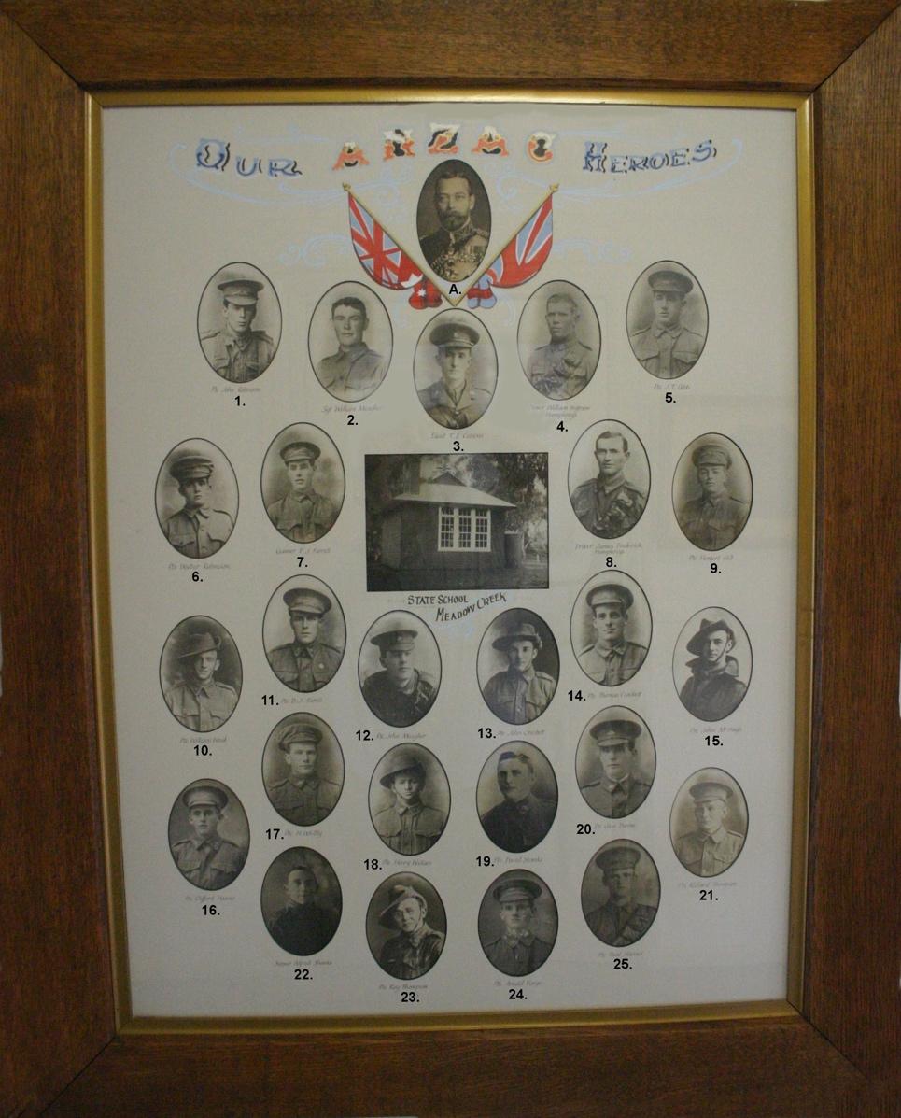

Article unveiling of a pictorial Honor Roll at Meadow Creek State School, The Chronicle 21/8/1918
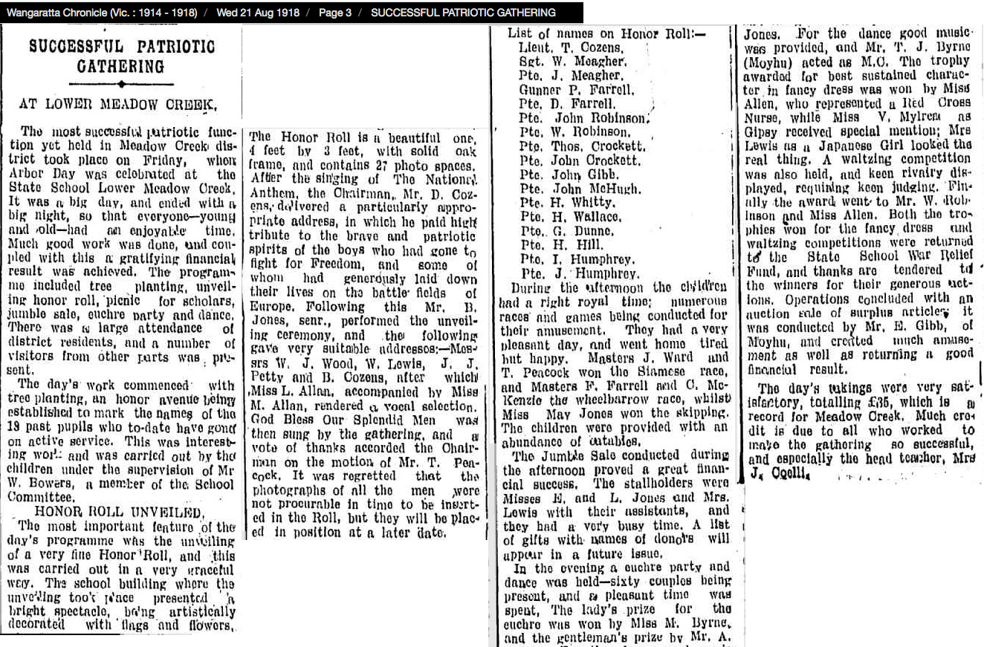

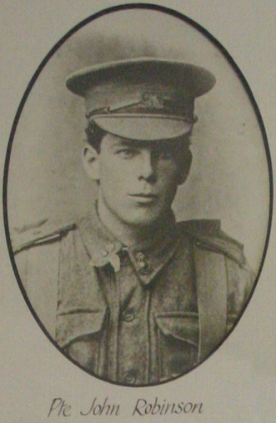 | 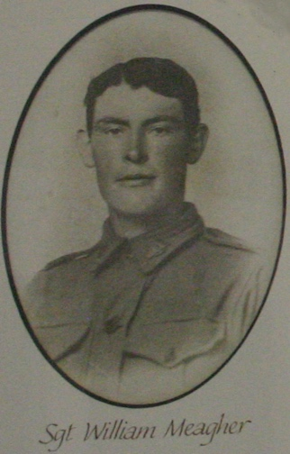 | 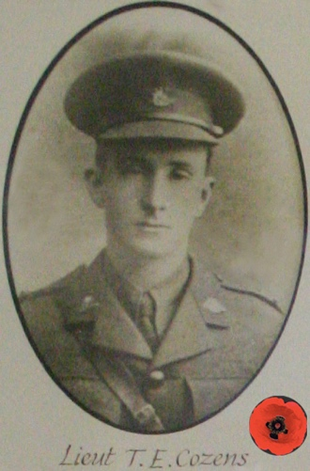 | 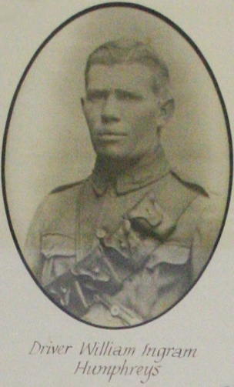
1. Pte John Robinson SN4884, b 10/1894,  E 7/10/1915 7th Bn to  5th Div Arty Col,  Dis 24/5/1919,  P. Mr D Robinson, Bobinawarrah, Vic | 2. Sgt William Meagher MiD, b 9/1894, E 21/9/1914, Inf Brig Train & 7th Coy Army Ser Corps,  Dis 23/1/1919, P: Mrs Meagher, Wangaratta, Vic | 3. Lt Thomas E Cozens SN825, b 6/1892,  E 3/02/1915, 21st Bn  KIA 24/2/1917, Warlencourt, France  P: Evan Cozens, Bobinawarra, Vic | 4. Dvr W. Ingram Humphreys, SN1797,  b 1890, E 3/08/1915, 5th Div Ammun Col, Ret 15/5/1919  P: Edward & Charlotte Humphreys,  Bobinawarrah, Vic
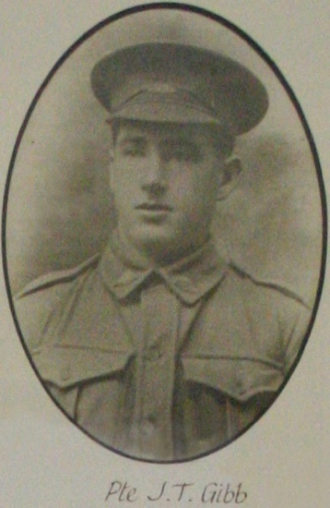 | 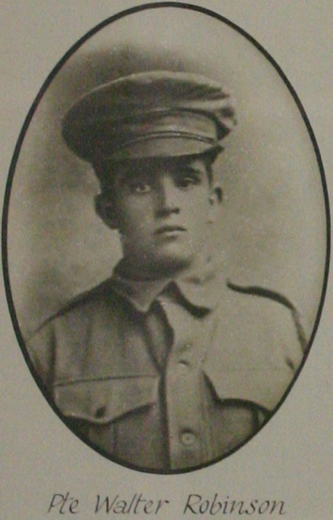 | 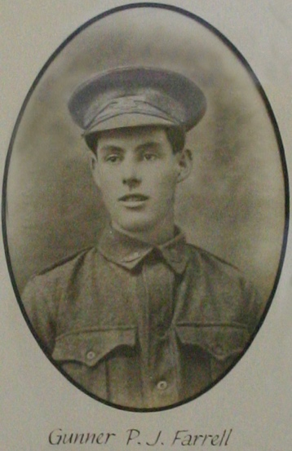 | 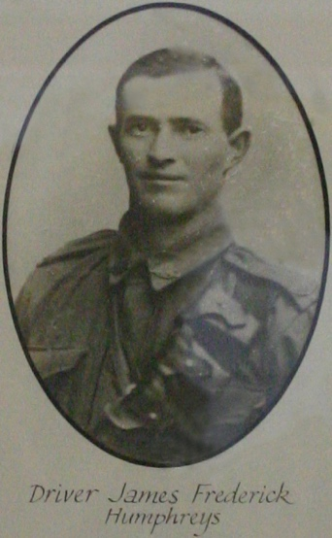
5. Pte John Taylor Gibb SN6748, b 9/1895,  E 16/09/1916, 5th Bn,  Dis 17/4/1919,  d 16/12/1964, P: Mr WD Gibb, Moyhu, Victoria | 6. Pte Walter Robinson SN1659, b 11/1893,  E 7/03/1916, 37th Bn & 59th Bn, Dis 19/10/1917, P: William Robinson, Carboor, Vic | 7. Gnr Patrick F Farrell SN3237, b 8/1/1896,  E 20/01/1917, 4th LH Reg  & 14th Field Arty Brig,  Dis 2/10/1919, d 2/7/1979,  P: Dominick Farrell, Moyhu, Vic | 8. Dvr James F Humphreys SN1798,  b 1888, E 3/08/1915, 5th Div Ammun Col,  Ret 15/5/1919  P: Edward & Charlotte Humphreys, Bobinawarrah, Vic

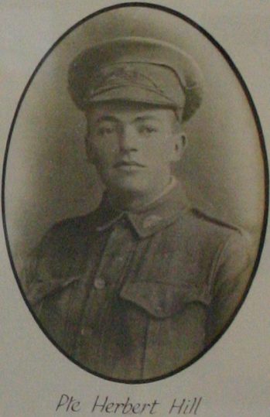 | 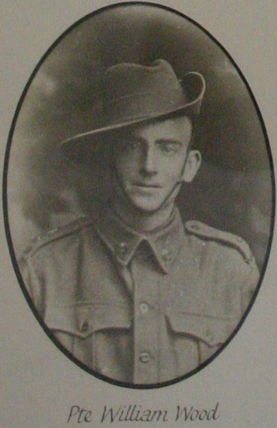 | 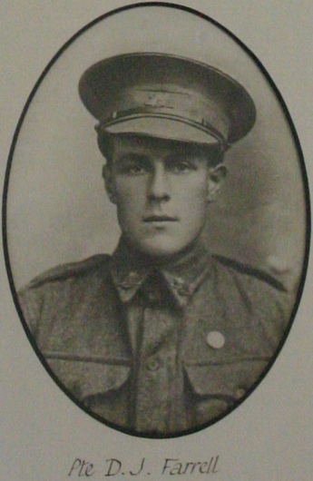 | 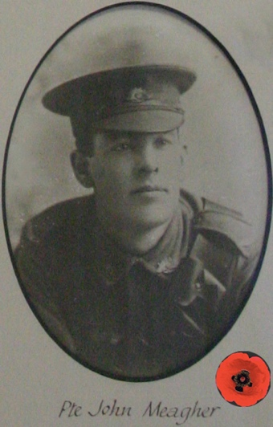
9. Pte Herbert Hill SN2334, b 9/1894,  E 10/03/1916, 37th Bn to 3rd MG Bn, Dis 6/8/1919,  P: Robert Hill,  Carboor, Vic | 10. Pte William Wood SN1055, b 3/1894,  E 25/1/1917, 1st Vet Sect, Dis 21/10/1919, P: Father, W J Wood, Moyhu, Vic | 11. Pte Dominic J Farrell SN2823, b 4/1894,  E 23/09/1916, 37th Bn  & 5th Bn, Dis 12/8/1919, P: Dominick Farrell, Moyhu, Vic | 12. Pte John P Meagher SN2332, b 4/1890, E 27/07/1916, 39th Bn,  KIA 4/10/1917, Broodseinde, Belgium.  P: Mrs Jane Hannan,  Moyhu, Vic
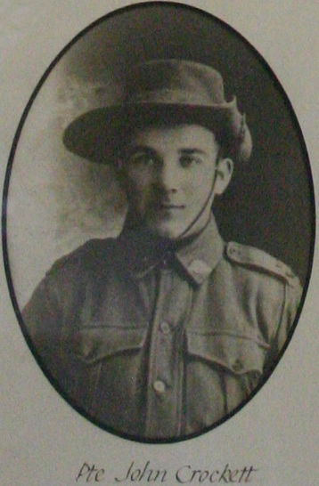 | 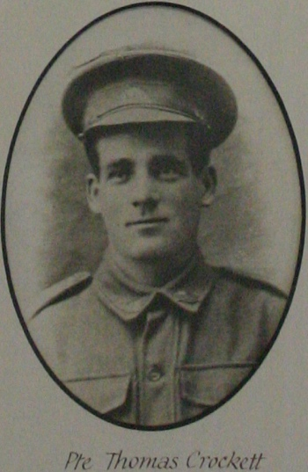 | 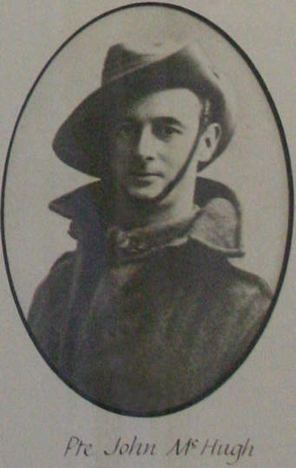 | 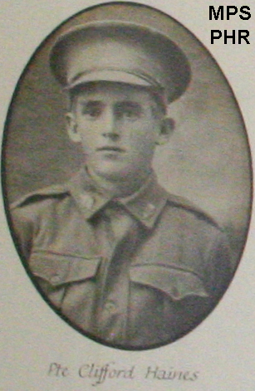
13. Pte John Crockett SN2423, b 5/1898,  E 18/03/1916, 37th Bn to 7th Bn, Dis 5/5/1919, P: Thomas William Crockett, Carboor, Vic | 14. Pte Thomas Crockett V39710, b 1/1893,  E 18/03/1916, D 6/6/1916. Meningitis, Alfred Hos. Melb, P: Thomas William Crockett, Carboor, Vic | 15. Pte John J McHugh SN3353, b 2/1895,  E 13/07/2017, 37th Bn,  Dis 7/8/1919, d 23/1/1956  P: Mother, Mrs A Ward, Dandenong, Vic | 16. Pte (Gnr) Clifford Hains (Haynes) SN1759, b 4/1884, E 4/01/1915  7th Bn to 24th Field Arty  Dis 17/7/1917,  P: Albert & Elizabeth Haynes, Moyhu, Vic

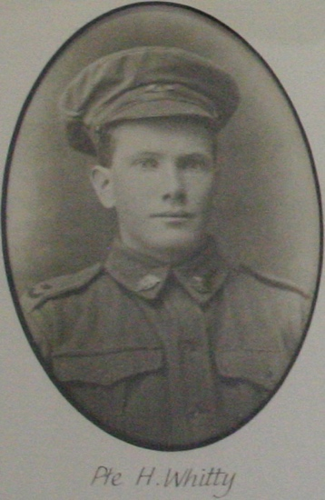 | 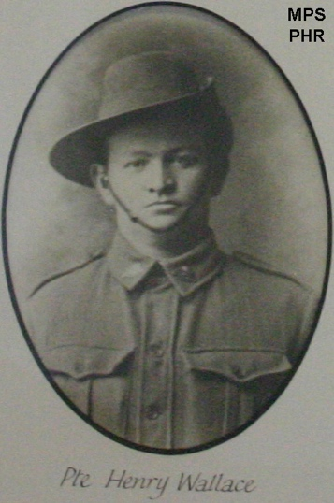 | 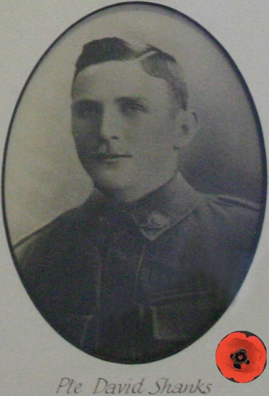 | 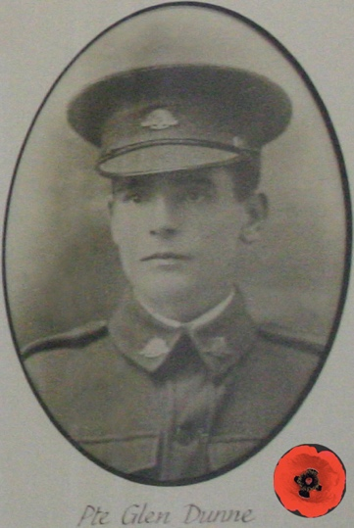
17. Pte Harry Whitty SN2170, b 2/4/1894,  E 1/05/1916, 37th Bn  Dis 14/8/1918,  P: James & Mary Whitty, Whitfield, Vic | 18. Pte Henry Wallace  SN 6835, b 11/1887,  E 2/9/1916, 5th Bn,  Dis 17/3/1919.  F: H Wallace,  Hansonville, Vic. | 19. Pte David Shanks SN3217, b 9/1874,  E 7/11/1916, 48th Bn  KIA 12/10/1917, Zonnebeke, Belgium  P: James C & Rose Ann Shanks, Bobinawarrah, Vic | 20. Pte James G L Dunne SN1175, b 9/1896,  E 19/01/1916,  KIA 7/1/1916, Armentieres, France  P: James & Mary Dunne, Meadow Creek, Vic
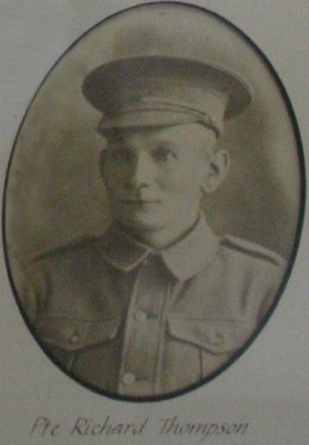 | 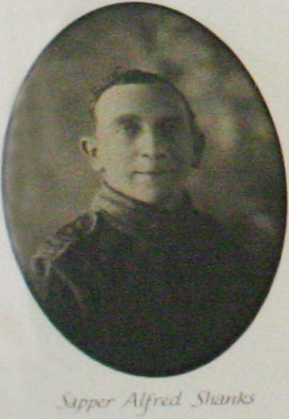 | 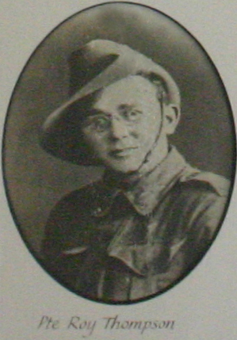 | 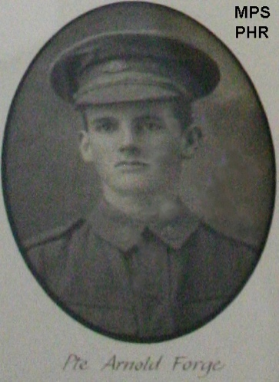
21. Pte Richard Thompson SN459  b 8/1872, E 14/09/1915  1st Remount Unit,  Dis 4/4/1917, W: Mrs Rose Thompson, Bobinawarrah, Vic | 22. Sap Alfred Shanks SN2464, b 2/1878,  E 5/01/1916, 2nd Tunnelling Coy, Dis 18/1/1918,  d 21/2/1959, S: Mrs S J Mybiea, Bobinawarrah, Vic | 23. Pte Roy Thompson SN6902, b 7/1896,  E 9/08/1917, 24th Bn,  Dis 13/3/1919, W: Mrs. E. Thompson, Wahroonga, NSW | 24. Pte (LCpl) Arnold Forge, SN 2063, b 5/1894,  E 1/5/1916, 37th Bn, to 5th Bn  Dis 15/5/1919, d 8/7/1963.  F: Robert Forge,  Myrrhee, Vic

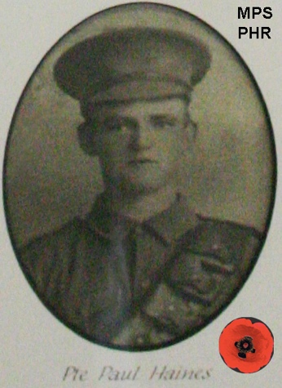 | Abbreviations under soldiers’ portraits  Ranks: Pte = Private, L/Cpl = Lance Corporal, Dvr = Driver, Gnr = Gunner, Bdr = bombardier, Spr = Sapper, Sig = Signaller, Tpr = Trooper, Cpl = Corporal, LSgt = Lance Sergeant, Sgt = Sergeant, Farr Sgt = Farrier Sergeant, CSM = Company Sergeant Major, Lt = Lieutenant,  QMS = Quarter Master Sergeant. Honours: MiD = Mentioned in Despatches,  MC = Military Cross.  Other: Bn = Battalion, LH = Light Horse, Vet =Veterinary, Sect = Section Arty = Artillery, Bde = Brigade, Rgt = Regiment.  SN = Serial number, b = born, E = enlistment, KIA = Killed in action, DOW = died of wounds, DOI = Died of illness in service OS,  Dis = Discharged, d = died after WWI.  Next of kin: P = parents, F = father, M = mother, S = sister, W = wife,  A = aunt.  MPSHR = also included on Myrrhee Primary School Pictorial Honour Board
25. Pte Paul Hains (Haynes) SN1347,
b 7/1897, E 18/03/1916, 37th Bn to 59th Bn, KIA 9/4/1918, Le Hamel, France, P: Albert & Elizabeth Haynes, Moyhu Vic

Table: Meadow Creek Primary School Pictorial Honour Roll, list of men honoured
Average age of enlistment 24 years and 10 months. Five made the supreme sacrifice, four KIA and one died of disease.

# | Name | Service # | VWMA URL
1 | Pte John Robinson | SN4884 | https://vwma.org.au/explore/people/334160
2 | Sgt William Meagher MiD | SN1252 | https://vwma.org.au/explore/people/103674
3 | Lt Thomas E Cozens # | SN825 | https://vwma.org.au/explore/people/310957
4 | Driver W Ingram Humphreys | SN1797 | https://vwma.org.au/explore/people/801664
5 | Pte John T Gibb | SN6748 | https://vwma.org.au/explore/people/328338
6 | Pte Walter Robinson | SN1659 | https://vwma.org.au/explore/people/200706
7 | Gunner Patrick F Farrell | SN3237 | https://vwma.org.au/explore/people/227516
8 | Driver James F Humphreys | SN1798 | https://vwma.org.au/explore/people/801665
9 | Pte Herbert Hill | SN2334 | https://vwma.org.au/explore/people/220251
10 | Pte William Wood | SN1055 | https://vwma.org.au/explore/people/287236
11 | Pte Dominic J Farrell | SN2823 | https://vwma.org.au/explore/people/319981
12 | Pte John P Meagher# | SN2332 | https://vwma.org.au/explore/people/198741
13 | Pte John Crockett | SN2423 | https://vwma.org.au/explore/people/75212
14 | Pte Thomas Crockett# | V39710 | https://vwma.org.au/explore/people/655965
15 | Pte John J McHugh | SN3353 | https://vwma.org.au/explore/people/341423
16 | Pte Clifford Hains (Haynes)* | SN1759 | https://VWMA.org.au/explore/people/294879
17 | Pte Harry Whitty | SN2170 | https://vwma.org.au/explore/people/305663
18 | Pte Henry Wallace* | SN6835 | https://VWMA.org.au/explore/people/143235
19 | Pte David Shanks# | SN3217 | https://vwma.org.au/explore/people/800761
20 | Pte James GL Dunne# | SN1175 | https://vwma.org.au/explore/people/130323
21 | Pte Richard Thompson | SN459 | https://vwma.org.au/explore/people/180231
22 | Sapper Alfred Shanks | SN2464 | https://vwma.org.au/explore/people/136905
23 | Pte Roy Thompson | SN6902 | https://vwma.org.au/explore/people/339907
24 | Pte (LCpl) Arnold Forge* | SN2063 | https://VWMA.org.au/explore/people/217548
25 | Pte Paul Hains (Haynes)*# | SN1347 | https://vwma.org.au/explore/people/210264
# Made the supreme sacrifice, * also on Myrrhee Primary School Pictorial Honour Roll.

