FULLWOOD/BARNES BROTHERS

SERGEANT JOSEPH FULLWOOD MM
1001 – 3rd Tunnelling Company
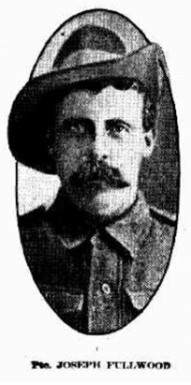
Photo Herald Monday April 24, 1916
Joseph Fullwood was born at Spring Creek, Victoria in 1871 the son of Peter and Margaret (nee Dial) Fullwood. He spent his childhood in Chewton, Victoria and at the age of 11 years the following was reported in the:
Mount Alexander Mail (Vic) Monday 6 March, 1882:
ITEMS OF NEWS
A boy named Joseph Fullwood, living at Chewton, while playing about fell and dislocated his forefinger. He was brought to the Hospital and had the dislocation reduced.

He married aged 22 years in 1893 in Victoria to Ada Thomasine Perkins and later went to the goldfields of Western Australia residing in the Coolgardie district in 1900. News of him was published in the:
Coolgardie Miner Wednesday January 10, 1900:
LOCAL AND GENERAL
The following were the admissions to the hospital on Monday and yesterday—Pritchett Quintrall, Londonderry; Frank Hart, Burbanks, Lawrence Rivers, John Reid, William Tulip and Joseph Fullwood, Coolgardie.

At Gwalia in 1903 they were listed with his occupation of a miner. Two years later the following was advertised in the:
Kalgoorlie Miner Tuesday September 26, 1905:
COOLGARDIE WARDEN’S COURT
Applications for prospecting areas were granted as follows: Joseph Fullwood, No 87 (Golden Queen);
Article abridged

In 1906 they were at the Lady Loch Mine, Coolgardie and in 1910 living at 26 Hesperus Street, Boulder. The following was reported in the:

Daily News (Perth) Monday April 22, 1912:
MAINLY ABOUT PEOPLE
At St Matthew’s Church, Boulder on Easter Monday, when Mr Arthur Ernest Livingstone, eldest son of Mr Alexander Livingstone, of Allendale, Victoria was married to Miss Lillian Perkins, daughter of Mr James Perkins of ‘Euston’, Ballarat. The bride looked charming in her cream canvas voile, with lace and insertion trimmings, orthodox veil wreath and bouquet, was given away by her brother-in-law, Mr Joseph Fullwood, and attended by bridesmaids, Misses Jessie Hamilton and Nina Sala. Mr F.W. Gerhard and Mr Chas. Fullwood officiated as best man and groomsman respectively. After the ceremony the party proceeded to the residence of Mrs J. Fullwood (the bride’s sister), who tendered them a nice breakfast. The reception was held in the Parish Hall, where an enjoyable evening was spent. The wedding presents were numerous and costly.
Article abridged
In 1914 Mrs Fullwood was residing at 19 Herbert Street, Footscray, Victoria and he was working at Bohemia Mine, Marvel Loch, W.A.

A recruiting campaign for miners to enlist with the Mining Corps canvassed the goldfields of the district towards the end of 1915.

At the recruiting depot in Kalgoorlie on 24 November, 1915 the forty-four year old miner from Forrester applied to enlist for active service abroad. Passing the preliminary medical examination personal particulars taken show he was 179cms 5ft 10½ins) tall with a chest expansion of 90-97cms (35½-38ins) and his blue eyes passed the eye test with fair vision in both eyes. A Distinctive mark was a scar on the inside of his left knee. Declared fit his application was accepted by the recruiting officer.

Completed Forms of Attestation describe him further weighing 76.3kgs (168lbs) with a fair complexion, blue eyes and dark brown hair. Religious faith was Church of England. Next-of-kin nominated was his wife Mrs Ada Fullwood, 19 Herbert Street, Footscray, Vic and allotted three-fifths of his pay in support of her and their children. He swore Allegiance to his King and Country the same day.

The following day acknowledgment to the departing volunteers was published in the:
Kalgoorlie Miner Thursday November 25, 1915:
WESTERN AUSTRALIAN EVENTS
MINERS’ CORPS, AIF
Forty-four miners have been accepted for the above corps and by Friday all will have left Kalgoorlie. Following is a list of those who have been accepted:-
F.M. Robertson, T.F. O’Dea, J.G. Pettigrew, H.G. Smith, W. Ritchie, R. Connell, E.W. Stephens, J. Richards, W.C. Kemp, H. Henriksen, J.D. Waddington, H. Lehman, J. Dixon, J.D. Munro, W. Sandercott, H. Porter, H. Jones, E. Cunningham, A. Crotty, G. Boyland, W. Kelly, W.J. Rogers, J.W. Campbell, W. Mahoney, J.D. Eddison, W.F. Horton, J.H. Harvey, A. McCormac, T. Bone, F. Copelin, M. O’Connor, F. Benbow, W. Williams, W.J. Lavers, W.J. Hall, C.C. Grieves, P. McDonald, W. Corcoran, J. Geddes, J. Long, J.K. Macbeth, A. Irving, J. Baxter, J. Fullwood.
Those miners who wish to join later on can enlist in the ordinary way, and if the West Australian quota is not complete they can be taken on at Blackboy Hill.
Basic training commenced at Blackboy Hill camp, near Perth on November 29, 1915 with No.3 Company of the Mining Corps.

The original No.3 Company consisted of Company Headquarters and 3 Sections recruited in the 5th M.D. (Western Australia). The major portion of No.3 Company was recruited by 2nd Lt. L.J. Coulter, A.I.F. who was sent from N.S.W. to W.A. for that purpose.

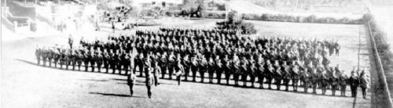Recruiting for the Miners’ Corps began officially on December 1st, 1915. The recruits were placed for basic training the following day at the Helena Vale camp at Blackboy Hill, W.A. as the Corps was being established.
No.3 Company recruits at Blackboy Hill, 3 December 1915 & on Parade - 16 December 1915
Photos courtesy Graeme Williams, grandson of 1202 Spr Charles Williams – 3ATC

No.3 Company, with a strength of 1 Officer and 274 Other Ranks embarked from Fremantle, W.A. on December 18, 1915 and sailed to Sydney, NSW on board the troopship SS Indarra.

On Boxing Day (Dec 26th), 1915 the Unit arrived in Sydney and marched into Casula Camp, near Liverpool, NSW.
They were joined by the 4th Section of the Tasmanian Miners, bringing the establishment strength up to 15 officers and 349 Other Ranks under the command of 2nd Lieutenant L.J. Coulter. Mining Corps Units from all Military districts came together at Casula to complete training as a Corps.

Meanwhile in Sydney, New South Wales a civic parade in the Domain took place on Saturday February 19, 1916, where a large crowd of relations and friends of the departing Miners lined the four sides of the parade ground. Sixty police and 100 Garrison Military Police were on hand to keep the crowds within bounds. The scene was an inspiriting one. On the extreme right flank, facing the saluting base, were companies of the Rifle Club School; next came a detachment of the 4th King’s Shropshire Light Infantry, then the bands of the Light Horse, Liverpool Depot, and the Miners’ on the left, rank upon rank, the Miners’ Battalion.

The Corps boarded HMAT A38 Ulysses in Sydney, NSW on February 20 and sailed for the European theatre. Arriving in Melbourne, Victoria on February 22 the Miners camped at Broadmeadows for a stay of 7 days while further cargo was loaded.

Another parade was held at the Broadmeadows camp on March 1, the Miners’ Corps being inspected by the Governor-General, as Commander-in-Chief of the Commonwealth military forces.

Leaving Melbourne on March 1, Ulysses arrived at Fremantle, Western Australia on March 7 where a further 53 members were taken on board.

His rank was Sapper with the regimental number 1001 and he remained with No. 3 Company.

On Wednesday March 8, 1916 the whole force, with their band and equipment, paraded at Fremantle prior to leaving Victoria Quay at 9.30 o’clock.

The ship hit a reef when leaving Fremantle harbour, stripping the plates for 40 feet and, although there was a gap in the outside plate, the inner bilge plates were not punctured. The men on board nicknamed her ‘Useless’. The Miners were off-loaded and sent to the Blackboy Hill Camp where further training was conducted.

The Mining Corps comprised 1303 members at the time they embarked with a Headquarters of 40; No.1 Company – 390; No.2 Company – 380; No.3 Company – 392, and 101 members of the 1st Reinforcements.

Finally departing Fremantle on April 1, Ulysses voyaged via Suez, Port Said and Alexandria in Egypt. The Captain of the ship was reluctant to take Ulysses out of the Suez Canal because he felt the weight of the ship made it impossible to manoeuvre in the situation of a submarine attack. The troops were transhipped to HM Transport B.1 Ansonia, then on to Valetta, Malta before disembarking at Marseilles, France on May 5, 1916. As a unit they entrained at Marseilles on May 7 and detrained on May 11 at Hazebrouck.

A ‘Mining Corps’ did not fit in the British Expeditionary Force, and the Corps was disbanded and three Australian Tunnelling Companies were formed. The Technical Staff of the Corps Headquarters, plus some technically qualified men from the individual companies, was formed into the entirely new Australian Electrical and Mechanical Mining and Boring Company (AEMMBC), better known as the ‘Alphabetical Company’.

On May 13, 1916 Sapper was assigned to the No. 4 Section of the Company who were attached for duty with the 254th Tunnelling Company, Royal Engineers.

The Unit Diary of the 3rd Tunnelling Company states the following duties carried out:
“On 19/7/16 the 3rd Aust. Tunnelling Company with the 61st Division Infantry attacked opposite Laventie.
The Company was ordered by the Chief Engineer XIth Corps to undertake push-pipe operations prior to the assault to enable communication trenches to be quickly constructed and to throw up crater lips to block machine gun fire.
Cont.

Cont.
Three sites were chosen:
No.1 at N.S.d.10.5 from Rhondda Sap resulting in a crater 220’ long resulting in a crater giving 6’ of cover.
No.2 at N.14.a.10.20 from Red Lamp Salient resulting in a crater 100’ long giving 6’ of cover.
No.3 at N.13.d.48.90 from Red Lamp Salient resulting in a crater 150’ long giving 5’ of cover.
The work was successful but unavailing as the 61st Division did not succeed in holding the ground to enable the craters to be formed into trenches, but the three craters particularly No. 1 were of great value for first aid dressing to wounded who had been collected and placed in the crater.
Two officers Major L.J. Coulter and Capt A. Sanderson (the latter returned to duty) were wounded. In addition to these officers Lt O.R. Howie did gallant work in exploding his push-pipe under heavy M.G. fire and shell fire after leads had been cut by shell fire.”
Sapper Fullwood was wounded in action on 19 July, 1916 receiving a gunshot wound to his left thigh and taken to the 2 / 3 S.M. Field Ambulance and then moved to the 7th Casualty Clearing Station.

The Unit Dairy recorded the following:
“Company Order No.55: 1001 L/Cpl J. Fullwood wounded 19/7/16”
There are no entries in his documents that his rank had changed to Lance Corporal at this time.

On 20 July, 1916 he was conveyed on Ambulance Train No.10 to Boulogne entering the 3rd Canadian General Hospital. The next day was evacuated to England on the hospital ship Cambria and admitted to the Military Hospital in Edmonton for further treatment. Base Records advised his wife on 4 August, 1916 that her husband had been wounded in action and again later named the hospital in England he had been admitted.

His name was among those listed in the 192nd Casualty List published in the:
Sunday Times Sunday August 13, 1916:
THE ROLL OF HONOUR – WOUNDED
Spr J. Fullwood (Footscray, Vic) Article abridged

Sapper proceeded from the Engineers’ Details camp to France on 18 October, 1916 arriving at the Aust General Base Depot the next day. He rejoined his Unit on 30 November, 1916. On December 1, 1916 he was appointed to be 2nd Corporal.

His service continued without incident until 10 March, 1917 when he was to be Corporal due to Corporal R.C. Devon being transferred. On 8 September he was to be Temporary Sergeant when Sergeant Murphy was evacuated. This appointment became Sergeant on 19 November, 1917 as Sergeant Murphy had not returned to duty since evacuated on 14 August.

Three Blue Chevrons were issued on 20 February, 1918 to wear on his uniform for serving two years overseas.

He went sick on 29 August, 1918 to the 47th Field Ambulance for Haemorrhoids and transferred to the 2 / 1 West Lancashire’s Field Ambulance two days later. He was discharged to his Unit on September 9 and rejoined the following day.

The 3rd Tunnelling Company’s Unit Diary recorded the following entry and citation:
In November, 1001 Sergeant Joseph Fullwood was awarded the Military Medal for conspicuous gallantry and devotion to duty during the construction of Machine Gun Posts, Observation Posts and important Tunnels.
Cont.
Cont.
Although frequently subjected to heavy shelling and M.G. Fire he set a fine example to his men and by personal supervision, never failed to keep them continuously employed throughout their shifts until the work was successfully completed.
On 1 November, 1918 Sergeant Fullwood left the field and marched out to the A.G.B.D. in Rouelles and was there when Peace was declared. He proceeded to Havre on November 23 and left France for Southampton on 23 November and reported for duty at A.I.F. Headquarters, London. He was discharged to furlough two days later and to report to the No. 2 Command Depot at Weymouth on 9 December, 1918. He marched in as ordered and remained there to await his return home.

Sergeant Fullwood embarked for Australia from Portland, England on 3 March, 1919 on H.T. Euripides for discharge due to Premature Senility (decline or deterioration of physical strength or mental functioning). Base Records advised his wife on 18 March that he was returning home. His name was published as returning in the:
West Australian Friday April 4, 1919:
RETURNING TROOPS – EURIPIDES
1001 Sgt J. Fullwood Article abridged

Due to his debility he had requested to return to Melbourne (3rd Military District) and not Western Australia. The ship docked in Melbourne on 25 April, 1919.

News of their arrival was published in:
The Argus Friday April 25, 1919:
SOLDIERS DUE TODAY
There will be a double disembarkation of troops today. The Victorians returning on the s.s. Euripides and the s.s. Nevasa will berth at the new pier, Port Melbourne at 11 o’clock and will be conveyed in motor cars to the A.I.F. Depot in Sturt Street, where relatives and friends should await. The procession will follow the usual route and the first cars should reach the city at about a quarter past 11 o’clock.
The party will comprise of 700 men, the majority being invalids. Article abridged

Military Discharge was issued in Melbourne (3rd M.D.) on 9 June, 1919 as medically unfit. Official notification to the 3rd Tunnelling Company that he had been awarded the Military Medal took place on 17 June, 1919. He joined his wife at 19 Herbert Street, Footscray giving his occupation as a miner.

Base Records advised Mrs Fullwood on 18 November, 1919 of the following:

“I have much pleasure forwarding hereunder a copy of the Extract Fourth Supplement No. 31405 to the London Gazette, relating to the conspicuous services rendered by the undermentioned member of the A.I.F.
AWARDED THE MILITARY MEDAL
HIS MAJESTY THE KING has been graciously pleased to approve of the award of the
Military Medal for bravery in the field to the undermentioned:
No. 1001 Sergeant J. Fullwood”

They also advised that this has been promulgated in the Commonwealth of Australia Gazette No. 115, dated 10th October, 1919.

In the After War Report of the 3rd Tunnelling Company the following is recorded:
HONOURS AND AWARDS
3rd TUNNELLING COMPANY
No. Rank Name Award Correct or Approx. Date of Award
1001 Sgt J. Fullwood MM 21/11/18

The Military Medal was forwarded to the Commandant 3rd Military District and received on 19 December, 1919 to present to Sergeant Fullwood at a suitable time.

For serving his country Sergeant 1001 Joseph Fullwood, 3rd Tunnelling Company was issued the British War Medal (35185) and the Victory Medal (34930) to wear with the Military Medal.

The War Medal was collected from Victoria Barracks, Melbourne by him on 27 April, 1922 and he returned and collected the Victory Medal on 31 July.

From 1921 their residence was 114 Gordon Street, Footscray and he was a labourer. In 1928 they were at the Waterloo Hotel, Bendigo and he was a miner. They returned to 198 Gordon Street, Footscray and retired.

A Statement of his Service was requested from Base Records by the Melbourne Branch of the Repatriation Commission and forwarded on 7 March, 1932.

Joseph Fullwood passed away on 28 December, 1934 aged 63 years at Campbellfield, Melbourne. Arrangements were published in the:
Argus Saturday December 29, 1934:
FUNERAL NOTICES
FULLWOOD—The Friends of the late Mr JOSEPH FULLWOOD (late A.I.F.) are respectfully informed that his remains will be interred in the Footscray Cemetery.
The funeral will leave his residence 19 Herbert Street, Footscray, THIS DAY (Saturday) the 29th December) at 11 a.m.
W.G. APPS AND SONS PTY LTD
Mrs Ada Fullwood died aged 60 years on 28 April, 1937. Announcements were printed in the:
Age Friday April 30, 1937:
DEATHS
FULLWOOD—On the 28th April, Ada Thomasine, the beloved wife of the late Joseph Fullwood (A.I.F.), 19 Herbert-street, Footscray, loving mother of Joseph (deceased), Charles, William (deceased), Peter and Eric, aged 60 years. Sweet rest.
FUNERALS
FULLWOOD—The Friends of the late Mrs ADA THOMASINE FULLWOOD are respectfully invited to follow her remains to the place of interment in the Footscray Cemetery. The funeral is appointed to leave from her residence, 19 Herbert-street, Footscray, THIS DAY (Friday), 28th April, at 11 o’clock,
HERBERT KING and SONS,
Undertakers – Footscray

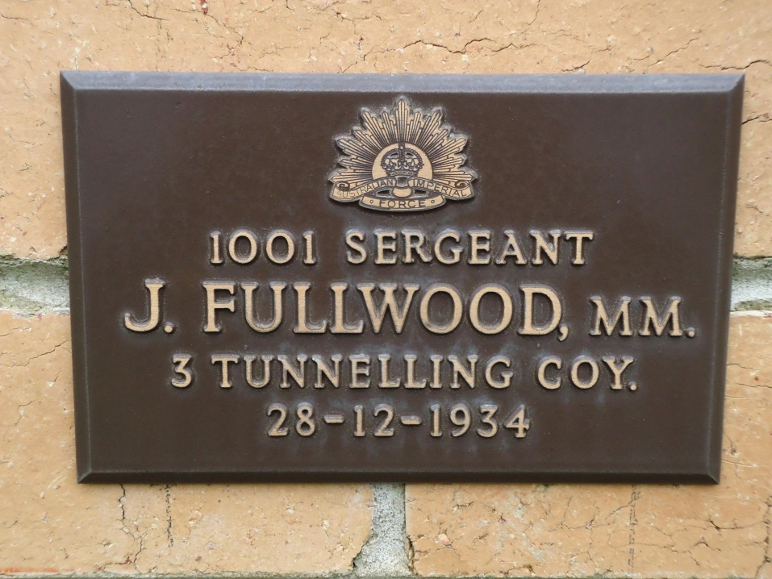Their grave is located in the Church of England portion of Footscray Cemetery within section FO-CE C in grave no. 1172.

His name and service is commemorated by a War Service Plaque in the Victorian Garden of Remembrance in the Springvale War Cemetery on Wall 21, Row E.

Commemorative Plaque Sergeant J. Fullwood MM
Victorian Garden of Remembrance, Melbourne
Photo supplied by Dept. Veterans Affairs and used with permission

His step-brothers also served.
SAPPER THOMAS BARNES
4269 – 3rd Tunnelling Company

Thomas Barnes was born in Castlemaine, Victoria in 1884 the son of John and Margaret (nee Dial) Barnes. He went to Western Australia and was working at Carnarvon in 1915.

At the recruiting depot in Carnarvon on 2 February, 1916 the single thirty-two year old labourer applied to enlist for service abroad and passed the preliminary medical examination. Declared fit his application was accepted by the recruiting officer.

Acknowledgement to the departing volunteers was published in the:

Northern Times Saturday February 12, 1916:
THE EMPIRE’S NEED
SEND-OFF TO RECRUITS
An extremely successful social, organised by the local branch of the Red Cross Society was held in the Masonic Hall of Friday night (4th instant) as a send-off to Mr Gilchrist, M.L.A. and Messrs Hicks, Angell, Barnes, Morton, Nilsson, McDonald, Bond Merry and Arnott, whom he is taking down with him to go into camp at Blackboy Hill. The hall was crowded, and all present vied with each other in showing their appreciation of their Member’s action and that of their fellow townsmen in deciding to volunteer for service at the front.
During the evening songs were rendered by Messrs Gilchrist, Moran, Fred Atkinson and Mrs Roberts, and dancing was indulged in till a late hour, everyone present having spent a most enjoyable time. As a result of the social, the funds of the Red Cross Society will benefit to the amount of about £7. Article abridged
Re-assessed at Blackboy Hill camp, near Perth on February 14 he was described as being 163cms (5ft 4ins) tall, weighing 63.6kgs (140lbs) with a chest expansion of 84-94cms (33-37ins). Fair in complexion with blue eyes and light brown hair and no distinctive marks. Church of England was his religion. Next-of-kin nominated was his father John Barnes of Specimen Hill, Chewton, Vic. He swore allegiance to King and Country on February 14 and allotted for basic training to Area 2 of the camp then transferred to the 53rd Depot Battalion on March 3. A week later on March 10 was assigned to the No. 6 Tunnelling Company.

Recruiting for the No. 6 Tunnelling Company had officially commenced on March 7, 1916 by Captain Lawson and his four officers. Instruction classes were formed of officers and N.C.O.’s as there was insufficient time to attend the Engineer’s School in Sydney. Recruits were forthcoming in abundant numbers and the aim was to have good physical types of skilled W.A. Miners.

At Blackboy Hill camp the new company paraded daily with sister companies until March 27 when the Company moved camp to Belmont camp. Barnes arrived at the camp where four sections were created and training continued through April and May. His rank was Sapper with the regimental number 4269. The remainder of May was occupied in the usual training: musketry, trench work and night work while equipment and clothing issue was also in progress. Here a difficulty was met in that the general size of the men was considerably above the average and some little trouble was experienced in getting all accurately fitted.

In Queensland early in May, 1916 the No. 4 Tunnelling Company consisting of six officers and 152 other ranks together with the 1st Reinforcements of fifteen other ranks making up two sections, embarked from Brisbane, Qld aboard HMAT A69 Warilda for Sydney, NSW.

At Rosebery Park, Sydney, NSW they joined their Headquarters and two sections (8 officers & 153 O.Rs.) plus 1st Reinforcements consisting of one officer and seventeen other ranks for final training.

The 7713-ton transport Warilda departed Sydney, NSW on May 22, 1916 and collected in Melbourne, Victoria the No. 5 Company recruited from Victoria, South Aust. & Tasmania made up of Headquarters and 2 Sections (8 officers & 173 men) (3 M.D.). One Section from Tasmania (3 officers & 76 O.Rs); also 1st Reinforcements for No. 5 Company (17 men from Vic. & 8 men Tas.) The ship departed on May 25, 1916 for Adelaide, S.A. to collect one Section of 3 officers & 76 O.Rs with 1st Reinforcements of 8 O.Rs.
The No. 6 Company paraded through the city of Perth where the fine physique of the men, who marched with arms bare to the elbow excited universal admiration.
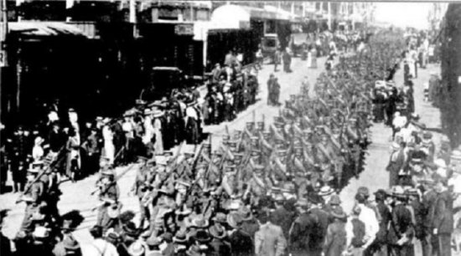
Western Mail June 1, 1916: –
Tuesday’s parade of troops. The No.6 Tunnelling Company and the members of the N.C.O. School,
Claremont, marching through the city.

The transport arrived in port at Fremantle, W.A. on June 1, 1916. The whole company consisting of 14 officers and 325 O.Rs along with 1st Reinforcements of 1 officer and 32 O.Rs entrained at Belmont at 2 p.m., every man physically fit being present and boarded Warilda which left the harbour the same evening.

Durban, South Africa was reached on June 16, 1916 and Cape Town on June 21, 1916 while St Vincent completed the African ports of call on July 7, 1916. Discipline was fairly good except at intermediate ports where Away without Leave caused concern. The fifty-eight day voyage experienced remarkable pleasant weather terminating at Plymouth, England on July 18, 1916. Four, Five and Six Companies comprising of 1064 officers and other ranks were detrained to Amesbury and Tidworth to begin training for the front at Perham Downs.

On 22 September, 1916 the Companies departed from No. 3 Details camp at Parkhouse for France arriving at the 2nd Aust General Base Depot the next day. On October 12 left for the 1st Anzac Reinforcements camp and four days later assigned to the 1st Anzac Entrenching Battalion which was an advanced section of the Base Depot that organised works near the lines and through duties, usually of ten days duration, would accustom the reinforcements to war conditions before being assigned to a company in the field. Sapper was assigned on October 26 to the 1st Canadian Tunnelling Company.

He was taken on strength with the 3rd Tunnelling Company in the field on 31 January, 1917.

Two Blue Chevrons were issued to wear on his uniform on June 1, 1917 for serving one year overseas.

Disciplinary action was taken for the following:
Offence: Late on Working Parade
Award: Forfeits 2 day’s pay by Major Sanderson 3/10/17

On 27 November, 1917 Sapper appeared before a Field General Court Martial at Les Brebis.
Charge: Taking himself without leave from his unit from 23 October
till November 12, 1917
Finding: Guilty
Sentence: 28 days F.P. [Field Punishment] 27/11/17
Period awaiting trial: 2/11/17 to 26/11/17 (25 days)
Total forfeiture: 63 days
Confirmed: Brigadier-General F. Sprine Commander 32nd Inf. Brigade 30/11/17

The Kalgoorlie Ladies sent comforts to the men and a thank-you letter signed by all recipients was returned and printed in the:
Kalgoorlie Miner Tuesday April 16, 1918:
TUNNELLERS’ COMFORTS
MEN WHO RECEIVED THEM
Sometime ago gifts were despatched to the front by the No. 1 Tunnelling, Pioneers and Engineers committee, and a list of recipients has now been received by the secretary, Mrs R.M. Jordan as follows—No. 4269 T. Barnes Article abridged

He went sick on 28 June, 1918 to the 34th Field Ambulance with P.U.O. (Pyrexia (fever) of uncertain origin) and transferred to the 1st Canadian Casualty Clearing Station. On July 5 was conveyed on Ambulance Train No.28 to Boulogne entering the 14th General Hospital with laryngitis. Two days later went to the 1st Convalescent Depot and a day later was discharged to the Base Depot as fit. He left the A.G.B.D. in Rouelles on 17 July and rejoined his unit two days later.

Sapper Barnes was killed in action on 31 July, 1918 in the field. The Unit Diary of the 3rd Tunnelling Company gives the following extract for that day:

“On 31/7/18, 4269 Spr Barnes, T was killed.”
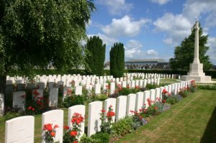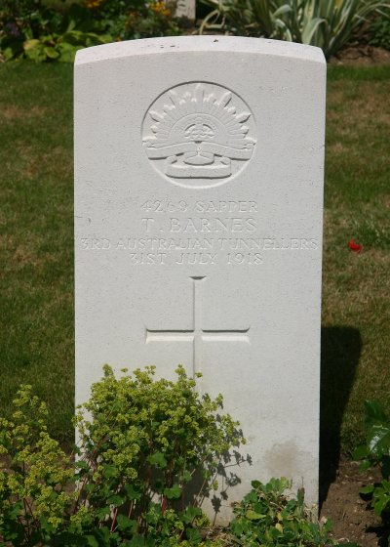
His burial was reported to be officiated by Rev. W.E. Burkitt, the Company’s attached padre, in Hersin Communal Cemetery Extension, France 5¼ miles south of Bethune.

His grave is located in section three within row A in grave no. 3.

Photo of headstone by kind permission of
The War Graves Photographic Project - www.twgpp.org
Military Authorities in Western Australia were advised on 9 August, 1918 of his demise and a confirmation cable was returned to London on 12 August. A copy of his war service was made for the Pension Department two days later.

News of his death was published in the:
Bendigo Independent Tuesday 13 August, 1918:
CASTLEMAINE SOLDIERS
KILLED IN ACTION
Sapper T. Barnes, son of Mr Barnes, of Specimen Hill, Chewton, who enlisted in West Australia, has been killed in action on July 31. This makes the fifth brother to be killed at the war. These gallant fellows were brothers of Mrs David Roderick, of Castlemaine, whose eldest son also paid the great price of patriotism.

The Argus Tuesday August 13, 1918:
FAMILY’S SACRIFICE – FIVE SONS KILLED
CASTLEMAINE, Mon.
Sapper T. Barnes of Specimen Hill, Chewton was killed in action in France on July 31. He was the fifth son of a family who made the supreme sacrifice.

Bendigo Advertiser Tuesday August 27, 1918:
NORTHERN VICTORIANS – KILLED IN ACTION
Sapper T. Barnes, Chewton. Article abridged

Base Records wrote to his father on 30 November, 1918 referring to the regrettable death of his son being in receipt of advice that he was killed in action on 31 July, 1918 and burial took place at Hersin Cemetery with Rev. Burkitt officiating.

Utmost care and attention was being devoted to the graves of soldiers and was understood that photographs would be taken as soon as possible and transmitted to next-of-kin. The writer advised that details were furnished by direction of the policy of the Department to forward all information received in connection with deaths of members of the Australian Imperial Force.

A copy of his Will from his Pay Book from A.I.F. Headquarters was filed on 10 December, 1918. He bequeathed all of his effects to his step-sister-in-law Mrs Ada Fullwood, 19 Herbert Street, Footscray, Vic.

The Commonwealth Savings Bank, Melbourne wrote on 8 February, 1919 to Base Records requesting the Certificate of Death and his next-of-kin. Records forwarded the Certificate and advised that his father was next-of-kin and gave his address.

The Bank wrote again on 17 March, 1919 requesting the same. Records replied with the next-of-kin information on 19 March.

Mrs Fullwood also requested a Certificate of Death on 3 March, 1919 and Records forwarded the Certificate on March 11.

A Form and Booklet were posted to his father on 1 December, 1919.

In the After War Report of the 3rd Tunnelling Company the following was recorded:

3rd Australian Tunnelling Company
Killed or Died of Wounds
No. Rank Name Casualty Locality Date Buried at
4269 Spr Barnes, T. Shell Givenchy 31/7/18 Hersin

On 3 March, 1920 photographs in triplicate were transmitted to his next-of-kin and a further batch of the same were sent on 1 December, 1921.

For his supreme sacrifice Sapper 4269 Thomas Barnes, 3rd Tunnelling Company was issued with the British War Medal (41102) and the Victory Medal (40863).

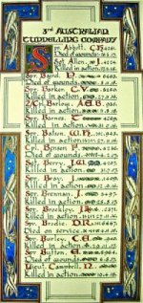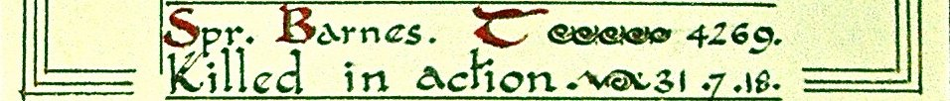
The Sydney Morning Herald - Saturday 23 July 1921:

ENGINEERS' ROLL OF HONOUR
The Royal Engineer War Memorial Committee are arranging to deposit a roll of honour of all ranks of the Royal Engineers whose names were officially published as killed in action or died of wounds or disease in the war in the chapel of St. Paul's Cathedral, and the Engineer corps of the dominions, colonial, and Indian armies have been invited to deposit similar rolls of honour in St. Paul's, to be attached to that of the Royal Engineers. This invitation has been accepted in Australia. The roll will be inscribed on vellum and enclosed in a casket of Australian timbers to rest on a slab of Australian marble.

This extract from Tunnellers Roll of Honour included in profile with the kind permission of the
Dean and Chapter of St Paul’s Cathedral, London
Photos courtesy of Robin Sanderson, Paris

The War Medal was forwarded on 3 March, 1922 to the Commandant 3rd Military District and sent out by post to his father and signed for on 22 September, 1922.

The Victory Medal was also sent by registered mail on 9 March, 1923 and receipted on March 22.

The Memorial Scroll (348430) and Memorial Plaque (348430) were mailed to his father on 30 March, 1922 and 13 November, 1922 respectively. These were receipted by him on 9 April, 1922 and 21 November, 1923.

A reminder was posted on 10 February, 1923 in regards to outstanding Form “A” on Hersin Communal Cemetery Extension.

On 6 January, 1926 a Register Order Form was dispatched to his father re Hersin Cemetery in France.

His name is commemorated on Panel 26 in the area of commemoration at the Australian War Memorial.

Names of soldiers were prepared for the State War Memorial and announced in the:

Western Mail Thursday July 17, 1930:
STATE WAR MEMORIAL
NAMES FOR TABLETS
To ensure that the memory of those West Australians who made the supreme sacrifice during the Great War shall endue for all time the walls of a special section in the basement of the State War Memorial have been set apart to carry their names. A list of 6,000 names has been prepared, and the first section of this is published hereunder. Abridged to Tunnellers

Spr. ABBOTT, Charles Henry, 3rd Tun. Coy. Sgt. ALLEN, Joseph, 3rd Tun. Coy.
Spr. BARNES, Thomas, 3rd Tun. Coy. Spr. BARRETT, Charles, 1st Tun. Coy.
Cpl. BENSON, Frederick, 3rd Tun. Coy. Sgt. BERRY, James Webster, 3rd Tun. Coy. MM
Spr BERRY, Wilfred, 2nd Tun. Coy.

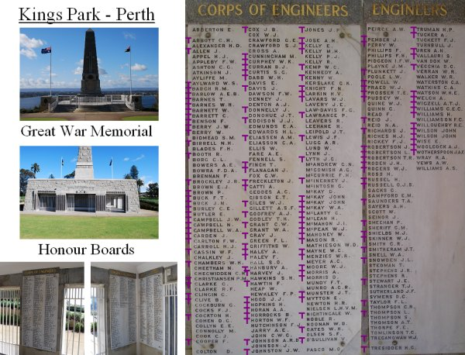LEST WE FORGET
added by tunnellers.net

PRIVATE JOHN BARNES alias PETER FULLWOOD
3059 – 28th Battalion

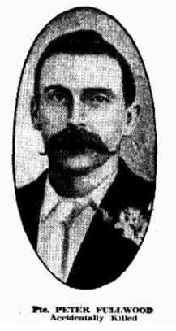Peter Fullwood was born in 1873 at Springdallah, Victoria, the son of Peter and Margaret (nee Dial) Fullwood. He went to the Western Australian goldfields and married in Coolgardie district in 1899 to Ettie Gulliver and they had three children. He was mining at Southern Cross, W.A.

At forty-two years of age he enlisted for active service abroad at Kalgoorlie on 2 September, 1915 taking his step-brother’s name of John Barnes and passed the medical examination. Stated he was born in Ballarat, Vic, was unmarried and gave his next-of-kin as his father John Barnes of Specimen Hill, Castlemaine, Vic.

Described as 183cms (6ft) tall, weighing 82.7kgs (182lbs) with a chest expansion 93-99cms (36½-39ins) and had a medium complexion with blue eyes and brown hair turning grey. Church of England was his religion. He was sworn in at Blackboy Hill camp, near Perth on September 8.

Assigned to the Reinforcements to the 28th Battalion in the rank of Private with the regimental number 3059 for basic training and on 1 November allotted to the 7th Reinforcements to the 28th Battalion.

On December 19 in the evening before his Unit was to embark overseas he fell from the balcony of the Midland Junction Hotel. Military authorities state he was picked up at 6.30 a.m. and taken to the No. 8 Aust General Hospital at Fremantle with injuries of a fractured skull, injured pelvis and ruptured bladder.

His father was notified by telegram and he lingered until 26 December, 1915 dying at 2 a.m. that morning.

Interment after a military funeral took place in the Anglican portion of Fremantle cemetery within section AA in gravesite No. 1627. His grave is marked with a Commonwealth War Grave headstone.

An inquiry was held by authorities. His wife Ettie Fullwood of Johnstone Street, Castlemaine, Vic applied for a military pension for herself and their children but was rejected as he had been A.W.L. at the time of his accident. After the war she was offered his military mementoes of the Memorial Plaque and Scroll (596599) but rejected these. His brother William Fullwood in West Footscray, Vic applied for them.

His memorial plaque in the Fremantle Cemetery reads:
A.I.F.
3059 Pte Peter Fullwood
28th Battalion
Died 26 December, 1915
Served as 3059 John Barnes

His name is commemorated on panel 113 in the Commemorative Area of the Australian War Memorial.

PRIVATE JOHN BARNES
2872 – 51st Battalion

John Thomas Barnes was born in 1882 at Fryer’s Town, near Castlemaine, Victoria the son of John and Margaret (nee Dial) Barnes. He was educated at Spring Gully School and went to mine at the goldfields in Western Australia.
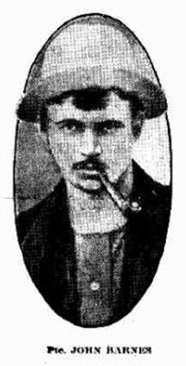He enlisted for service at Blackboy Hill camp, near Perth on 23 June, 1915. Personal details taken were his height of 165cms (5ft 5ins) tall, weighing 64.5kgs (142lbs) with a chest expansion of 86-92cms (34-36½ins) and had a dark complexion with blue eyes and black hair. Religious faith was Church of England. Next-of-kin nominated was his father John Barnes of Specimen Hill, Chewton, Vic.

Allotted to the 11th Battalion 9th Reinforcement his rank was private with the regimental 2872.

The Reinforcement embarked from Fremantle on HMAT A20 Hororata on 1 October, 1915 for the Suez. Transferred on 8 January, 1916 at Tel-el-Kebir was taken on strength with the 51st Battalion. They joined the B.E.F. in France.

Private Barnes was reported missing in action on 8 September, 1916. The Red Cross Bureau conducted an inquiry and located a witness who recorded the following statement:
BARNES, J. 2872
ASHE, J.V. 3469
Pte H. Worthington 2852 - D Coy reported:
They were killed at Mouquet Farm on September 3. Pte Cook, B Coy, batman to Lieut. Morell was alongside them when they were killed in the charge. Cook gave me the facts himself and could supply details. Ashe was a battalion bomber as was Barnes. Ashe came from W.A. and Barnes came from the goldfields. I knew them both well.

A Court of Inquiry was held by the Military and was deemed the forty year old soldier to have been killed in action on 3 September, 1916. A location where he was buried was given as East of Thiepval, 4 miles N.E. of Albert, France.

After the war lone graves were located and brought to Military Cemeteries and he was reinterred in Regina Trench Cemetery, Grandcourt, Picardie, France in section 8 within row H in grave no. 8.

For his supreme sacrifice Private 2872 John Barnes, 51st Battalion was issued with the 1914-15 Star (4574), British War Medal (19860) and the Victory Medal (19786) plus the Memorial Plaque and Scroll (323361).

His name is commemorated at the Australian War Memorial in the commemorative area on panel 152.

LEST WE FORGET

PRIVATE GEORGE BARNES
565 – 7th Battalion

George Barnes stated he was born in Footscray, Melbourne, Vic but his father gave Fryer’s Town on 26 October, 1891 as his birthplace and date.

He was working in a Tannery when he enlisted for active service in Footscray on 20 August, 1914.

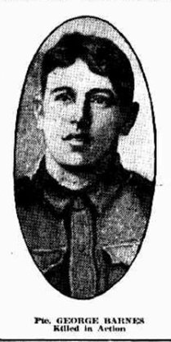Forms of Attestation describe him as 175cms (5ft 9ins) tall, weighing 70.9kgs (156lbs) with a chest measurement of 94cms (37ins). Next-of-kin nominated was his father John Barnes of Castlemaine, Vic. He signed and took ‘the Oath’ the same day.

Allotment was with the 7th Battalion with the regimental number 565 in the rank of Private. The troops boarded in Melbourne on HMAT A20 Hororata departing on 19 October 1914 for the Suez.

They departed for the Gallipoli Campaign on H.M.T. Galeka from Alexandria on 5 April, 1915.

Private Barnes was killed in action on 26 May, 1915 aged 22 years.
A newspaper report states he was killed by a sniper in Shrapnel Valley.

Burial took place in Shrapnel Valley Cemetery, near Anzac Cove in section 11 within row D in grave no. 17.

The 1914-15 Star (7697), the British War Medal (1810) and the Victory Medal (1816) were issued to Private 565 George Barnes, 7th Battalion for his supreme sacrifice.

On panel 49 in the commemorative area of the Australian War Memorial his name can be located.

LEST WE FORGET

PRIVATE HERBERT BARNES
1201 – 5th Battalion

Born in Castlemaine, Victoria on 26 June, about 1893 the son of John and Margaret (nee Dial) Barnes he was named Herbert Barnes.
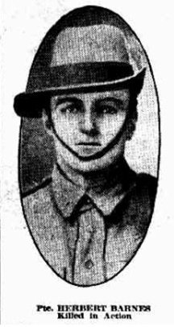At 21years of age he enlisted for service abroad on 18 September, 1914 in Melbourne, Victoria.

Attestation Forms reveal he was 169cms (5ft 6½ins) tall, weighing 63.6kgs (140lbs) with a chest expansion of 88-93cms (34½- 36½ins). Medium was his complexion with blue eyes and light brown hair. Religion was Roman Catholic. Next-of-kin nominated was his sister Mrs H.E. Williamson of Footscray. The ‘Oath to King and Country’ was taken the same day.

He was assigned to the 5th Battalion ‘B’ Company in the rank of Private with the regimental number 1201 and the troops embarked from Melbourne on board HMAT A32 Themistocles on 24 December, 1914 for the Suez.

They departed Alexandria to join the Gallipoli Campaign on 5 April, 1915. He was evacuated for medical treatment at Alexandria and embarked on 14 July, 1915 on the transport Itonus rejoining his Battalion at Anzac five days later.

Private Barnes was killed in action between 14 and 16 August, 1915 at 22 years of age. He has no known grave and memorialised on Lone Pine Memorial, Anzac Cove, Gallipoli, Turkey.

At the Australian War Memorial in the commemorative area his name appears on Panel 42.

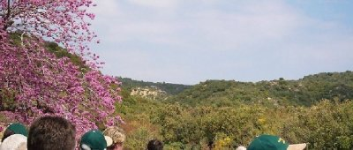The following was published in the Herald dated 24 April, 1916 on his bravery in the field:
Private Herbert Barnes, 22, was the youngest member of the family. He fought his last fight at Lonesome Pines on 14 August, 1915, B Company 15th Battalion, of which he was a member, received orders to hold a trench with some men of the 7th Battalion. For 48 hours they held on grimly and four Victoria Crosses were won by men on duty in the trench. Private J. Owens, one of the survivors, tells the story of Private Barnes valour as follows:
“Private Barnes, while observing, was wounded in the mouth by a bomb, and knocked off the parapet. He started to run to get out of the way of the explosion when he thought of some engineers and other men who were working a few yards away building up the trenches and filling up sandbags.
There were plenty of overcoats and blankets lying about. They were used for the purpose of throwing over the bombs as they came among us, and, picking up one of these without a thought of danger for himself he rushed to the bomb and covered it over. He did it just in time, for it exploded a second later without doing any damage. There was no doubt that his presence of mind saved several from being severely wounded, if not killed.
“That was not all that chap did. He was told to go and have his mouth dressed at the hospital station on the beach. But he replied, “Never mind, I will be alright in an hour or two: I know that every man is wanted. God knows that what he said was true. There were 80 left to represent a company of 220. About 20 of these were either exhausted or their nerves shattered to such an extent that they could not be trusted to man a trench.
“Next night, while on the same post a bomb came and killed Barnes. If ever there was a game lad he was one.”
Shrapnel Valley, Gallipoli, Turkey 2005

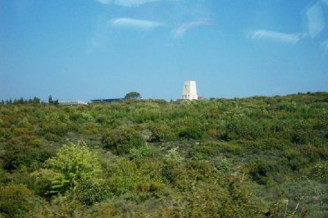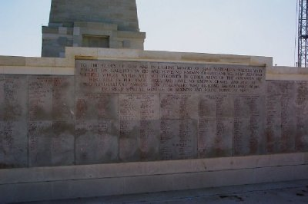
Lone Pine Memorial, Gallipoli, Turkey 2005

LEST WE FORGET

PRIVATE EDWIN BARNES
53894 – 28th Battalion (New Zealand Force)

Edwin Barnes stated he was born on 26 December, 1890 at Cobar, Australia the son of John and Margaret Barnes. He said he was married in 1916 with one child and a gold miner working at the Waihi Gold Mining Company, Waihi, NZ. His previous military experience was 5 years with the Australian Light Horse until leaving Australia.

At Hamilton, N.Z. on 24th April, 1917 the twenty-six year old enlisted for service abroad. Personal details taken show he was 175cms (5ft 9ins) tall, weighed 65.4kgs (144lbs) with a chest expansion of 82-92cms (32-36ins) having a dark complexion, hazel eyes which passed the eye test with good vision and brown hair. Religious faith was Church of England. Next-of-kin nominated was his wife Mrs Harriett Ethel Barnes of Burgess Street, Te Aroha.

His rank was Private with the regimental number 53894 with ‘B’ Coy 4th Otago Regiment. After 134 days training embarkation commenced on HMNZ T89 on 14 July, 1917. He overstayed leave in Capetown and was transhipped to the transport H.M. Norman on 28 August, 1917 and disembarked at Plymouth on 24 September, 1917. Proceeded overseas to France on 14 April, 1918 and assigned to 2nd Battalion Otago Regiment on 8 June. After the Armistice he was an absentee from 30 November, 1918 and noted still absent on 22 May, 1919. Presented himself in England and appeared before a District Court Martial at Torquay and found guilty on both charges described and sentenced on 10 January, 1920.

Private Barnes embarked for New Zealand on 15 January, 1920 on S.S. Athenic. Military Discharge was issued on 24 April, 1920 after spending 2 years and 235 days overseas.

The British War Medal and Victory Medal were issued for service for his country to Private 53894 Edwin Barnes, 2nd Battalion Otago Regiment, NZ.

In 1928 he was a miner living at Clark Street, Waihi, NZ and by 1935 had returned to Burgess Street, Te Aroha, Auckland being a pensioner and from 1946 to 1949 was living at Boundary Street, Te Aroha and a retired miner. Mrs Barnes was listed residing at Lipsey Street, Te Aroha in 1949.

Edwin Barnes passed away in June, 1953 in Te Aroha, Auckland, NZ.

Mrs Harriett ‘Ettie’ Barnes died on 3 February, 1956 aged 67 years and she was buried in Tahuna Maukoro Cemetery, Waikato, Auckland, NZ.

PRIVATE HARRY LESLIE BARNES
40481 – 3rd A.I.R. (New Zealand Forces)

Harry Leslie Barnes was born in Chewton, Victoria in 1886 the son of John and Margaret (nee Dial) Barnes. He went to New Zealand and was registered residing at Greenhills, Awarua working as a quarryman 1911 to 1914. In 1916 he was bushfelling at Mataura Island, Southland.

His father had written to authorities asking that his son Harry be exempt from service due to the loss of several of his sons

At the recruiting depot in Auckland, NZ on 28 September, 1916 the farmer enlisted for active service abroad and passed the medical examination. Deleting a few birthdays to twenty-five years by giving his birthdate as 15 April, 1891 was accepted and sworn in the same day. Personal details taken show his birthplace as Canada and named his father as Joseph to conceal his identity and was 178cms (5ft 10ins) tall with black hair, brown eyes and a ruddy complexion. Presbyterian was his religious faith. Next-of-kin nominated was J.E. Miller, Clevedon and later changed to his brother J.E. Barnes of 15a Park Avenue, Auckland.

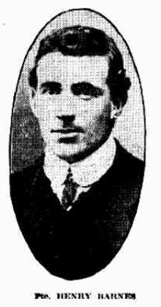Basic training assignment was with ‘A Coy’ 23rd Depot Battalion from 14 November, 1916. His rank was private with the regimental number 40481.

Embarked on 14 March, 1917 on the transport HMNZ T79 Ruapehu and during the voyage was treated in the ship’s hospital for German measles. Troops arrived at Devonport, England on 21 May, 1917. Proceeded overseas to France on 22 June and taken on strength with 3rd A.I.R. on 8 September, 1917.

Suffered right Inguinal Hernia on 17 October, 1917 and evacuated to Etaples and then to Codford, England and after treatment in several hospitals during February, 1918 appeared before a medical board where he was diagnosed with Chronic Bronchitis on 15 October, 1918. Other medical conditions were recorded was 4 years prior to enlistment he suffered pneumonia and enteric fever and probably had old right apical tubercule. Condition became worse due to service. Present condition: looks well – well-built man – pain across lower part of chest – shortness of breath – not losing weight – cough and stricture – diminished resonance at apex – loud rhonchi (wheezing) as both bases – no ? in heart – acne improving – sputum – TB not found.

He was still at Codford when Peace was declared.

Private Barnes embarked at Liverpool, England for home after one year and 302 days abroad on board H.T. Manganui on 2 December, 1918.

After two years and 65 days serving his country military discharge was issued on 6 February, 1919.

He was issued with the British War Medal and the Victory Medal.

In 1919 he was registered at Park Road, Newmarket, Auckland with the occupation of farmer. He married in 1923 to Gladys Vera Shaw. They were living from 1935 to 1938 at Clevedon, Auckland and from 1946 at East Road, Clevedon working as a farmer. In 1957 he was at Alma Street, Awarua, South Island. He was a labourer living at Alma Street, Wyndam in 1963.

Harry Leslie Barnes died on 15 August, 1965 aged 78 years and was buried in the cemetery at Invercargill, South Island, NZ.
PRIVATE DAVID RODERICK
3239 – 57th Infantry Battalion

Bendigo Independent Tuesday 13 August, 1918:
CASTLEMAINE SOLDIERS
KILLED IN ACTION
Sapper T. Barnes, son of Mr Barnes, of Specimen Hill, Chewton, who enlisted in West Australia, has been killed in action on July 31. This makes the fifth brother to be killed at the war. These gallant fellows were brothers of Mrs David Roderick, of Castlemaine, whose eldest son also paid the great price of patriotism.
Mrs. David Roderick was born Ann Louisa Fullwood in 1875, the daughter of Peter and Margaret (nee Dial) Fullwood.

Private David Roderick was killed in action on 28 January 1917 at Needle Trench, near Gueudecourt, and was buried in the Guards’ Cemetery, LesBoeufs, 16 kilometres north-east of Albert.

The Bendigo Independent, Victoria – Wednesday 21 February 1917:
CASTLEMAINE SOLDIERS.
ANOTHER POPULAR LAD KILLED.
CASTLEMAINE, Tuesday.
On Monday the Rev. J. R. McCue, Baptist minister, received a request from the Defence Department to inform Mr. David Roderick, the well-known secretary of the P.L.U., that his eldest son, David, had been killed in the trenches in France. Great regret is felt at the sad event. The young man, who was about 22 years of age, was well-known as a pastrycook at Penney's. He was a member of the Rechabites, and was altogether a fine type of fellow. Additional sympathy is felt for his bereaved mother because she had already lost several brothers by death on active service — the heroic Barnes Bros., of Chewton. In yesterday's issue it was stated that Private McDonald was the sixth of a tent of eight to be killed, David Roderick was seventh of the group to fall.

© Donna Baldey 2018
www.tunnellers.net

ADDENDUM

Margaret Barnes (formerly Fullwood, nee Dial) was the mother of eight sons who served in WW1. Four were killed in action and one died accidentally while serving with the A.I.F. One grandson serving with the A.I.F. was also killed in action.

Surviving the war were two sons who served with the N.Z.E.F. and one son who served with the A.I.F.

