Wilfred Fewkes Partridge
Biography:

- Life before the war
- Life during the war
- Life after the war
- Anzac Spirit

Wilfred Fewkes Partridge, a male, who was like many others, embarked for the war, and luckily made it home. We do not know a lot about Wilfred before the war, and even less about after the war. We do know that he was born in Keyneton, South Australia between December 1st and 31st in 1881. Amy Brazely was his wife and they had two children, who if they had the same features as him, would have had brown hair, blue eyes and fair complexion. Before the war, Wilfred had studied at the University of Adelaide, and as of November 1899, had passed his final exams in Latin, Law of Property and English Language and Literature. These qualifications allowed him to work at several newspapers around Australia including working at the ‘Renmark Pioneer’, the editor of “New Times’ at Kerang, Victoria, sub-editor of ‘Northern Star’ at Lismore, NSW and editor of ‘Daily Telegraph’, Charters Towers in Queensland. We also know that he was 5 foot 7, and an educated man who made the decision to embark on a journey with no known outcome.

There is not much known information about Wilfred during the war, apart from the number of times he went to hospital and his rank. On the 6th of March, 1917, he enlisted and embarked around 3 months later on the 23rd of June, 1917 on HMAT A30 Borda. He was a private, the lowest rank of the military, so had no heavy responsibilities within his infantry battalion, the 43rd. During the war he went to hospital multiple times, including the possibility of influenza, tonsillitis, being sick in general, influenza, gastritis, typhoid fever and wounded, staying in hospital for 6 days before returning. After all of these difficulties, Wilfred still survived, leaving to return home on the 4th of December 1919, after 2 ½ years of battle. According to Wilfred’s service records, he was also taken on strength to the 11th Australian Light Trench Mortar Battery from the 4th September 1918 till an unknown date, and served in the Australian Imperial Force Head Quarters till the 31st December 1918. He then returned on the 7th January 1919 and continued serving in the Australian Imperial Force Head Quarters until the 22nd April 1919, where he then returned to the Australian Light Trench Mortar Battery from the 23rd April 1919 until the 10th August 1919.

After the war, little to no information is known. We do know he was 38/39 years of age when he got home, discharging on the 4th December 1919, but date and age of death is not known. Wilfred won three medals, the Star Medal, British War Medal and the Victory Medal. Of all the information that is known about Wilfred before and during the war, after the war is a mystery that is yet to be solved. Wilfred had had appendicitis before the war, which was never operated on, so it is possible that his appendix may have burst after all that time, or he lived for a while after he came home and died of natural causes. Wilfred may have possibly gone back to his journalism career, writing about perspective in the war or taught subjects including Latin, Law of Property and English Language and Literature.

Anzac Spirit refers to the qualities shown by Australians at the war, qualities including endurance, courage, ingenuity, good humour and mateship. These are all qualities that were important to have. As Arthur Bourke OAM said "a powerful driving sensation that can only be felt. It is a feeling that burns in the heart of every Australian and New Zealand countryman. A warm, tender, fiery, even melancholy ideal that nurtures intense patriotism in the innermost soul of everybody." Mateship in particular was important as throughout the war they had to all work together and find the good in the bad. The war was a difficult place to be and having no mates for two years would have made the situation even more difficult than it already was. Wilfred used these qualities throughout the war multiple times, having courage and endurance to leave his family and to continue for two years after being in hospital multiple times with gastritis, tonsillitis, influenza, but always returning to battle. He also fought within the 43rd Battalion, the 11th Australian Light Trench Mortar Battery and finished serving in the Australian Imperial Force Head Quarters. By fighting in each of these battles, Wilfred must have had ingenuity, courage, endurance and mateship to survive and to continue to fight through each battle.

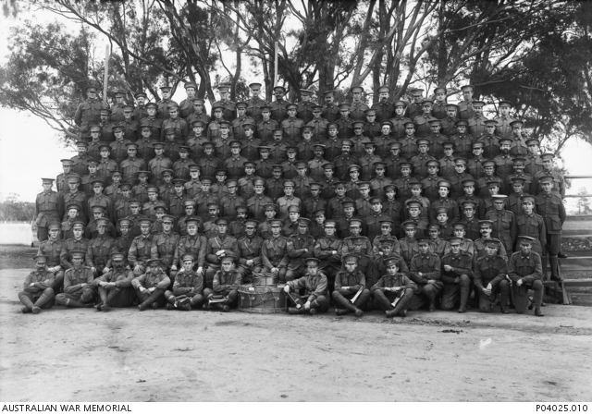

1. RSL Virtual War Memorial 2018, Returned & Services League of Australia SA Branch, accessed 25 February 2018, <https://rslvirtualwarmemorial.org.au/explore/people/67958>.

2. Australian War Memorial 2018, accessed 25 February 2018, <https://www.awm.gov.au/advanced-search/people?roll=First%20World%20War%20Embarkation%20Roll&people_preferred_name=Wilfred%20Fewkes%20Partridge&people_service_number=3152>.

3. 43rd Australian Infantry Battalion 1916, Photograph, Australian War Memorial, accessed 25 February 2018, <https://www.awm.gov.au/collection/C1013892>.

4. AIF Project 2016, accessed 25 February 2018, <https://aif.adfa.edu.au/showPerson?pid=234689>.

5. National Australian Archives 2018, Australian Government, accessed 25 February 2018, <https://discoveringanzacs.naa.gov.au/browse/records/309960/5>.

6. ‘University Examinations’ 1899, The Express and Telegraph, 24 November, accessed 25 February 2018, <https://trove.nla.gov.au/newspaper/article/209518185?searchTerm=(Wilfred%20Fewkes%20Partridge)%20&searchLimits=q-field0|||q-type0=all|||q-term0=Wilfred+Fewkes+Partridge|||q-field1=title%3A|||q-type1=all|||q-term1|||q-field2=creator%3A|||q-type2=all|||q-term2|||q-field3=subject%3A|||q-type3=all|||q-term3|||q-year1-date|||q-year2-date>.

7. ‘Personal’ 1914, The Mail, 28 February, accessed 25 February 2018, <https://trove.nla.gov.au/newspaper/article/59648544?>.

8. First World War 1914-18 2018, accessed 25 February 2018, <https://www.awm.gov.au/articles/atwar/first-world-war>.

9. Anzac spirit 2018, accessed 25 February 2018, <https://www.awm.gov.au/articles/encyclopedia/anzac/spirit>.

10. Intelligence Summary 1918, Photograph, Australian War Memorial, accessed 26 February 2018, <https://www.awm.gov.au/collection/C1344155?image=14>.

