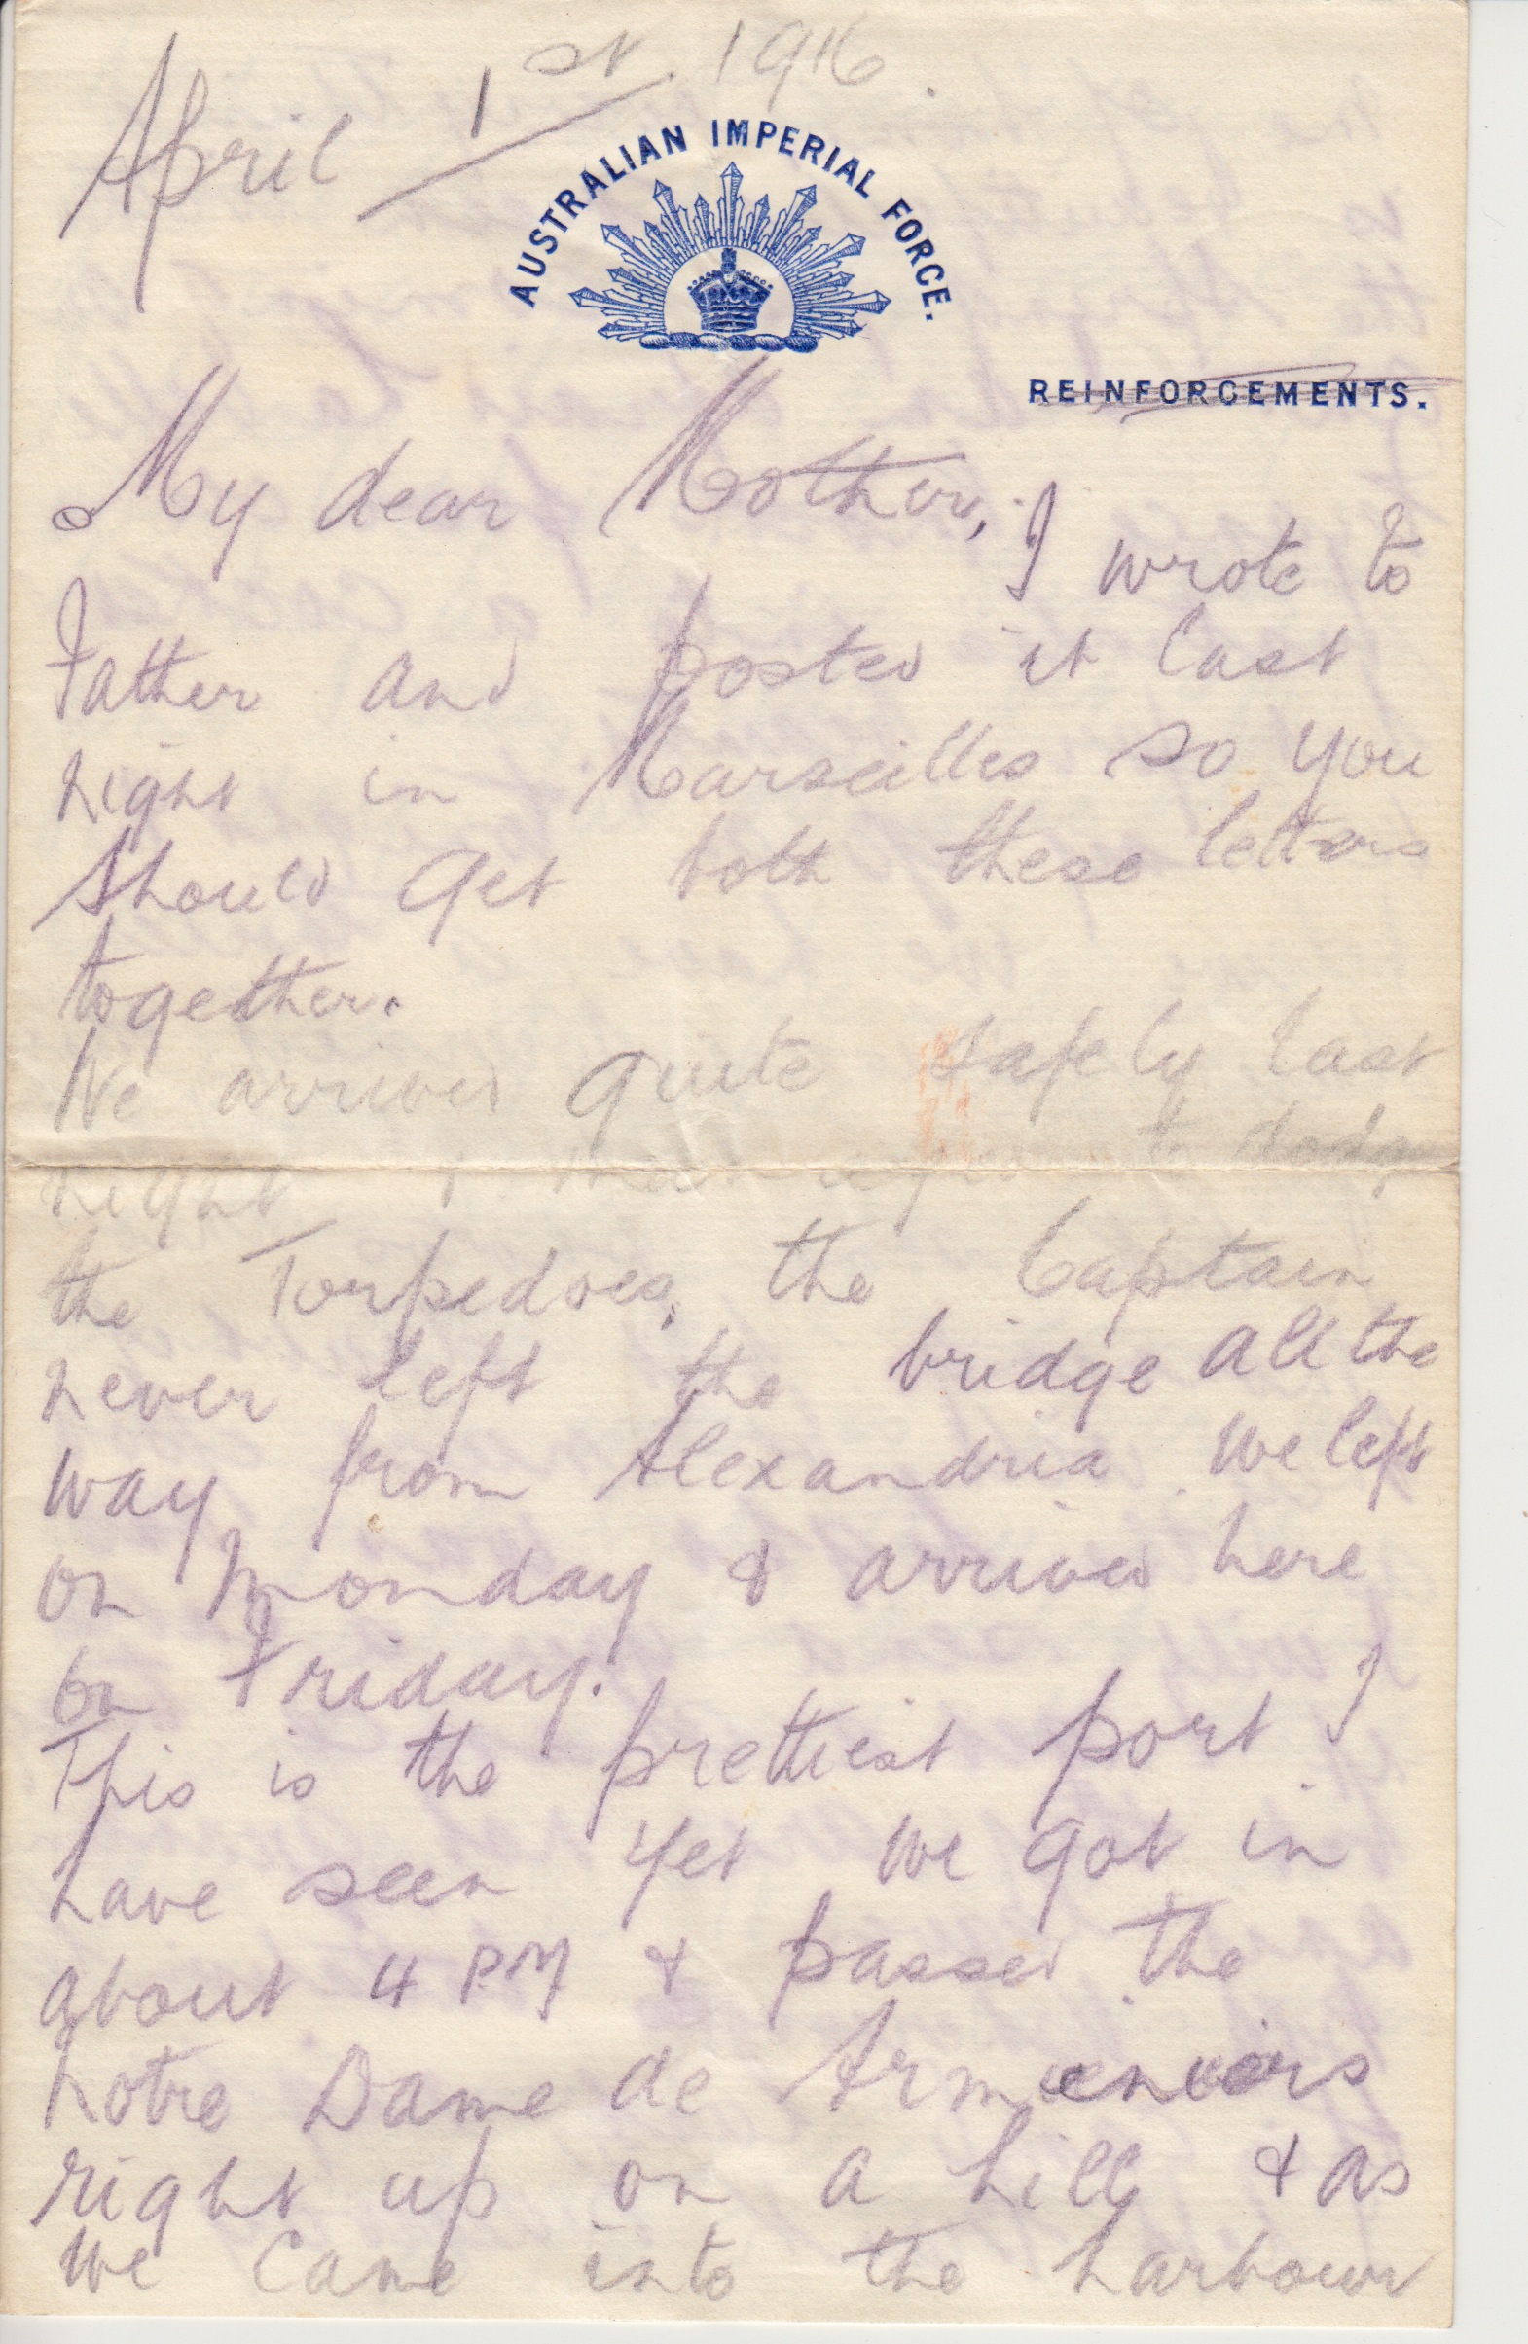 | 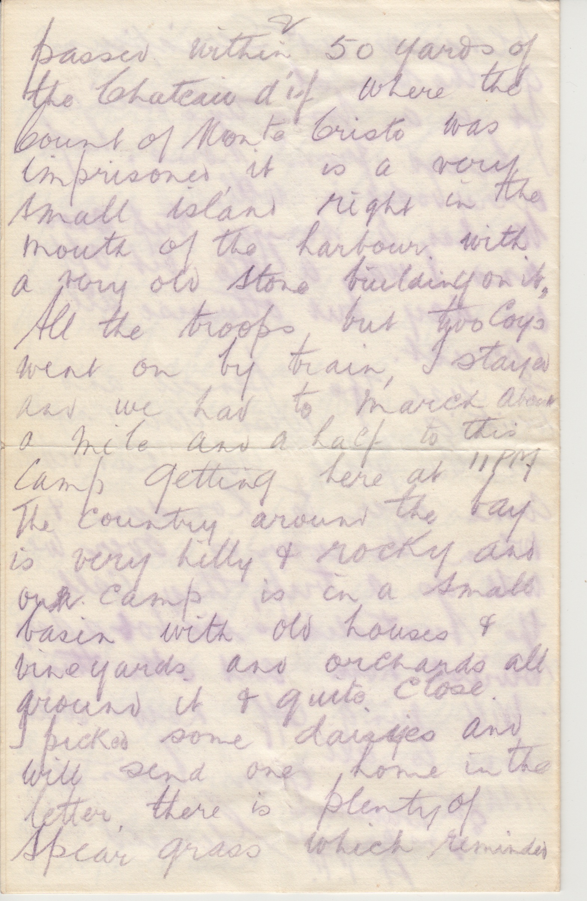
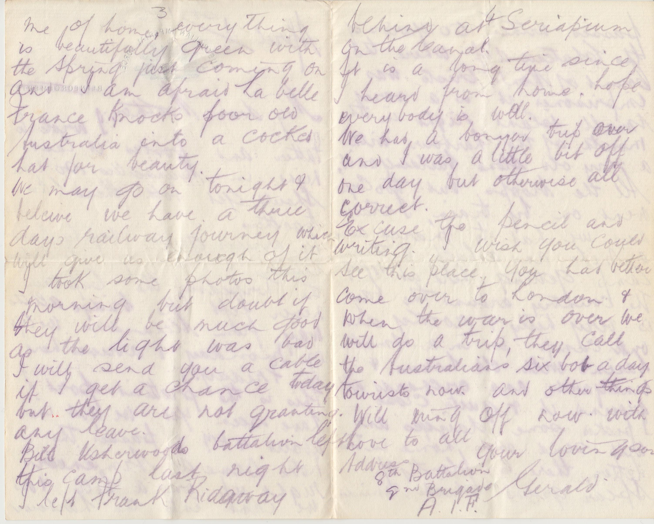
Transcript
Australian Imperial Force
April 1st, 1916
My dear Mother,
I wrote to father and posted it last night in Marseillaise so you should get both of these letters together.

We arrived quite safely last night. I managed to dodge the Torpedoes, the Captain never left the bridge all the way from Alexandria. We left on Monday and arrived here on Friday.

This is the prettiest port I have seen yet. We got in about 4 pm and passed the Notre Dame de Armeniers right up on a hill & as we came into the harbour, passed within 50 yards of the Chateau d'uf where the Count of Monte Cristo was imprisoned, it is a very small island right in the mouth of the harbour with a very old stone building on it. All the troops but two corps went on by train, I stayed and we had to march about a mile and a half to this camp getting here at 11 pm. The country around the bay is very hilly and rocky and our camp is in a small basin with old houses & vineyards and orchards all around it & quite close.

I picked some daisies and will send one home in the letter, there is plenty of spear grass which reminded me of home. Everything is beautifully green with the Spring just coming on and I am afraid La belle France knocks poor old Australia into a cocked hat for beauty.

We may go on tonight I believe. We have a three day railway journey which will give us enough of it. I took some photos this morning but doubt if they will be much good as the light was bad. I will send you a cable if I get a chance today but they are not granting any leave.

Bill Usherwoods battalion left this camp last night. I left Frank Ridgeway behind at Seriapium on the Canal.

It is a long time since I heard from home, hope everybody is well.

We had a bonzer trip over and I was a little bit off one day but otherwise all correct.

Excuse the pencil and writing. I wish you could see this place. You had better come over to London & when the war is over we will do a trip, they call the Australians six bob a day tourists now and other things. Will ring off now with love to all.

Address Your loving son
8th Battalion Gerald
2nd Brigade, A.I.F
(Written from near Fleurbaix, Northern France)

