SAPPER WILLIAM JOHN BISHOP
49 – 1st Australian Tunnelling Company

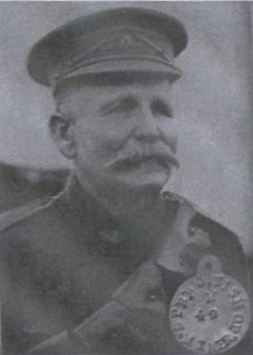
William John Bishop
taken from ‘Relatively Speaking’, FHANQ, July 2013

I was named after my Great Grandfather Bill Bishop who had Served during WW1 in France for 19 months from the ripe old age of 62 to 64.

If you saw the 2010 Australian movie “Beneath Hill 60” he was one of them.

He was a Mining Engineer from Gympie in Queensland.

His four sons also joined up and apparently he thought he had better go look after them. Two of the boys were wounded but all made it home alive. Sadly James of the 5 th Lighthorse passed away at a young age because of his injuries.
Bill received a thank you letter from Prime Minister Andrew Fisher.
