Donald Trevlyn Hood

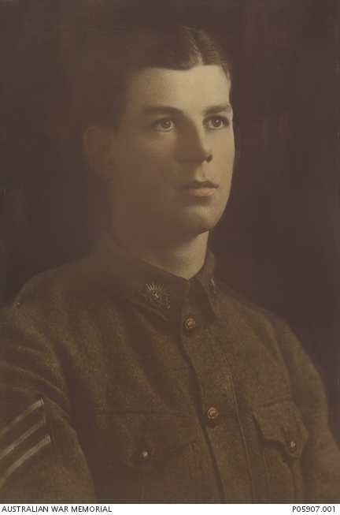
Born: Hobart, Tasmania, 2nd of November 1895
Home Town: Adelaide, South Australia
Schooling: Kyre College, Adelaide
Occupation: Bank clerk
Enlisted: 3rd of March 1915, Keswick, South Australia
Service Numbers: 596, 59
Embarkation: Embarked from Adelaide, South Australia, on board HMAT A2 Geelong on 31 May 1915
Last Rank: Sergeant
Last Unit: 2nd Division Headquarters
Died: Killed in Action, Ypres, Belgium, 29th of October 1917, aged 21
Cemetery: Ramparts Cemetery, Row B, Grave No. 8, Ypres, Belgium
Memorials: Adelaide National War Memorial, Australian War Memorial, Roll of Honour, Unley Arch, Unley HB01 Town Hall

Donald Trevlyn Hood was born on the 2nd of November in 1895 in Hobart, Tasmania as the son of William Percy and Caroline Burbury Hood. As a child, he grew up in the city of Adelaide, South Australia with his brothers Rupert and Kenneth, who also served in the army, and attended Kyre College, which was also located in Adelaide. Donald enlisted to join the Australian Infantry Forces on the 3rd of Mach in 1915 in Keswick, South Australia at the age of 19 years and 4 months. Prior to enlisting in the army, he worked at a bank as a clerk. His first rank was as a private, his unit was the 27th Battalion, C Company, and his service numbers were 59 and 596. He embarked from Adelaide on board the HMAT A2 Geelong on the 31st of May in 1915. The ship landed in Gallipoli and the soldiers then proceeded to fight on the Gallipoli Campaign and after that, the Western Front. In March of 1916 he transferred to a new unit, the 2nd Australian Division Headquarters. Donald was killed in action at the age of 21 in the Third Battle of Ypres on the 29th of October in 1917. The cemetery in which Donald’s grave can be located is in the Ramparts Cemetery in Ypres, Belgium. His grave is in row B and is the 8th grave along. The memorials in which Donald’s service is commemorated can be located at the Adelaide National War Memorial, the Australian War Memorial in the Roll of Honour, and in the Unley HB01 Town Hall.

<https://rslvirtualwarmemorial.org.au/explore/people/143450> Accessed 14 June 2017.
<https://www.awm.gov.au/collection/R1631838?search> Accessed 15 June 2017.
<https://www.aif.adfa.edu.au/showPerson?pid=142209> Accessed 20 June 2017.

