Graham Natt SMITH was born on 30th September 1922 to Morrell Murray Smith and Jessie Smith, of Brookmor, via Morgan. Morrell was a veteran of the ‘Great War’ and Grahams Uncle Clem, was killed in that conflict. Graham had a brother with the AIF, another brother in the RAN and a sister in the WAAAF's.
Graham was born at Strathalbyn but educated at Taylorville school and won a scholarship that gained him two years at the Waikerie Higher Primary School. He passed his Intermediate with credits.
Before enlisting on 16th August 1941 in Adelaide, he was working as a station hand on his uncle's station at Wurrulde, and with his father at Boggy Flat, where his grandparents took up land in 1897.
Graham was described as 18 years and 10 months old, 6’ 3” tall, 153 lbs with brown eyes and hair. He had a “medium” complexion. He had burn scars on the left side of his head.
After completing his initial training Graham sailed in March 1942 via NZ for Canada, where he gained his wings. After leave in New York he sailed for the UK.
After, four months in England he was promoted to Sergeant, and was flying Whirlwind and Typhoon fighter planes on missions over France and attacking German airfields and shipping.
On 12-3-1944 Graham was training in a Typhoon fighter over Dorsett when his plane unexpectedly spun into the ground killing him instantly.
Graham had been assessed as an excellent pilot and received his commission six weeks before he was killed. He died aged 21 years and 6 months. No cause could be determined for the plane accident but it was believed to be caused by equipment failure.
In a letter to Mr. and Mrs. Smith the CO of Graham's squadron wrote: "Graham joined this squadron more than a year ago and for a considerable time had been engaged on operational flying against the Hun. He was always most eager to engage the enemy and was an exceptional pilot. The country can ill afford the loss of such a pilot. Your grand boy was a most popular member of the squadron and we -all feel we have lost a loyal and sincere friend. May I express the sympathy we all feel for you in your sad loss."
Graham SMITH is interred in the Bath Cemetery and is commemorated on the Australian War Memorial on the Roll of Honour.

Graham is also commemorated with a tree and plaque here in the WAIKERIE War Memorial Gardens

.
Pilot Officer Graham Natt SMITH
30-9-1922 – 12-3-1944

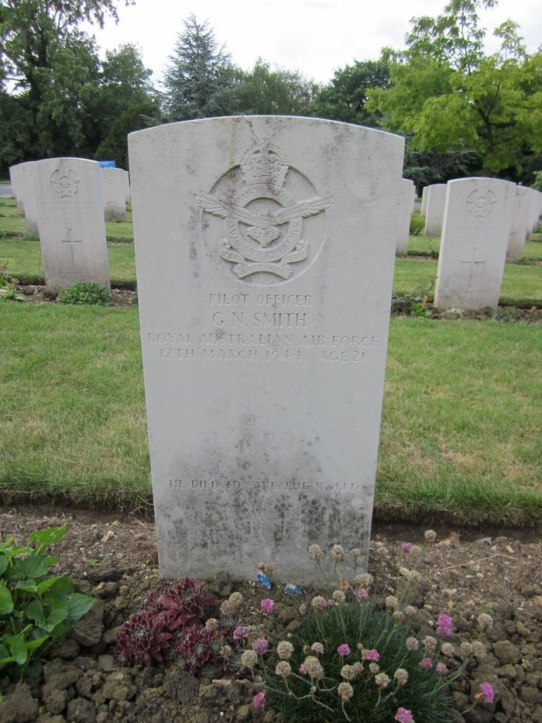

LEST WE FORGET
Waikerie RSL Sub branch

