Norman Dudley HAINES was born at Swan Reach on the 1st of July, 1917 the son of William Walter and Anna Maria HAINES. He had a brother Ray. Norman was working in Swan Reach at the outbreak of the war.

In 1941 he had already married Jessica Mildred Haines and they were living at Swan Reach, on the 8th of November, 1941, Norman completed his attestation in ADELAIDE and at 24 years of age joined the Royal Australian Air Force.

Norman completed his initial training and was in the process of pilot officer training in 1942, when he returned home to visit Jessie in the first week of July 1942. Jessie was heavily pregnant with their first child, and due to his training being conducted in South Australia at that time Norman was expected to be able to attend the birth.

On the 4th of August 1942, Norm was in a crew during training in Avro Anson bomber training aircraft “R3542” over Montieth near Murray Bridge. Flight Officer Lawrence WOTZKO (pilot), Sgt Gordon COOPER (observer)and Leading Aircraftsmen Leslie CADD and Norman HAINES were in the crew. They had been flying for a number of hours and were training in low level formation flying when at about 10am a collision occurred with another Anson aircraft “W2165”. The crew of “W2165” were Sgt Mervyn NICHOLLS, Sgt Hugh PHILLIPS, and Leading Aircraftsmen James RICHARDSON and Colin SAY.

The aircraft “R3542” crashed into the Murray River in about 90 feet of water. Aircraft “W2615” crashed nearby into ground on the bank of the river. All aboard both aircraft were believed killed instantly. The fuselage of aircraft “R3542” was recovered but Leading Aircraftsman HAINES and Flight Officer Lawrence WOTZKO’s bodies were never recovered despite long and methodical searches over six days.

One week after his death, Norm and Jessies daughter, Patricia Kathleen HAINES, was born in Swan Reach. In 1947 Jessie HAINES married Arnold HORSTMANN in Swan Reach.

A memorial service was held at Swan Reach Lutheran Church which was so well attended it was unable to hold all the mourners in attendance.

Norm is remembered at the family burial plot in the Swan Reach cemetery and is commemorated on the RAAF memorial in the Rookwood War Cemetery in NSW. He is commemorated on the Centennial Park War Cemetery Memorial, the Montieth Memorial and on the Australian War Memorial Roll of Honour.

Norman is also commemorated with a tree and plaque here in the WAIKERIE War Memorial Gardens.

Leading Aircraftsman Norman Dudley HAINES
1-7-1917 – 4-8-1942
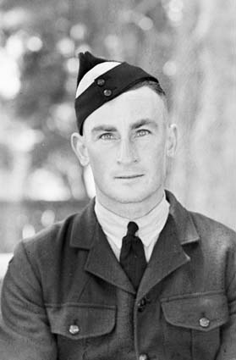
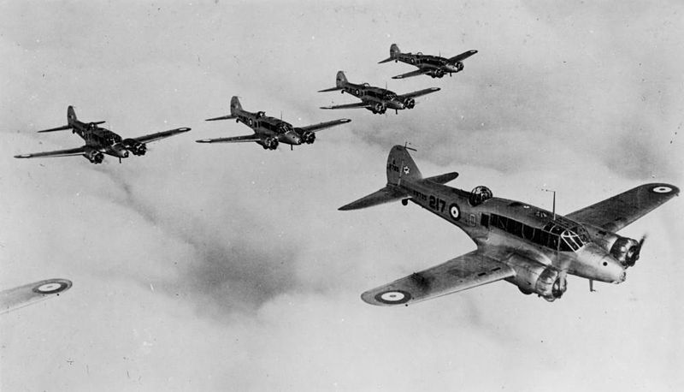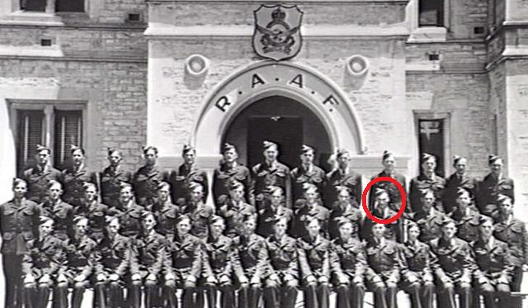
(RAAF Anson Bomber aircraft) HAINES circled, RAAF Training School, Mt
Breckan, VICTOR HARBOR, Jan 1942. Nine
of these 40 men died in aircraft action or
training before the war ended 3 years later.

LEST WE FORGET
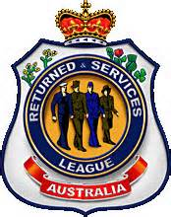
Waikerie RSL Sub branch

