Graham Sydney READ was born in 20th July, 1923 to Mr. Jack READ and Mrs Jessie Stella READ at Renmark. Graham was called Toby by family and friends. Tobys older sister, Gladys “Beth” was 2 years older than him.
Tobys father, Jack, died in the 1920s as a result of injuries sustained in World War 1.
Toby was educated at the Waikerie Primary and Higher School. Toby was also a keen cyclist, regularly riding in the Waikerie Cycling club events.
As soon as he could join, Toby enlisted in the RAAF in 1942. He completed training in South Australia and further training interstate before attaining the rank of Sergeant Air Gunner.
In January 1943 Toby was posted to Europe joining the 405 squadron, Royal Canadian Air Force. Changing to Avro Landcaster Bombers Toby was part of the famous Pathfinders squadron based at Gransden Lodge, England.
He took part in famous missions over Hamburg and Essen in July and in multiple missions over Berlin.
On the 28th September 1943, Toby and his crew took off and again flew to Berlin on another mission. Unfortunately this was to be their last, they were shot down and all aboard killed.
Toby READ is commemorated at the Runnymede War Memorial Cemetery and on the Australian War Memorial on the Roll of Honour.

Toby is also commemorated with a tree and plaque here in the WAIKERIE War Memorial Gardens.

Sergeant Air Gunner
Graham Sydney “TOBY” READ
20-7-1923 – 28-9-1943

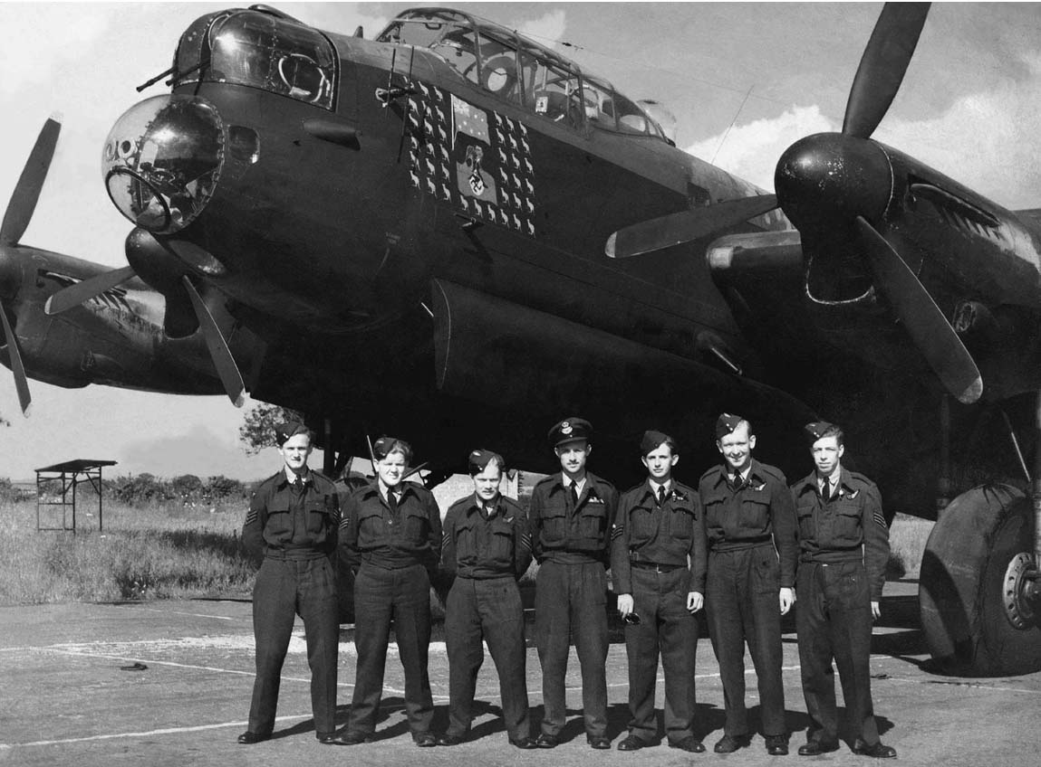
An Australian Aircrew with the 405th R.C.A.F, August 1943

LEST WE FORGET
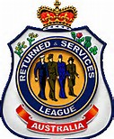
Waikerie RSL Sub branch

v

