William Dennis BLAKE was born in 1st March 1920 at Waikerie to William Harvey Blake and Marion Beatrice Blake. Bill was the eldest son of his family and very much looked up to by his four brothers and a sister. Bills Father, Lt. William BLAKE, served in “The Great War” at Gallipoli and in France. He was wounded four times and awarded the Military Cross for Bravery before returning and settling in the Waikerie area. He did not speak of the war.

Bill was educated at the Waikerie Primary school before moving to Boarding school at the age of 14 with his brother, Robert, 13. When war broke out, both enlisted, Bill riding his horse 120 miles to enlist in the Army in Adelaide. He trained in Victoria and Townsville before being sent to New Guinea as a member of the 2/6 Independent Company (later called 2/6 Commando).

The 2/6th Commando Squadron was raised in May 1942 as the 2/6th Independent Company, its main role was to conduct irregular type warfare including small scale raiding, sabotage, long-range patrols and reconnaissance operations rather than the traditional commando type direct action operations. As such, for the most part the unit conducted operations in small groups operating inside enemy territory, or out in front of larger friendly forces. In early August 1942, the 2/6th arrived in Pt Morseby and due to the deteriorating situation in the Owen Stanley Ranges, they were sent to the Kokoda Track. In late August he 2/6th moved to cover the Goldie River Valley in order to block any Japanese outflanking manoeuvres. They patrolled between 6 September and 12 October 1942 to cover wider lines of possible Japanese approach through the Yodda Valley, the jungle tracks around Esau Creek and the Brown River, and along Engineer Road in support of Honner Force. These patrols were varied in size and duration, ranging from four or five men to 150 and from five to six days up to months. In some cases they acted as independent, long-range patrols, while others were in close contact with regular formations
In October 1942, the offensive started in the battles of Buna and Gona, the 2/6th patrolled in front of the US Army's 1st Battalion, 126th Infantry Regiment, along the coast from Pongani to Buna. Arriving at the front line at Buna on 20 November 1942, the 2/6th was engaged in the heavy fighting around the New Strip airfield until the early December 1942 during which time they were employed mainly in a traditional infantry role. After fighting the Kokoda Track campaign and then Oro Bay, Private William Dennis Blake was only 20 years of age when he was shot by a Japanese sniper at Buna whilst fighting at the New airstrip.

On Sunday, December 2, 2007, the 65th anniversary of his death, Bills three surviving brothers Robert (84), Roger (80), and Maurice (77), together with nephew Bill (53), made the emotional pilgrimage to his grave at Bomana War Cemetery. Earlier, they flew over their brother’s battlefields of the Kokoda Track, Buna and where he had been killed at Gona. The Blake family have never forgotten their brother.

William Dennis BLAKE is interred in the Bomana War Memorial Cemetery and is commemorated at Keswick Army Base on the M & Z Special Unit memorial and on the Australian War Memorial on the Roll of Honour.

Bill is also commemorated with a tree and plaque here in the WAIKERIE War Memorial Gardens.

Private William Dennis BLAKE
1-3-1920 – 2-12-1942

Pte William Dennis BLAKE Maurice, Roger & Robert Blake at their brother
1941 Williams grave, Bomana War Cemetery, 2007

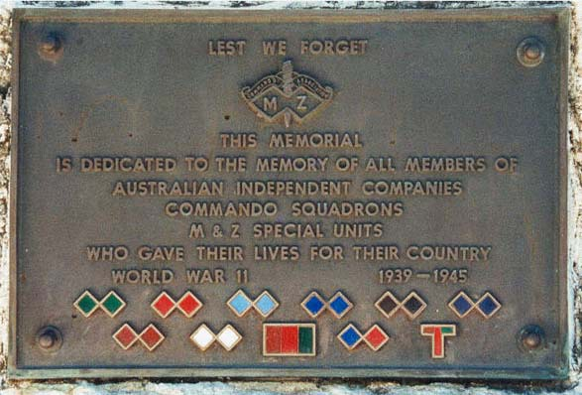
Keswick Special Unit 2/6 Independent Company
and commando memorial (Commandos) Colour patch

LEST WE FORGET
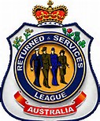
Waikerie RSL Sub branch

