Brian Richard Alan Jones, Perth Modern School 1963-65.
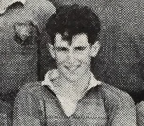 | 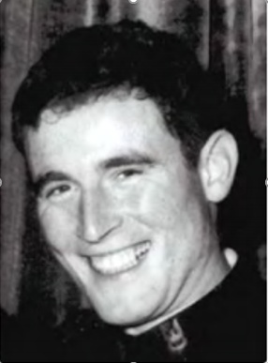

Brian was born in the UK on 18 April 1948. He attended Moseley Grammar School in Birmingham prior to his family migrating to Australia. His father, Harry Jones, was a chartered engineer and lecturer.
Brian was enrolled in his third year of high school at Perth Modern School on 12 February, 1963 and sat for his Junior Certificate at the end of that year. He gained passes in English, French, History, Geography, Maths A, Maths B, Science A and Science B. He played rugby for the school in 1964 and sat for his Leaving Certificate in November 1965.
Brian enlisted in the Australian Army on 5 July 1968, graduated from Portsea Officer Cadet School on 14 June 1969 and was commissioned as a Second Lieutenant in the Royal Australian Infantry. He was posted to the Special Air Service Regiment (SAS) in Swanbourne on 23 June 1969 and passed the demanding SAS selection course in July 1969. Brian was deployed to South Vietnam with 2 Squadron, SAS in February, 1971.
Brian died two months later in Vietnam. It was a sad and tragic death because he was killed by a member of his own patrol. Following is an edited extract from Dr David Horner’s book SAS Phantoms of War (pages 373-8) that describes how it happened.
Brian Jones’ six-man patrol plus four engineers were patrolling with SAS Sergeant Danny Wright’s 10-man patrol on 10 April 1971 in the district of Xuyen Moc south-east of Saigon, now called Ho Chi Minh City. They were searching for a Viet Cong bunker system that was to be destroyed by the engineers. Finding an ox-cart track, 2nd Lt Jones informed Sgt Wright that the track was the western boundary of the bunker system and that the bunker system was 60 metres further on.
Wright, who was in charge of the overall group, deployed his troops in a defensive position while he went forward with Jones and Warrant Officer Tough, commander of the engineer party, to locate the bunkers. Before leaving the defensive position, Wright briefed Sgt Kim Pember, second-in-command of his own patrol, and Jones’ second-in-command, a corporal, that he would be going forward on a reconnaissance. The reconnaissance party moved off to the east for approximately 110 metres but could not locate the bunkers.
The reconnaissance party turned north-east. As they were moving in an arc, Wright reminded Jones that if they continued, they would end up in front of the area where Jones’ patrol was in a defensive position. After walking some distance further, Jones was well ahead of Wright. Wright tried to gain Jones’ attention to stop him with a series of loud hisses and ‘psts’. Jones kept walking. Wright opened his mouth to call to Jones when there was a burst of fire from an M16 rifle and Brian Jones collapsed. Wright yelled ‘cease fire’ and ran forward.
As Wright had feared, Jones had wandered back towards his own patrol’s defensive positions. Through an oversight, one member of Jones’ patrol, Private Jeff Matthews, had not been briefed that a reconnaissance patrol would be moving across their front. Pte Matthews stated, “…I looked to my front to see, 10 metres away, a weapon pointing at me from the scrub with the figure still completely concealed by the foliage. I had my safety catch on automatic when I first heard the movement. I aimed instinctively and pulled the trigger.”
Brian died as he was being placed aboard the evacuation helicopter. He was a capable and popular officer.
Brian was eight days short of his 23rd birthday when he died. He is buried in Alice Springs Memorial Cemetery. He left a wife, Trish, and a son, Jason Courtney. Jones Park near the SAS Barracks in Swanbourne is named after him. The author of this article was in the same class as Brian at Mod in 1963. He is remembered as a big lad with a cheery grin and a happy demeanour.
LEST WE FORGET.

