Childhood home of Claude Benson
Bensonville”, 126 Twin Road,
North Ryde, City of Ryde Library

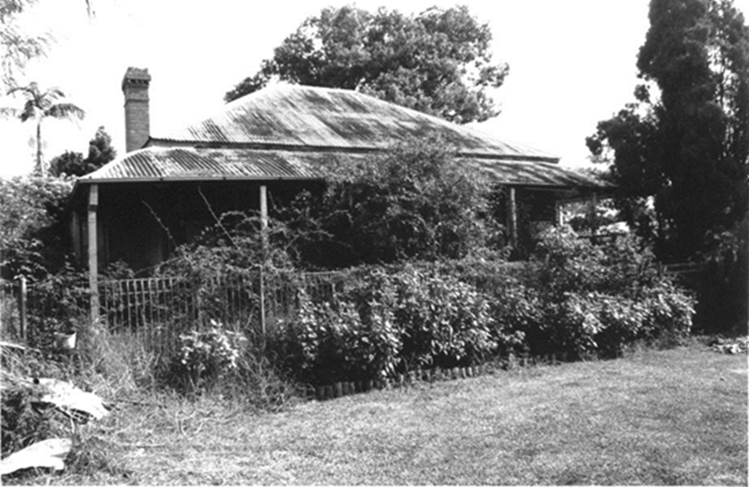

Loading the hay at “Bensonville” 1908
