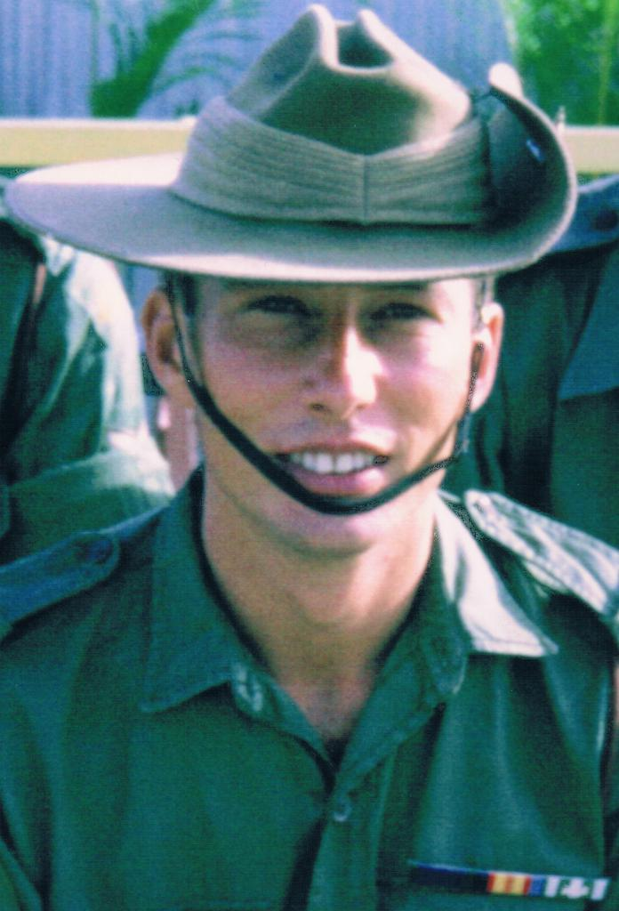

BRUNO A J ADAMCZYK
9RAR

Bruno enlisted in '63
He opted for a six year stint.
Then he went to South Viet Nam
Quite happy to be involved in it.

The temporary corporal was in his element
He loved the army life
But before too long
It landed him in strife.

For Bruno was killed in action
In a bunker system in July 12, '69.
There in Phuoc Tuy Province
Whilst serving in the front line.

Bill Charlton c 2019

