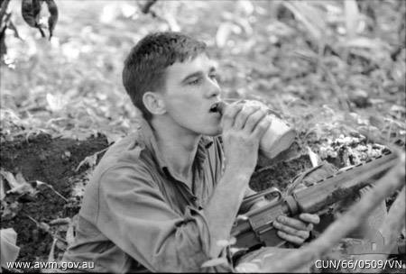
PAUL LARGE*
6RAR

This photo reminds me of the terrible cost,
When a young digger’s life is suddenly lost.
Captured in time drinking from his canteen.
As moving a photograph as I’ve ever seen.

For young Paul was killed at the Battle of Long Tan.
Facing the enemy as he made his last stand.
There was no finer digger that fought in the line.
His memory must endure the harsh test of time.

He was not meant to be there, but he volunteered.
The service he gave must be greatly revered.
For he gave up his life doing what he thought right.
A selfless sacrifice, during that terrible fight.

Paul Large upheld our finest Anzac traditions,
Serving his country in such trying conditions.
The bravery he showed must be conserved for all time,
As a shining example of our men in the line!

Look back at the photo and see what I mean.
It’s a classic life moment as ever I’ve seen,
Of a handsome young digger photographed in a war,
Taking a drink before giving his all!

*Previously published as –‘In Memory Of Paul Large’

Bill Charlton c 2015

